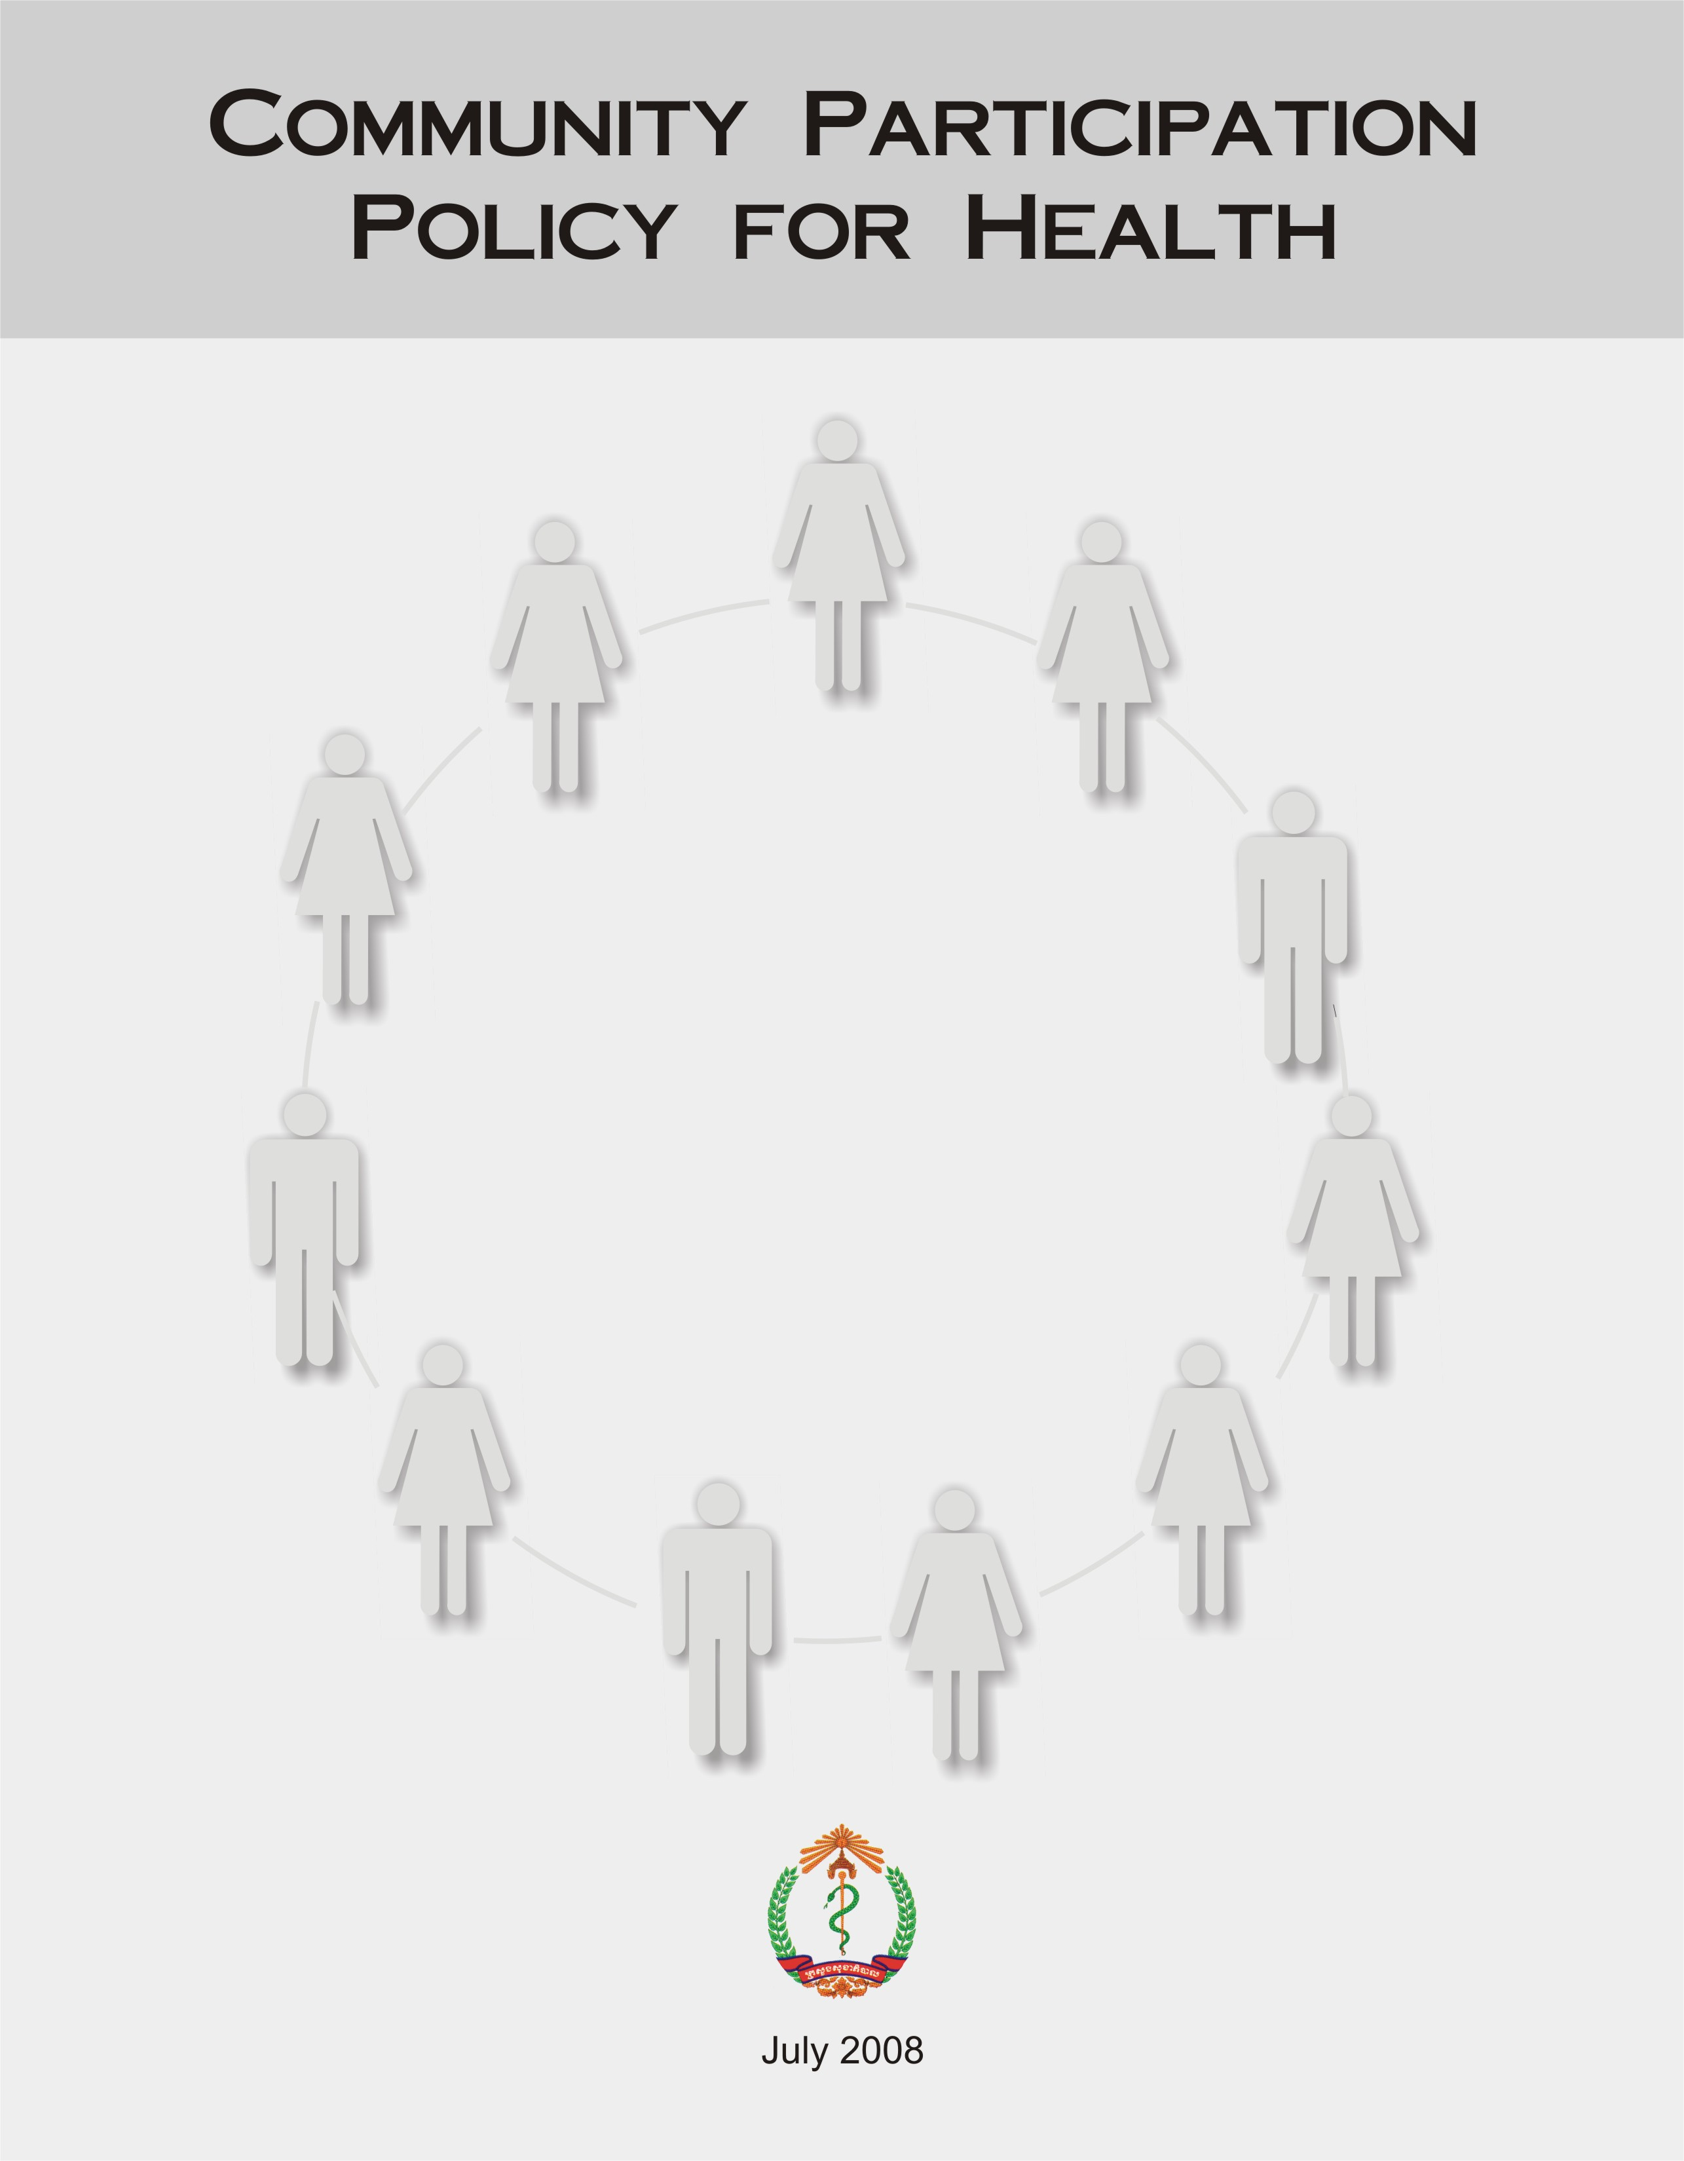

The people have the right and duty to participate individually and collectively in the planning and implementation of their health care facilities.

Primary health care requires and promotes maximum community and individual self-reliance and participation in the planning, organization, operation and control of primary health care, making the fullest use of local, national and other available resources; and to this end, develops through appropriate education the ability of communities to participate.

WHO/UNICEF, Alma Ata 1978: Primary Health Care, WHO Geneva 1978
(WHO Health For All Series No.1)

TABLE OF CONTENTS

ACKNOWLEDGEMENTS.......................................................................................................4
FORWARD..............................................................................................................................5
GLOSSARY OF ABBREVIATIONS & ACRONYMS................................................................7
INTRODUCTION.....................................................................................................................8
FRAMEWORK FOR THE ORGANIZATION OF COMMUNITY PARTICIPATION.................11

1. community participation structures 11
1.1 The Village Health Support Group (VHSG) 11
1.1.1 Membership 11
1.1.2 The Criteria for Selection of VHSG Leader/Members 12
1.1.3 Roles and Responsibilities of the VHSG Leader 13
1.1.4 The Scope of Work of the VHSG 13
Health information systems: 13
Provision and follow up of information and essential services: 14
Provision and follow up of essential diagnosis and treatment services (Following National Guidelines): 14
Provision of essential commodities: 15
1.1.5 The VHSG Leader/Members are responsible to attend the following meetings: 15
1.2 The Health Center Management Committee (HCMC) 17
1.2.1 Membership 17
1.2.2 Roles and Responsibilities of the HCMC 17
2. community participation supportive mechanisms 18
2.1 Partners in Community Participation 18
2.1.1 The Community 18
2.1.2 The Health Centre 18
2.1.3 The Operational District 19
2.1.4 The Provincial Health Department 19
2.1.5 The Commune Councils 19
2.2 Benefits/Incentives for the VHSG 20
2.3 Training and Capacity Building: 20
2.4 Financing Mechanisms 21

ACKNOWLEDGEMENTS

The Ministry of Health, which provided senior leadership for the revision of the Community Participation Policy for Health, would like to acknowledge key stakeholders for providing support and guidance throughout the highly participatory process.

The revision of the Community Participation Policy for Health was undertaken to strengthen and support the important work of community health volunteers in Cambodia. The revised policy aims to clarify community structures, scope of work, and supportive mechanisms to maximize community participation and improve the health situation throughout the Kingdom. This process would not have been possible without the committed efforts of the Community Participation for Health Taskforce, chaired by Dr. Lo Veasna Kiry, the Director of the Department of Planning and Health Information, Ministry of Health (MoH). His dedicated leadership and tireless efforts to ensure proper coordination and his commitment to the consultative process have been invaluable to the revision of the Community Participation Policy for Health. The active participation of the following members of the Taskforce is also highly appreciated:

Dr. Lim Thai Pheang MoH
Dr. Prak Piset Rang Sey MoH
Dr. Ly Vichea Ravuth MoH
Dr. Chea Samnang MRD
Mme. Teng You Ky MRD
Dr. Kou Sothea MWA
Mr. Chea Bun Heng MOI
Dr. Thor Rasoka UNICEF
Dr. Niklas Danielsson WHO
Dr. Uy Sam Onn CRC
Dr. Sek Sopheanarith USAID
Mr. Prateek Gupta BASICS
Mr. Yim Sovan MEDICAM/PFD
Ms. Kristina Mitchell Secretariat
Dr. Loun Mondol MoH/Secretariat
Dr. Sin Sovan MoH/Secretariat

We would like to thank Dr. Sin Somuny, Executive Director of MEDICAM in addition to other MEDICAM staff in Phnom Pehn, Battambang and Siem Reap for their valuable input and assistance in coordinating and facilitating the election of the NGO representative, the Provincial Consultative Workshops in Battambang and Siem Reap, the National NGO Consultative Workshop in Phnom Penh and the input of the NGO voice overall.

We offer our thanks to Mr. Robert Kolesar from the American Red Cross for his significant technical support and guidance to the Taskforce and the Secretariat throughout the entire revision process.

Our gratitude also extends to all National Programs, Provincial Health Department Staff, Operation District staff, HC staff, Commune Council members, VHSG/health volunteers, and community members who participated and contributed their time and views during the revision process in Phnom Penh and in Battambang, Siem Reap, and Kratie provinces.

FORWARD

In September 2007, The Ministry of Health's Department of Planning and Health Information initiated a national dialogue on Community Participation with the goal of revising the National Community Participation Policy for Health.

The policy development process used a highly participatory and evidence-based approach, engaging all key stakeholders to build consensus around the policy decision-making based on best practices as well as experience of the many health development partners in Cambodia. The process was steered by an appointed Community Participation (CP) Taskforce, chaired by Dr. Lo Veasna Kiry, the Director of the Department of Planning and Health Information Systems, with representation from the Ministries of Health, Rural Development, Women's and Veteran's Affairs, and Interior; the Cambodian Red Cross, UNICEF, WHO, USAID, BASICS, as well as one representative from the NGO community elected through MEDICAM.

Key steps in the process included:

- The development of a participatory roadmap by Taskforce members: the road map ensured that every opportunity would be given for stakeholders to participate in the process, along with the core Taskforce members.

- The drafting of the outline and policy components of the CP policy: three “task teams” were created from amongst Taskforce members to work on specific policy components including key community participation structures, the scope of work for the community participation structures, and supportive mechanisms for community participation.

- A literature review was conducted to compile best practices and lessons learned relating to each policy component in order to ensure that decision making throughout the process was evidence-based and consistent with international best practices.

- Regional Consultative Workshops were conducted in Battambang and Siem Reap as well as Kratie province to present the first draft and solicit feedback from stakeholders including Commune Councils, HCMCs, VHSGs, OD staff, PHD staff, Health Center staff, NGOs, and community members.

- A National NGO Consultative Workshop was conducted in Phnom Penh to engage NGOs and solicit input on the second draft.

- Individual consultations were conducted with key stakeholders such as National Programs, IOs, and NGOs.

- A National Consultative Workshop was conducted in Phnom Penh for review and final comment on the third draft, participation included key stakeholders from the CP Taskforce, relevant ministries, National Programs, PHD representatives, OD representatives, and NGOs.

- A detailed review of the final draft was conducted by the Director of the Department of Planning and Health Information and other Taskforce members.

This process was financially supported by the United States Agency for International Development (USAID), the Child Survival Collaborations and Resource Group (CORE) and the American Red Cross.

GLOSSARY OF ABBREVIATIONS & ACRONYMS

ANC Antenatal Care
ARI Acute Respiratory Infection
BASICS Basic Support for Institutionalizing Child Survival
BS Birth Spacing
CBD Community Based Distributor
CC Commune Council
CCWC Commune Committee for Women and Children
CENAT National Tuberculosis Program
CDOTS Community Direct Observation of Therapy Watchers
CHBT Community Home Based Care Teams
C-IMCI Community Integrated Management of Childhood Illnesses
CIP Commune Investment Plan
CNM National Malaria Centre
CORE Child Survival Collaborations and Resource Group
CP Community Participation
CPA Complementary Packages of Activity
CRC Cambodian Red Cross
DOTS Directly Observed Therapy Short course
EPI Expanded Programme on Immunisation
HC Health Centre
HCMC Health Centre Management Committee
HIS Health Information System
HSP2 Health Sector Strategic Plan 2008-2015
IEC Information, Education, Communication
MOH Ministry of Health
MOI Ministry of Interior
MNCH Maternal Newborn and Child Health
MPA Minimum Package of Activities
MRD Ministry of Rural Development
MWVA Ministry of Women’s and Veteran’s Affairs
NCHP National Centre for Health Promotion
NGO Non-Governmental Organisation
OD Operational District
PFD Partners for Development
PHC Primary Health Care
PHD Provincial Health Department
RCV Red Cross Volunteer
RGC Royal Government of Cambodia
RH Referral Hospital
TB Tuberculosis
TBA Traditional Birth Attendant
UNICEF United Nations Children’s Fund
USAID United States Agency for International Development
VHV Village Health Volunteer
VHW Village Health Worker
VHSG Village Health Support Group
VMW Village Malaria Worker
WHO World Health Organization

INTRODUCTION

The Ministry of Health's Health Sector Strategic Plan 2008 – 2015 clearly defines its vision and mission as stated below:

The Vision is “to enhance sustainable development of the health sector for better health and well-being of all Cambodians, especially of the poor, women and children, thereby contributing to poverty alleviation and socio-economic development.”

The Mission of the Ministry of Health is “to provide stewardship for the entire health sector and to ensure supportive environment for increased demand and equitable access to quality health services in order that all the peoples of Cambodia are able to achieve the highest level of health and well-being.”

A value-based commitment of the Ministry of Health is Equity and the Right to Health for all Cambodians.

Working Principles of the HSP2:

Community Participation is an integral component of Working Principle 2 and a cross-cutting theme of all the following principles.

- Social health protection, especially for the poor and vulnerable groups: To promote pro-poor approaches, focusing on targeting resources to the poor and groups with special needs and to areas in greatest need, especially rural and remote areas, and urban poor.

- Client focused approach to health service delivery: To offer services with emphasis on affordability and acceptability of services, client rights, community participation and partnership with the private sector.

- Integrated approach to high quality health service delivery and public health interventions: To provide comprehensive health care services including preventive, curative and promotion in accordance with nationally accepted principles, standards and clinical guidelines, such as MPA and CPA, and in partnership with the private sector.

- Human resources management as the cornerstone for the health system: To be operational and productive driven by competency, ethical behavior, team work, motivation, good working environment and learning process.

- Good governance and accountability: To provide stewardship for both the public and private sectors, focusing on a sector wide approach, effective planning, monitoring of performance, and coordination.

Figure 1 from Chapter 2 of the HSP2 outlines the “Health System Organization”, in which “community participation”, “close contact with the population”, and references between the Health Centres and Community are highlighted. The Community Participation Policy for Health provides a framework for this level of the health system.

The consolidation phase of the HSP2 will follow three parallel tracks that will provide a robust platform for policy formulation and scaling-up. Track 1 is to decide over a package of key policies and develop their implementation tools. The Strategic Framework for Community Participation in Health is specifically mentioned in the consolidation phase.

Objectives of the Community Participation Policy for Health

The Community Participation Policy for Health has been revised through a participatory process that is in line with the HSP2’s values and working principles. Through the CP structures and mechanisms outlined in the policy, community members are actively encouraged to participate in the health system for the overall improvement of the health situation throughout the Kingdom of Cambodia.

Main objectives include:
- Involving the community, through the VHSG and the HCMC in the process of the management of the Health Centres, with the goal of organizing accessible, affordable, effective, and sustainable quality health services, adapted to the specific community needs .
- Increasing the Health Centres’ accountability to users regarding their duty to provide quality services by supporting and working with the VHSG and other community participation structures.
- Encouraging and enabling the VHSG to promote informed health seeking behaviour to community members.
- Providing an improved framework for all health actors working at the community level to promote the sustainability of community participation.
- Identifying funding mechanisms to finance the sustainability of community participation structures.

Principles of Community Participation

- Ownership/Representation: In the newly revised VHSG, one VHSG Leader per village will be elected by community members themselves. As now there is one VHSG per village, and all other health volunteers in the community are now included in the VHSG as “VHSG Members”, the views and concerns of community members can be communicated through an expanded and defined structure, thus facilitating feedback to Health Centre staff while promoting community representation and ownership of the Health Centre.

- Gender Balance: It is important that a gender balance exists within the VHSG and that the poor living in the community have a voice in the community participation process.

- Transparency: Interaction and communication between the Health Centre and the community is now facilitated through the revised VHSG and the corresponding feedback/information sharing meetings (VHSG, HCMC, Commune Council, etc.) as described in the CP policy. Through this improved and structured system, the flow of information is facilitated between the community and the Health Centre.

This principle is in line with the HSP2 Health Service Delivery Chapter 4, point 4.4, which highlights the need to “monitor client satisfaction in public health service through regular client surveys; and improve communication and coordination between health facilities and Health Center Management Committees (HCMC), VHSGs, Health Equity Fund implementers and Commune Councils”.

Further, in Chapter 6: Health Service Governance, point 6.4, it specifically states to: “Strengthen the function of HCMCs and VHSGs as focal points of communication between consumers and suppliers”.

- Partnership: All partners in community participation, including community members, the VHSG, the HCMC, the HC team, the OD, the PHD, and the Commune Council must work together to build a common vision towards achieving true community participation for the sake of improving the health and well being of community members. All health stakeholders should actively support this principle.

In the HSP2 Health Service Delivery Chapter, partnership is highlighted in point 1.6 which states that it is important to “strengthen integrated outreach and community-based models of care as an intermediate strategy for scaling up maternal, newborn and child survival interventions, especially in communities with limited access to health facilities; ensure effective involvement of local authorities and volunteers (VHSGs) in provision of selected services and information for improved MNCH”.

FRAMEWORK FOR THE ORGANIZATION OF COMMUNITY PARTICIPATION

1. community participation structures

1.1 The Village Health Support Group (VHSG)

Each village has one Village Health Support Group (VHSG). The VHSG includes one VHSG Leader and other supporting VHSG Members.

1.1.1 Membership

- One elected VHSG Leader
- VHSG Members: one VHSG member responsible for 10-50 households, as
defined by the OD Director and the needs of the community.

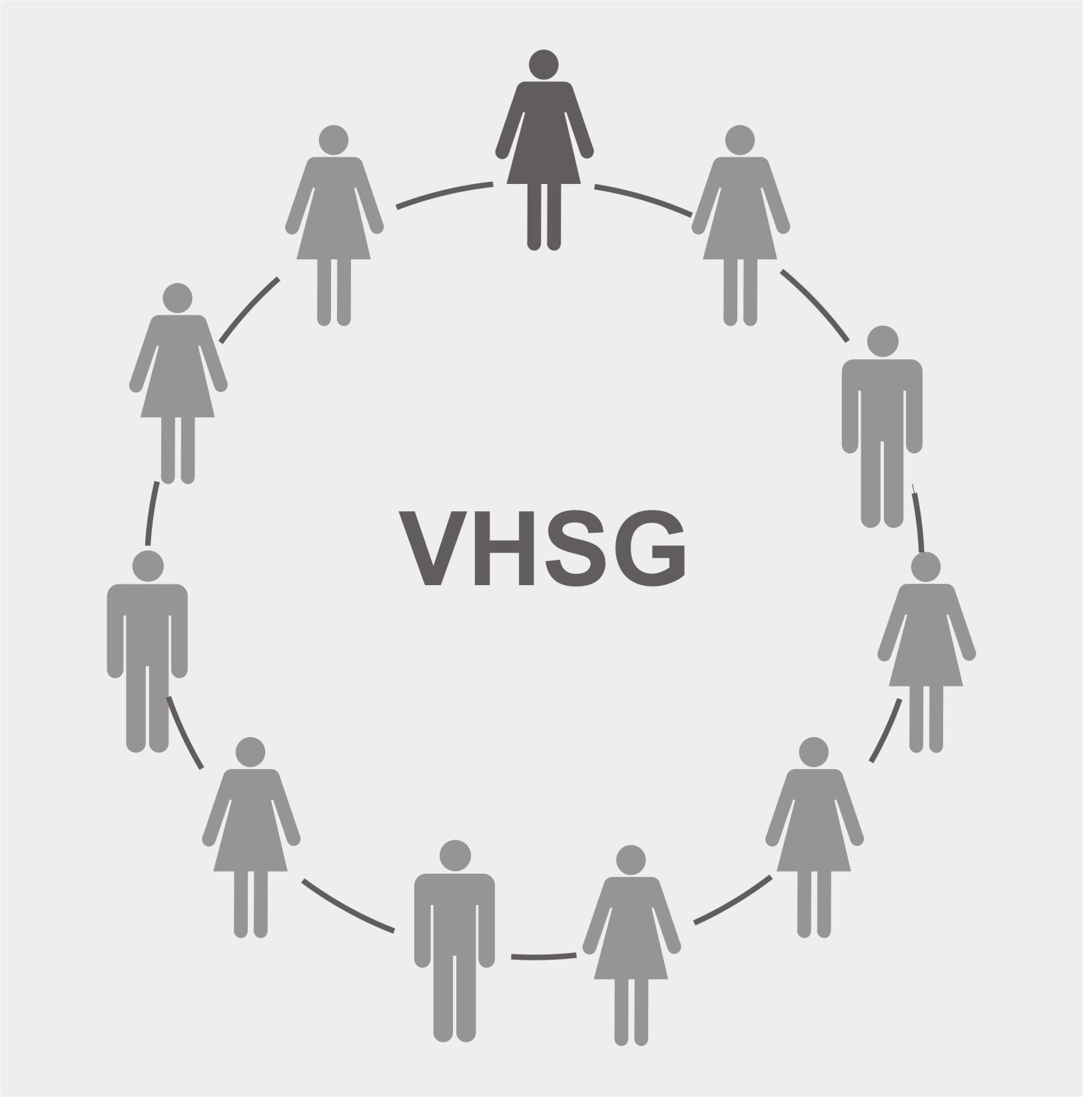

The Village Health Support Group (VHSG)

- 1 VHSG Leader – elected by the community.
- Other VHSG Members – maintaining gender balance; one VHSG member per 10-50 households depending on community needs.

Examples of VHSG Members may include:
- Red Cross Volunteers (RCV)
- Community Based Distributors (CBD)
- Village Malaria Workers (VMW)
- Community Home Based Care Teams (CHBT)
- Community Direct Observation of Therapy Watchers (CDOTS)
- Traditional Birth Attendants (TBA)
- Community-Based Peer Educators for Chronic Disease
- Mother Support Groups
- Other health volunteers (i.e. VHVs)

1.1.2 The Criteria for Selection of VHSG Leader/Members

- The VHSG Leader must be elected by community members
- The VHSG Leader should be literate
- VHSG Leader/Members must live in the village where they are elected/selected
- VHSG Leader/Members should have good communication skills and be motivated to work for the benefit of their community
- VHSG Leader/Members should be between 20 and 55 years old

The VHSG Leader and members are formally recognized by the local heath authorities. The HC is responsible to submit a list of all active VHSG Leaders and members in their catchment area to the OD. The OD is responsible for organizing identification (ID) cards to submit to the PHD. The PHD Director is responsible to sign the ID cards.

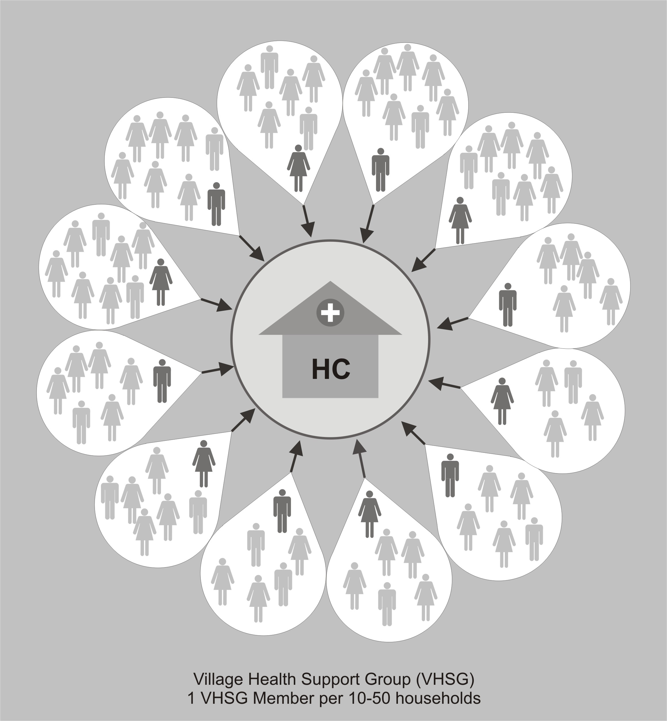

The VHSG Membership in each village should be determined jointly by the community, the OD, and the HCMC. Membership should be based on the scope and scale of VHSG responsibilities in the community in order to support implementation of community-based health activities following the VHSG Scope of Work.

1.1.3 Roles and Responsibilities of the VHSG Leader

The VHSG Leader is the primary point of contact for all health activities in the village. His/her main roles are to: (1) ensure the regular flow of information between the community and the HC, and (2) coordinate the VSHG to implement the Scope of Work for the VHSG in their village.

The elected VHSG Leader from each village in the HC catchment area is responsible for:

- Providing feedback from the community to the HC, and keeping the VHSG and the community informed about HC activities;
- Coordinating training activities for the VHSG to support HC activities in the community;
- Providing information about HC services and fees to the community;
- Reporting consumer satisfaction and dissatisfaction to the HCMC regarding the quality of health care in HCs, access to HCs, user fee rates, etc.;
- Facilitating outreach activities with the VHSG Members, the HC and the community;
- Promoting client rights and good governance.

1.1.4 The Scope of Work of the VHSG

The following Scope of Work is intended as a “menu of activities” for VHSG Members with the goal of promoting a well functioning system among the different community participation structures, and improving the health situation in their village. The Scope of Work is not intended to be exhaustive; indeed, there are likely many more real and potential roles and responsibilities for VHSG Members.

Health information systems:

  - Assist the HC with disease surveillance/monitoring and case reporting to the VHSG Leader during Monthly Village Health Meetings (including “Zero Reporting”);
- Report disease outbreaks to the HC in a timely manner;
- Keep a register of all children below five years of age in the village, recording each child's name, sex, date of birth, and parents' name;
- Keep a register for all women and reproductive age and pregnant women
- Assist the HC in collecting vital registration statistics including notification of pregnancies, births and deaths;
- Literate VHSG Members should be trained and encouraged to complete verbal autopsies for deaths that occur in the village versus a simple checklist provided;
- Collect information through appropriate tools on health and health-related problems in the community, inform and report to the HC in a timely manner.

Provision and follow up of information and essential services:

- Facilitate the identification of the poor for fee exemption and Health Equity Fund coverage;
- Provide health education, promote improved health practices, and distribute health IEC materials. Health topics to be covered include: Key Family Practices, family planning, antenatal care, clean delivery, post natal care, breastfeeding, complementary feeding, safe water, hygiene and sanitation, malaria and dengue control, HIV/AIDS/STIs, tuberculosis, immunizations, non-communicable and chronic diseases, mental health, tobacco and alcohol, and gender-based and family violence;
- Mobilize families and assist HC staff during outreach activities and health campaigns;
- Assist in the mobilization of resources for sustainability of Health Centers;
- Assist families with early identification of the danger signs for severe/serious illnesses;
- Promote and strengthen the HC referral system and assist in logistics such as transportation.

Provision and follow up of essential diagnosis and treatment services (Following National Guidelines):

- Promote correct home care for illnesses following the C-IMCI training curriculum for Community Health Volunteers;
- Provide Community Based First Aid and rehabilitation;
- Identify and refer children with acute malnutrition; follow up on children with acute malnutrition under community based management and provide health education on feeding malnourished children;
- Provide Home Based Care;
- Assist HC to detect chronic diseases;
- Provide DOTS for TB patients when requested by the HC;
- Provide ORS including Zinc for diarrhea in children.

In remote and difficult to access communities:

- Provide early diagnosis and treatment (EDAT) for malaria when delegated by the OD director;
- Diagnosis and treat ARI with antibiotics in children when delegated by the OD director.

Provision of essential commodities:

- Distribute micronutrient supplementation (Vitamin A, Iron, Folic Acid, etc.);
- Distribute mebendazol;
- Distribute oral re-hydration treatment with zinc;
- Distribute condoms and family planning supplies;
- Distribute long lasting insecticide treated mosquito bed nets and hammock nets;
- Distribute abate;
- Distribute food supplementation (i.e. sprinkles) and Ready to Use Supplementary Foods (RUSF).

1.1.5 The VHSG Leader/Members are responsible to attend the following meetings:

- Monthly Village Health Meetings: The VHSG Leader is responsible for organizing and facilitating monthly meetings in their village. All VHSG Members should support the VHSG Leaders through their participation in the Monthly Village Health Meetings. The purpose of these meetings is to:
- discuss health issues effecting the village and take action to solve problems;
- gather information and feedback from all VHSG Members to be communicated to the HCMC;
- share information and feedback from the HCMC through the VHSG Leaders who attend the HCMC meetings.

- VHSG Leader Meetings: The VHSG Leaders from each of the villages in the HC catchment area should meet at least once every two months with the Health Centre Team at the Health Centre. The purpose of these meetings is to:
- share information, discuss and find solutions to health issues effecting the villages in the HC catchment area;
- allow the VHSG Leaders who attend the HCMC meetings to share reports from the HCMC meetings to all VHSG Leaders in the HC catchment area.

  - Health Center Management Committee (HCMC) Meetings: 4-7 VHSG Leaders from the Health Centre catchment area will be members of the HCMC and will attend the quarterly HCMC meetings at the Health Centre. The purpose of the HCMC meeting is to:
- update the VHSG Leaders on HC activities to keep the population in the HC catchment areas fully informed about the HC activities and other important events and information related to health;
- discuss and find solutions to issues related to HC service delivery following feedback provided by VHSG Leaders;
- take HCMC meeting minutes that document main discussion points and decisions in order to follow up on actions. Meeting minutes should be copied to the OD and the CC.

Regular meetings to ensure communication and feedback between
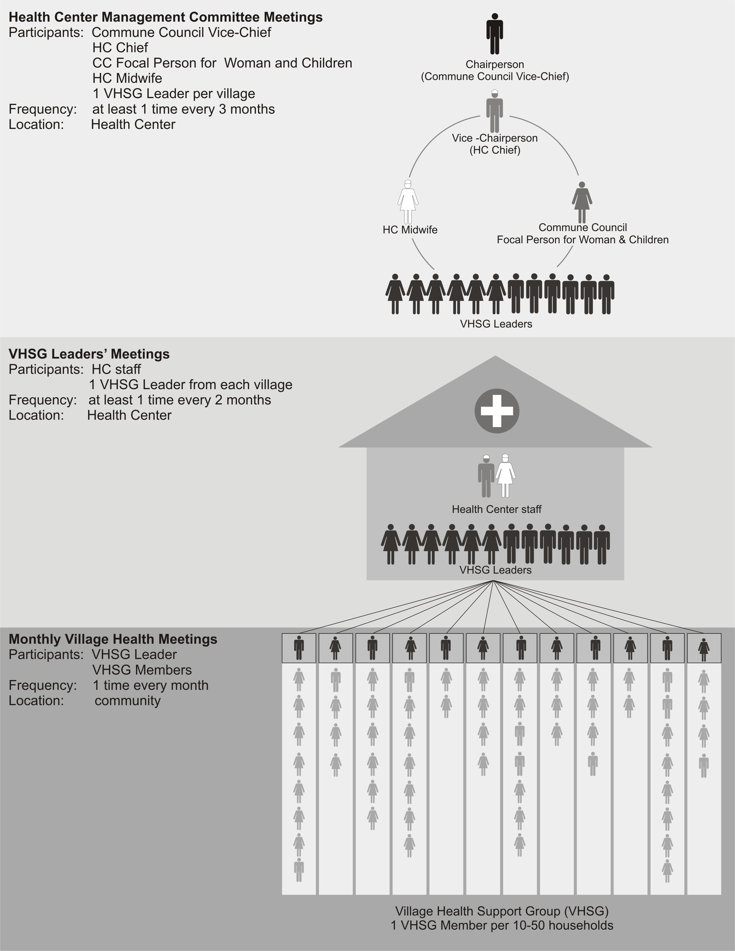
the HC and the community

1.2 The Health Center Management Committee (HCMC)

1.2.1 Membership

The HCMC should have approximately 9-11 members including:

  - Chairperson: The Vice-Chief of the CC in charge of social affairs including health, education, etc. In the case where a HC covers more than 1 Commune, the Chairperson of HCMC will be the Vice-Chief of the CC where the HC is located.
  - Vice-Chairperson: The Chief of the HC. In the case that the Chairperson of the HCMC is absent, the Vice Chairperson will become the acting Chairperson.
  - Other members:
    - 1 additional member from the CC, preferably the Focal Person for Woman and Children
    - 1 additional HC staff, preferably the HC midwife, who acts as the HCMC Secretary
    - 4-7 VHSG Leaders from the HC catchment area, ensuring that each Commune covered by HC is included and ensuring a gender balance

1.2.2 Roles and Responsibilities of the HCMC

      - Oversee and provide strategic guidance for overall management and development of HC services:
- Participate in the quarterly review and implementation of the HC Annual Operational Plan (AoP) and ensure the link between the HC, the AoP and the Commune Investment Plan (CIP);
- Set and periodically review user fee levels in consultation with the VHSG Leaders and the Commune Council;
- Facilitate the process of the identification mechanism for the poor to be exempted in accordance with the Ministry of Planning guidelines for identification of poor;
- Support HC in developing/setting-up effective transportation arrangements/mechanisms for referrals.

  - Maintain linkages between the HC and communities through VHSG Leaders and other CP structures and facilitate inter-sectoral coordination to promote Community Participation in health and health-related areas:
- Obtain and act upon comment/suggestions and complaints of community members/service users about the HC management and health service delivery and to identify appropriate solutions and opportunities for improvements;
- Ensure through the VHSG Leaders and other appropriate channels that important health information is given to the population especially at the times of disease outbreaks;
- Promote awareness of consumer and provider rights;
- Through the VHSG, coordinate health and health-related activities of all health volunteers in the community.

  - Promote healthy behaviour and Community Participation in HC activities with the VHSG:
- Assist in the organization of health campaigns for health activities and communicable disease prevention;
- Organize and support health service delivery as defined in the Scope of Work for the VHSG;
- Monitor the quality of services provided by the HC.

- Strengthen an effective functioning of the HCMC and the VHSG:
  - Participate in defining the benefit package for the VHSG;
  - Support the functioning of HCMC and VHSGs through resource identification and mobilization, and advocacy.

2. community participation supportive mechanisms

2.1 Partners in Community Participation

2.1.1 The Community

The work of the VHSG is highly important and valued and must be supported with the goal of improving the health of people in villages. The primary supportive mechanism for the VSHG is the community itself, which must have ownership of the VHSG as this structure directly represents community members within the health system. Community members can support the VHSG by:
- Electing the VHSG Leaders through transparent and fair elections;
- Respecting, recognizing, and collaborating with the VHSG Leaders and Members;
- Reporting illnesses to VHSG Leaders and Members;
- Utilizing HC services as recommended by VHSGs and HC staff;
- Participating in HC outreach activities and campaigns;
- Maintaining vaccination cards for all women and children;
- Providing information and feedback on health issues to the VHSG including their satisfaction and dissatisfaction regarding health services;
- Working together with the VHSG in order to increase the accountability of the Health Centre in order to provide high quality comprehensive health care services that respond to the needs of the community.

2.1.2 The Health Centre

The Health Centre is a key supportive structure linked to the VHSG and is responsible for:
- Ensuring that VHSG Members, at all times, have all supplies and equipment needed to fulfill their obligations in the community which should be included in the HC requests;
- HC staff should provide supportive supervision to VHSG Members in the village at least once every month, i.e. during outreach visits;
- HC staff must be accessible to the VHSG at all times and respond to urgent requests for support;

- HCs and ODs should keep a roster of all VHSG Members including mobile phone contacts where applicable;
- The HC support and HC staff obligations vis-à-vis the VHSG should be reflected in the MPA guidelines and the AoPs;
- VHGS disease reporting and case management should be recorded by the HCs and included in the monthly Health Information System reports (including birth and death notification);
  - The HC should follow the monitoring and evaluation standards developed for activities in the VHSG Scope of Work, and the records should be kept in an easily accessible location.

2.1.3 The Operational District

The OD has the responsibility to assist the HC team to monitor and supervise the Community Participation process. The OD staff are responsible for training HC staff on various components of the VHSG Scope of Work as well as ensuring that the VHSG is adequately trained by the HC staff. In remote and difficult to access areas, the OD is responsible for assisting with the identification of key health issues that VHSG Members should focus on, as well as ensure that the resources are available to the HC and VHSG to carry out their activities. The OD is responsible for submitting a list of VHSG Leaders/Members to the PHD who is responsible for authorizing and signing the VHSG identification cards.

2.1.4 The Provincial Health Department

The PHD has the responsibility to promote, monitor and assist the OD in their goal of improving the health situation in communities. They play a key role in advocacy with local authorities.

2.1.5 The Commune Councils

Commune Councils provide the overall management, and oversee the functioning of the HCMC. They provide support such as maintenance of Health Center infrastructure (linked to financial resources) and in other non-medical aspects of support of the implementation of the Scope of Work for the VHSG such as:

- Assisting to mobilize resources to support the HCMC and VHSG;
- Establishing and organizing the HCMC;
- Actively chairing the HCMC meetings and collaborating with the Health Center through the Commune Committee for Women and Children’s Affairs;
- Developing specific roles and participating in Health Center planning process during the HCMC;
- Encouraging the HCMC members to participate in the annual Commune Investment Plan (CIP);
- Ensuring that the HCMC is involved in the set up and monitoring of user fee systems in the Health Centers;
- Supporting open communication for VHSG Leaders/Members to report community views to the Health Center;

- Advocating for community health rights through monitoring customer satisfaction and health provider behaviour toward clients, which in turn could be reported to relevant provincial departments.

2.2 Benefits/Incentives for the VHSG

- Opportunity to take action to improve health among people in their village;
- Respect, recognition and collaboration from other community members;
- Identification (ID) cards officiating recognition from local health authorities;
- Free health care services at the HC for VHSG Leaders/Members and their immediate family members (based on the Family Book);
- Free health care services at the Referral Hospital in their province for VHSG Leaders/Members;
- Opportunities for skill development through trainings and capacity building activities;
- The work of the VHSG should be recognized in local media and outstanding VHSG Leaders/Members should be officially rewarded for their accomplishments and contributions to improving health in the community;
- Other incentive support, either in kind and/or in cash (see possible financing mechanisms below).

2.3 Training and Capacity Building:

The PHD and OD are responsible for providing training to HC staff who in turn train the VHSG. VHSG Leaders have the responsibility for coordinating training and capacity building for VHSG Members in their villages.

Support for VHSG training can also be carried out by other structures such as NGOs, MoH Departments, and National Programs using training packages and/or training materials for VHSG Members approved by the Ministry of Health, such as the C-IMCI Training Curriculum for the VHSG.

Supervision, Training, Feedback and Reporting
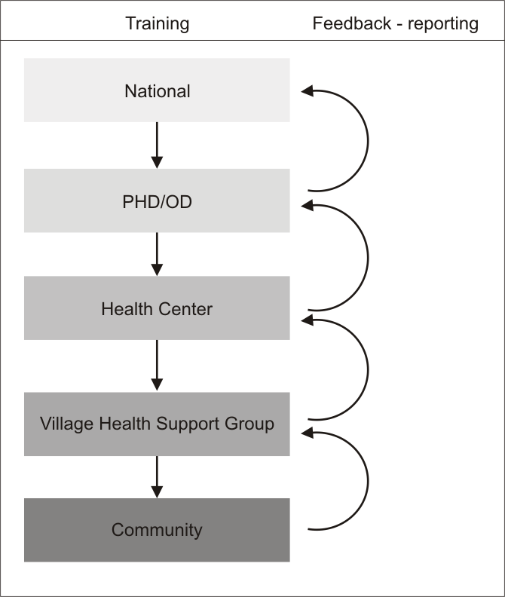

2.4 Financing Mechanisms

VHSG Leaders and Members should not have to pay out-of-pocket expenses in order to fulfill their responsibilities. Some examples of financing mechanisms to support the VHSG include the following:

- The Health Centre: The HCMC should advocate for appropriate financial resources in its AoP to cover costs associated with fulfilling VHSG roles and responsibilities including the implementation of the VHSG Scope of Work.

  - The Community: The HCMC may encourage the development of community financing mechanisms such as Community Participation Funds, Community Empowerment Funds, or Community Health Insurance. These mechanisms may be established or further developed through the social marketing of health products and performance-based investments.

  - The Commune Council: A portion of the Commune Council budget (CIP) can be earmarked for social services like VHSG management and capacity building, administrative and logistic support for referral cases (i.e. through funding transportation costs), and/or other activities as defined in the Scope of Work for the VHSG.

Reference: Health Strategic Plan 2008-2015, Accountability Efficiency Quality Equity, MoH, 2008, pg. 19
Reference: Health Strategic Plan 2008-2015, Accountability Efficiency Quality Equity, MoH, 2008, pg. 23
Reference: Health Strategic Plan 2008-2015, Accountability Efficiency Quality Equity, MoH, 2008, pg. 87
Reference: Health Strategic Plan 2008-2015, Accountability Efficiency Quality Equity, MoH, 2008, pg. 49
Reference: Health Strategic Plan 2008-2015, Accountability Efficiency Quality Equity, MoH, 2008, pg. 62
Reference: Health Strategic Plan 2008-2015, Accountability Efficiency Quality Equity, MoH, 2008, pg. 47
The C-IMCI training curriculum is currently being revised to train VHSGs to deliver effective health education and promotion at the village level.
Reference: Standard Operating Procedures for Implementing Community Home-Based Care Activities and MMM Activities in Cambodia, pg 39, 2006
Reference: Guidelines on Community DOTS Implementation, pg 47 – 50, 2004
Reference: VMW Project: Community Based for Malaria Control for Remote and Hyper-endemic Villages in Cambodia, 2005
According to national guidelines when they are developed
Representative VHSG Members in the HCMC will be elected by VHSGs and formal nomination letters for membership will be issued by the Commune Council Chief.

