Working Paper

Scale Up of Multiple Micronutrient Powder In-Home Fortification
December 2012
Draft prepared by UNICEF for:
Ministry of Health, National Maternal and Child Health Center, National Nutrition Program
Nutrition Working Group
Contacts: jconkle@unicef.org ; sun@unicef.org

Contents
Background 2
Strategic Targets, Monitoring and Evaluation 4
Targeted Districts and Health Centers 5
Supply – Equipment Needs 8
Costing of Future Needs 8

Background
In order to fully address micronutrient deficiency in young children improved sanitation and reduced infection is needed alongside improved diet and micronutrient supplementation. Fortification of staple foods is not sufficient for infants; dietary shifts resulting in improved diet, whether through homestead food production, commercially produced foods, or changes in caretaker behavior, are not expected to happen on a large scale quickly. Micronutrient supplementation addressing the multiple deficiencies in young children is needed in the country, but a restriction of high-dose preventive iron supplementation meant that only Vitamin A supplementation was implemented in the past; this was not adequate and child anaemia remains a public health issue. The development of low-dose multiple micronutrient powder and subsequent efficacy trials in Cambodia provide an alternative to high-dose preventive iron supplementation for anaemia reduction. This scale-up plan focuses on free distribution of multiple micronutrient powder through the public health system to children 6-24 months. Private sector distribution is not covered.
Past Research
From 2004 to 2008 there were three trials in Cambodia looking at the use of multiple micronutrients for home fortification. The Cambodian trials have seen reductions in child anemia of 21-35% in their study population, even with the high rates of hemoglobin disorders. The maximum reduction in anemia that can be achieved with MNP in Cambodia is still unknown; previous studies did not cover the entire age range, from 6 to 24 months, and results from the first effectiveness trial will not be available until 2013. In food insecure populations provision of foods or supplements that also contain some energy and protein has been shown to be effective at increasing growth. MNP supplementation has not conclusively shown improved growth internationally or in Cambodia and the intervention is not expected to be sufficient for reducing the high rates of stunting and wasting in the country.
Programme Background
In 2010 blanket MNP distribution to children 6-24 months started through the public health system. Blanket distribution to young children is indicated in Cambodia because of the high rates of anemia. However, when anemia rates drop there may be a need to shift to private sector distribution to children 6-59 months, combined with public distribution targeted to poor households or areas. Unitl now Unicef, World Vision International, and Malteser International are procuring the MNP.
In 2011 the National Nutrition Program developed a tentative scale-up plan and Standard Operating Procedures for NGOs wishing to collaborate on MNP supplementation. As per the Standard Operating Procedures, the MNP supply is procured centrally (UNICEF pledged to support initial scale-up supply) and distributed via government channels; Training of Trainers is carried out by the NNP; and NGOs support sub-national “step-down” training on MNP (province-district-health center-community), continued monitoring and supervision, and community awareness raising and nutrition promotion. All implementation is done through existing, government, public health structures. This type of collaboration aims to strengthen government health systems, avoid fragmented and sporadic implementation, and ensure sufficient community awareness.
One of the most important elements of NGO involvement in MNP is to ensure that the intervention is linked to appropriate infant and young child feeding practices. MNP should be added to an appropriate complementary food. The Complementary Feeding Communication Campaign was planned to coincide with initial implementation of MNP, but the campaign was not explicitly linked because the campaign has a nationwide focus and MNP is not yet a national programme. Efforts are currently underway, supported by HKI, to explicitly link the interpersonal communication component of the campaign to MNP. Communication tools are being revised based on formative research and all implementing partners will be expected to use these standardized messages. In the future mass media could also be adapted to promote both appropriate complementary feeding and MNP.
CDHS 2010 estimated coverage at 1.7%. In 2011 two additional NGOs became involved in the programme, bringing the total of involved DPs to six (UNICEF, WHO, WVI, Malteser, SHARE, SP). National coverage of children 6-24 months by the end of 2011 was estimated at ~6.5% based on supply data from the Central Medical Stores and coverage estimates from Provincial Health Departments. In 2012 there was not an increase in coverage and there was a stock-out in all areas not supported by WVI in the second half of the year. The stock-out was the result of a procurement delay, which was caused by UNICEF introducing a new financial system, a new supplier having problems with design using Khmer font, and procedural requirements of CMS that were not planned for. Going into 2013 three additional NGOs have become partners (HKI, IRD, Magna) and coverage is expected to increase to 21%.

Strategic Targets, Monitoring and Evaluation

The National Nutrition Strategy 2009-2015 outlines the urgency of tackling anemia in children, and calls for complementary strategies to tackle this, including MNP home fortification. In the Health Strategic Plan 2008-2015, there are anthropometric, breastfeeding and vitamin A supplementation coverage indicators for nutrition; there is no indicator for child anemia. In 2011 Micronutrient Supplementation Policy and Guidelines were drafted, endorsing MNP for the treatment and prevention of anemia in infants 6-24 months. This document lays out the program management roles and responsibilities, and distribution channels for the MNP. The policy was endorsed and disseminated in 2012.
At the present time, annual coverage of the program is monitored by relying on supply data and direct communication with sub-national levels. Operational Districts and Provinces receive reports from health centers, based on a simple tally sheet system. It was decided not to implement a full monitoring system specifically for MNP because there is a functional Health Management Information System in Cambodia and WHO received financial support to pilot integration of MNP into the HMIS from 2010 to 2012. However, MNP was not included in the 2012 revision of the HMIS. MNP was not included because it is not yet a national programme and because registers and yellow cards have not been revised to include MNP. While parallel reporting systems should be avoided, as the programme grows there is a need for more systematic monitoring.
The other source for monitoring coverage is household surveys. In the 2010 CDHS a question on MNP use was added to achieve a baseline estimate for coverage. If a question is included, national level coverage estimates will be available from the 2014 Cambodia Socio-Economic Survey; and the 2015 CDHS will also provide coverage estimates.
In addition to coverage estimates the 2015 CDHS will provide the first national level effectiveness evidence on MNP for anaemia and growth. The final evaluation of the Joint Programme will provide effectiveness evidence from four provinces in 2013. HKI and UNICEF both supported formative assessments looking at acceptability and caretaker perceptions in 2012. In general, MNP was found to be acceptable with some issues concerning taste and side effects. Distribution by local health center staff during outreach and revision of training and communication materials is expected to address the issues of taste and side effects.

Targeted Districts and Health Centers

In 2010 province-wide implementation in 1 province (S. Rieng) and localized implementation in 5 provinces (Battambang, K. Thom, Kandal, P. Penh, Preah Vihear) started. Localized implementation means that all health centers in the province are not covered, and in some cases covered health centers do not implement in all of the villages in their catchment area. In 2011 and 2012 localized implementation in four additional provinces (O. Mean Chey, Takeo, K. Chhnang, P. Veng) started and province-wide implementation started in 1 province (K. Speu). For 2013, implementation will start in K. Cham, bringing the total number of provinces to 12 and the number of Health Operational Districts to 32.
All of the districts, apart from six in Battambang and Takeo, are supported by development partners. There is some anecdotal evidence that MNP is not used correctly in Takeo; areas without NGO support should be monitored closely by the national programme during initial implementation.
Figure 1. 2013 Coverage of MNP by Health Operational District
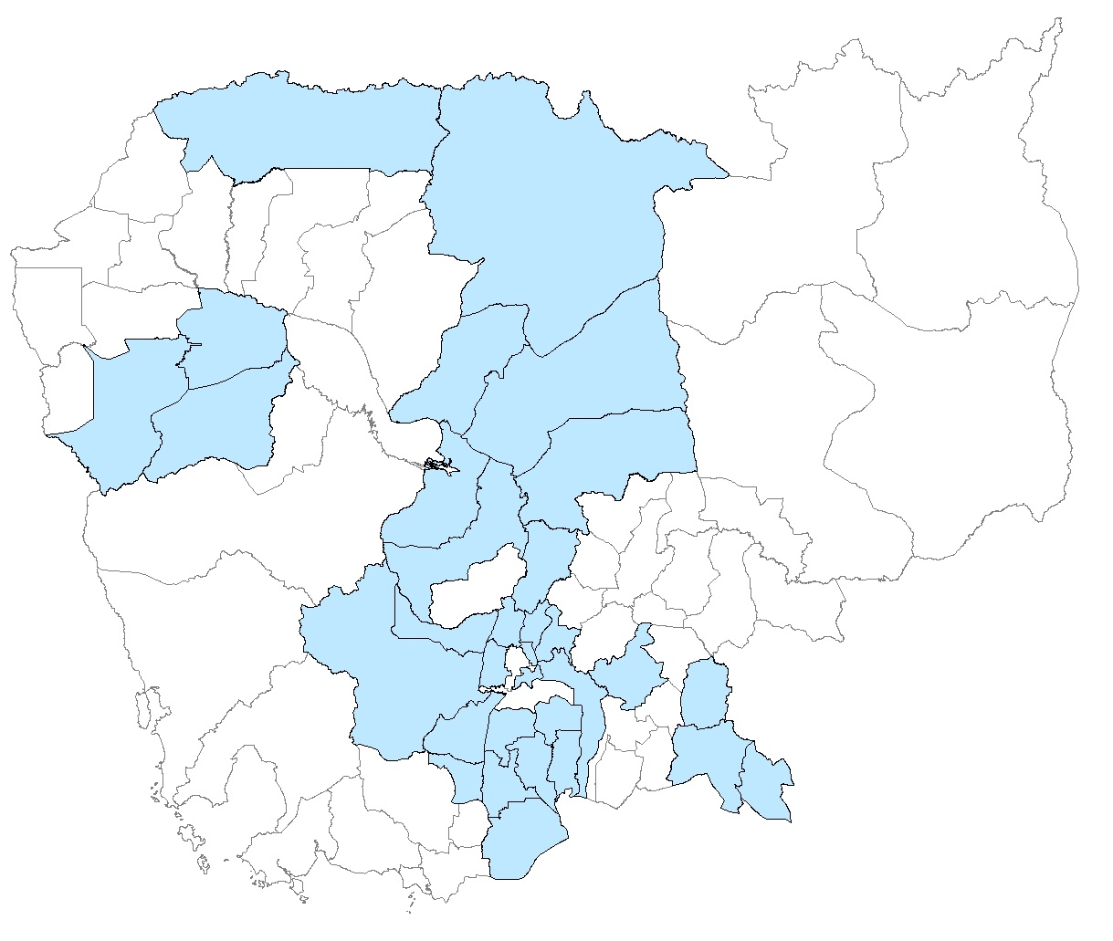
A concern with current coverage is that initial implementation has not focused on reaching the absolute poorest, or the geographically most isolated. The remote provinces of the North East of Cambodia generally have the worst health and nutrition indicators. There is a need to test the MNP program in areas with ethnolinguistic minorities; communication resources and methods of delivery may need to be adapted for these areas.

Table 1. Coverage of MNP by Operational District
Green – Implementing in 2012
Yellow – Implementing in 2013
Orange – Under consideration for implementation in 2013
Province | OD | Province | OD
Banteay Meanchey | Mongkol Borei | Koh Kong | Smach Mean Chey
Banteay Meanchey | Poipet | Koh Kong | Srae Ambel
Banteay Meanchey | Preah Net Preah | Kratie | Chhlong
Banteay Meanchey | Thma Puok | Kratie | Kratie
Battambang | Thmar Koul | Mondul Kiri | Sen Monorom
Battambang | Maung Russei | Phnom Penh | Cheung
Battambang | Sampov Luon | Phnom Penh | Kandal
Battambang | Battambang | Phnom Penh | Lech
Battambang | Sangkae | Phnom Penh | Tbong
Kampong Cham | Chamkar Leu - Stueng Trang | Preah Vihear | Tbeng Meanchey
Kampong Cham | Choeung Prey – Batheay | Prey Veng | Kamchay Mear
Kampong Cham | Kampong Cham - Kg. Siem | Prey Veng | Kampong Trabek
Kampong Cham | Kroch Chhmar - Stung Trang | Prey Veng | Mesang
Kampong Cham | Memut | Prey Veng | Neak Loeung
Kampong Cham | O Reang Ov - Koh Soutin | Prey Veng | Pearaing
Kampong Cham | Ponhea Krek – Dambae | Prey Veng | Preah Sdach
Kampong Cham | Prey Chhor - Kang Meas | Prey Veng | Svay Antor
Kampong Cham | Srey Santhor - Kang Meas | Pursat | Bakan
Kampong Cham | Tbong Khmum - Kroch Chhmar | Pursat | Sampov Meas
Kampong Chhnang | Kampong Chhnang | Ratanakiri | Banlong
Kampong Chhnang | Kampong Tralach | Siemreap | Kralanh
Kampong Chhnang | Boribo | Siemreap | Siem Reap
Kampong Speu | Kampong Speu | Siemreap | Sot Nikum
Kampong Speu | Kong Pisey | Siemreap | Ankor Chhum
Kampong Speu | Ou Dongk | Sihanoukville | Preah Sihanouk
Kampong Thom | Baray and Santuk | Stung Treng | Steung Treng
Kampong Thom | Kampong Thom | Svay Rieng | Chi Phu
Kampong Thom | Stong | Svay Rieng | Romeas Hek
Kampot | Angkor Chey | Svay Rieng | Svay Rieng
Kampot | Chhouk | Takeo | Ang Rokar
Kampot | Kampong Trach | Takeo | Bati
Kampot | Kampot | Takeo | Daun Keo
Kandal | Ang Snuol | Takeo | Kirivong
Kandal | Kean Svay | Takeo | Prey Kabass
Kandal | Koh Thom | Oddar Meanchey | Samraong
Kandal | Ksach Kandal | Kep | Kep
Kandal | Muk Kam Poul | Pailin | Pailin
Kandal | Ponhea Leu
Kandal | Lovea Em
Kandal | Saang
Kandal | Takhmao

Supply – Equipment Needs

The delivery method for MNP is outreach by health center staff with “mop-up” activities by community volunteers. The equipment needs of outreach are covered by the MoH and Pooled Fund, and are outside the scope of this scale-up plan. The commodities needed for MNP scale-up are the commodity itself and communication materials. In 2012 MNP was included on the Essential Drugs List, making MNP eligible for government procurement; government has not yet procured MNP. In addition to the lack of co-financing, a concern for MNP is that it is currently packaged in a composite foil that is difficult to recycle. Sight and Life is running an international competition to develop new packaging; there is no strategy for dealing with MNP waste in Cambodia. Communication materials currently being developed for MNP include a counseling flipchart, poster, and leaflet. With at least nine DPs involved in implementation in 2013, coordinated printing could help to bring down costs through economy of scale.

Costing of Future Needs

Formative research has shown that initial implementation requires intense monitoring and supervision, along with community awareness raising and nutrition promotion. For initial scale-up the NNP is partnering with NGOs in nearly all implementation areas; there is also a heavy focus on integrating MNP into broader nutrition packages. This costing focuses on equipment needs and the following costs are not included in the overall costing:
- Outreach costs are shared by government and DPs involved in the Pooled Fund. Health center staff are paid by government and there is no formal system for remuneration of volunteers. There should be no MNP-specific costs.
- There is no definitive plan for a mass media communication campaign on MNP. A three year campaign would cost approximately USD 0.5 million.
- As of 2012 MNP training is integrated into IMCI, the Minimum Package of Activities for Nutrition for health center staff, and the Baby Friendly Community Initiative (BFCI)/ C-IMCI for community volunteers. These trainings are covered by the Pooled Fund and other DPs. At the national level the NNP has included ~USD 50,000 for trainings that include MNP. At the sub-national level the need to train volunteers adds substantial cost. For every 10 health centers ~USD 2,000 is required for MNP specific training.
- For monitoring and supervision the focus is to eventually integrate into the HMIS and regular supervision of health centers. However, during initial implementation activity specific supervision is needed. The national program has budgeted ~USD 40,000 in the 2013 AOP.

Figure 2. Annual cost in USD of selected components of MNP Programme, 2013-2015

MNP

With more suppliers of MNP the cost has been dramatically reduced in recent years, going from USD .027 to .017 per sachet containing 15 micronutrients. The cost is now USD 3.11 per child per year, including printing and packaging. In 2011 and 2012 MNP costs for 6.5% coverage were ~USD 97,000; this cost is expected to increase to ~USD 313,000 in 2013 to achieve 21% coverage. Future projections are based on current costs and an increase in coverage to 24% in 2014 and 29% in 2015.
- 2013: 313,000
- 2014: 357,000
- 2015: 432,000

Communication Materials
At the beginning of 2013 MNP will be integrated into the BFCI Flipchart and there will be a poster and leaflet developed. The estimated cost of each is: flipchart – USD 4.00; poster – USD 0.15; leaflet – USD -.10. Flipcharts and posters will be delivered once to all villages and health centers in implementation areas. One leaflet will be given to each caretaker receiving MNP as they enter the programme; this cost is recurrent. Annual costs are estimated by applying coverage estimates to the number of villages and health centers.
- 2013: 35,000
- 2014: 15,000
- 2015: 19,800

