

**FOOD AND NUTRITION SECURITY VULNERABILITY**

**TO MAINSTREAM HYDROPOWER DAM DEVELOPMENT**

**IN CAMBODIA**

**INLAND FISHERIES RESEARCH AND DEVELOPMENT INSTITUTE (IFREDI)**

**Fisheries Administration**

**Ministry Of Agriculture, Forestry And Fisheries**

**November 2012**

Table of Contents

1. INTRODUCTION 9

2 MAIN FINDINGS 11

2.1 IMPORTANCE OF FISH TO FOOD AND NUTRITION IN CAMBODIA 11

2.1.1 The Cambodian diet - food consumption 11

2.1.2 The Cambodian diet – energy and nutrition 20

2.2 FISH CATCHES DERIVED FROM THE CONSUMPTION STUDY 26

2.3 ESTIMATED CHANGES OF THE SUPPLY /AVAILABILITY OF FISH AND OTHER AQUATIC ANIMALS UNDER CAMBODIAN DAM DEVELOPMENT SCENARIOS 28

2.3.1 Modelling approach and hypotheses 28

2.3.2 Predicted changes to capture fisheries yield 33

2.3.3 Predicted changes to the supply of aquatic resources for consumption 36

2.4 THE POTENTIAL IMPACT OF HYDROPOWER DAM DEVELOPMENT ON FOOD AND NUTRITION SECURITY IN CAMBODIA 39

2.4.1 Ecological zone impact 39

2.4.2 Urbanity impact 39

2.4.3 Gender impact 40

2.4.4 Age groups and pregnant women impact 40

3 CONCLUSIONS 41

Citation:

IFReDI 2012: Food and nutrition security vulnerability to mainstream hydropower dam development in Cambodia. Synthesis report of the FiA/Danida/WWF/Oxfam project “Food and nutrition security vulnerability to mainstream hydropower dam development in Cambodia”. Inland Fisheries Research and Development Institute, Fisheries Administration, Phnom Penh, Cambodia. 41 pp.

Report prepared by IFReDI, with inputs from R. Johnstone, E. Baran (WorldFish Center), Chheng P., Touch B.T., So N. and H.E. Nao Thuok

**FOREWORD**

For centuries the mighty Mekong has provided a secure source of food and nutrition to the peoples of South East Asia. In more recent times, the huge potential energy of the Mekong has also been seen as a source of power, and many hydro-electric schemes have been considered to tap the energy of this mighty river. However, the potential to produce power and the resource to provide food are not entirely compatible. When considering the requirements of today's population, wise decisions will need to be made in order to secure best advantage for the people of Cambodia. These decisions need to be based on sound, accurate facts.

This study has considered the likely impacts of building dams on the Mekong, using various scenarios based upon current proposals and plans. These impacts include the likely effect of such dams on fish migration to and from their spawning grounds; the subsequent effect on breeding and therefore revised prediction of fish stocks; the potential changes to food security arising from changes to yields on capture fisheries, and lastly, the potential impacts to the diet and nutrition, focusing particularly on those who depend on fish for essential elements of their intake.

Armed with this knowledge and full understanding of the impacts of any decisions made to dam the Mekong Cambodia's leaders will be better prepared to properly weigh the consequences of their decisions.

The Fisheries Administration is grateful for the support received from development partners in carrying out this study. Danida, Oxfam Australia and WWF have generously provided funds to enable the work to be carried out. I am also grateful for the close working partnership which developed between the FiA staff and these organisations during the course of the study. This close working partnership enabled many problems to be faced and inevitable obstacle to be overcome in a timely manner.

**H. E. Professor Nao Thuok**

Delegate of the Royal Government of Cambodia,

Director General, Fisheries Administration,

Ministry of Agriculture, Forestry and Fisheries,

Kingdom of Cambodia

**EXECUTIVE SUMMARY**

The ‘Food and Nutrition Security Vulnerability to Mainstream Hydropower Dam Development in Cambodia’ Project examine national food and nutrition vulnerability arising from the potential construction of Stung Treng (ST) and Sambor (SB) dams.

This project consisted of three components: i) an assessment of the food consumption in rural households nationwide ii) an assessment of the impacts of Cambodian mainstream dams on fish yield and iii) an assessment of the impacts of Cambodian mainstream dams on fish consumption and food security in Cambodia. The project was implemented, under IFReDi’s responsibility, from June 2011 to September 2012 by a multidisciplinary team (hydrological modeller, dam specialist, fishery scientists, nutritionists, surveyors) supervised by an external Technical Advisory Committee.

The Household Food Consumption Survey was carried out in 1,200 households nationwide, in five ecological zones of the country (Phnom Penh, Coastal zone, Plains, Plateau/Mountain and Tonle Sap) following and was done taking into consideration the stratification framework of the National Institute of Statistics for the National Census.

**2011 BASELINE ASSESSMENT OF NUTRITION IN CAMBODIA**

The purpose of this baseline was dual: i) to assess the current food consumption and energy and nutrient intake of Cambodians; ii) to assess the relative contribution to food and nutrition security made by three major ecological groups of fish species of various sensitivity to dam development:

* a: floodplain residents or “black fish” resilient to dam impact such as snakeheads (រ៉ស់);
* - short-distance migrants restricted to local tributaries sensitive to dam development on tributaries or “grey fish” such as Kryptopterus (ត្រីកំភ្លៀវស្ទឹង) and
* - long-distance transboundary migrants or “white fish” very sensitive to dam development such as Henicorhynchus (ត្រីរៀលតុប).

The contribution of other aquatic animals (OAA) was also considered in this assessment.

**Conclusions**

The Cambodian diet is a combination of rice, fish and vegetable, reaching 955 grams per person per day. Aquatic resources are the second largest dietary component at 173 grams per person and per day, accounting for 18% of the total food intake. Aquatic resources are also the major contributor of animal intake[1] (76%, of which half is freshwater capture fish).

Inland fish consumption amounts to 110 g/person/day or 40.3 kg/person/year, while that of *marine fish* reaches 16.2 kg/person/year. The consumption of other aquatic animals (marine + freshwater) is 5.1 kg/person/year. The smallest contribution to the diet comes from the aquaculture sector, with 1.3 kg/person/year only (2%). These results are consistent with the results of the previous fish consumption studies in Cambodia.

Of the inland fish, floodplain resident fish (i.e. black fish)comprise 30% of total fish intake, followed by long-distance transboundary migrants (white fish) very sensitive to dam development (25% of total fish intake). The overall per capita consumption of floodplain resident fish is relatively higher than other fish categories due to their availability throughout the year.

In the Cambodian diet, rice is the major energy contributor (60% of the total energy intake), followed by aquatic resources (12% to the total energy intake). Fish and other aquatic animals contribute 37% of total intake of protein per person, 28% of total fats intake per person and 37% of total iron intake per person. As the overall intake of fat in the Cambodian diet is very low, the fat and protein contributed by fish is very important. The survey results also shows that only 25% of the population meets the necessary levels for energy and only 19% meet the required levels for iron.

*Across all ecological zones* fish and fish products are generally eaten more than any other of the body building foods such as meat or poultry. Higher consumption of fish is observed in the *Coastal* area and *Tonle Sap* and the lowest consumption is observed in the *Mountains and Plateaus*.

*In terms of gender*, the consumption of fish and fish products by men and women is similar.

*Disaggregation by age group* shows that the consumption pattern is the same for all age classes, only the quantity consumed varies. Proportionately, pre-school children have their fish intake dominated largely by inland fish and fish products. Adolescents and pregnant women are also relatively more dependent on the availability of inland fish for their overall food security.

**ASSESSMENT OF FISH CATCHES BASED ON THE CONSUMPTION STUDY**

Total fish yield derived from above individual fish consumption figures multiplied by the current Cambodian total population (i.e. 14,100,000 persons) indicates that the yield of inland fish amounts to 570,000 tonnes per year. When complemented by other aquatic animals, this amounts to 625,000 tonnes of inland capture resources harvested each year. These results are consistent with previous estimates.

Marine resources amount to 254,000 tonnes per year (more specifically 229,000 tonnes of fish and 16,000 tonnes of other marine aquatic animals).

This brings the figure for capture fisheries to 870,000 tonnes per year, and the grand total for aquatic resources in Cambodia to 889,000 tonnes per year (including 19,000 tonnes of aquaculture products).

**IMPACT OF MAINSTREAM DAMS ON THE FISH YIELD**

The study built into a model:

* the predicted future yields of inland fish and other aquatic animals
* the predicted future quantities from the aquaculture sector and from imports,
* the losses from non-consumptive disposal (exports, utilization for aquaculture feed and fertilizer, and post-harvest waste),
* the expected changes in river hydrology and accessible wetland habitats, and
* the population growth

for each development scenario and for each hypothesis about reservoir production yield.

**Conclusions**

In 2030 the human population of Cambodia is expected to reach 20 million (+43 %), which will be the most significant obstacle to improved or sustained food security.

In absence of mainstream dams and regardless of the population growth, the increased output from the aquaculture sector and forecasted declines in exports will be balanced by losses experienced by capture fisheries in response to dam development on tributaries and irrigation development in the lower part of the basin (i.e. loss of wetlands producing capture fish). The supply of aquatic resources appears relatively insensitive to the level of aquaculture production from dam reservoirs. Thus the aquaculture sector would not compensate for losses to supply arising from Cambodian mainstream dam impacts.

Given the population growth, the relative stability of the farmed fish supply and the decline of the capture fish yield for reasons other than mainstream dams (i.e. 4-5% decline), the study predicts fish consumption reduced by 30.6% in 2030 even in the absence of mainstream dams.

The development of *Stung Treng dam alone* is predicted to reduce yields of fish and other aquatic animals further by 6% to 24% or 34,000 – 145,000 tonnes. The *Sambor dam alone* is predicted to reduce yields of fish and other aquatic animals by 16% - 30 % or 98,000 – 182,000 tonnes compared to 2011 baseline values. The *combination of Stung Treng and Sambor dams* is predicted to reduce yields of fish and other aquatic animals by a similar amount (98,000 – 182,000 tonnes) because the Sambor dam alone would then block all fish migrations upstream (maximum impact regardless of other upstream dams).

Mainstream Cambodian dams are therefore predicted to reduce the supply of inland fish and other aquatic animals by between 34,000 to 182,000 tonnes from the baseline values. The uncertainty range depends mainly upon the hypothesized distribution of long distance migrants spawning habitat, which highlights the importance of new research on spawning areas.

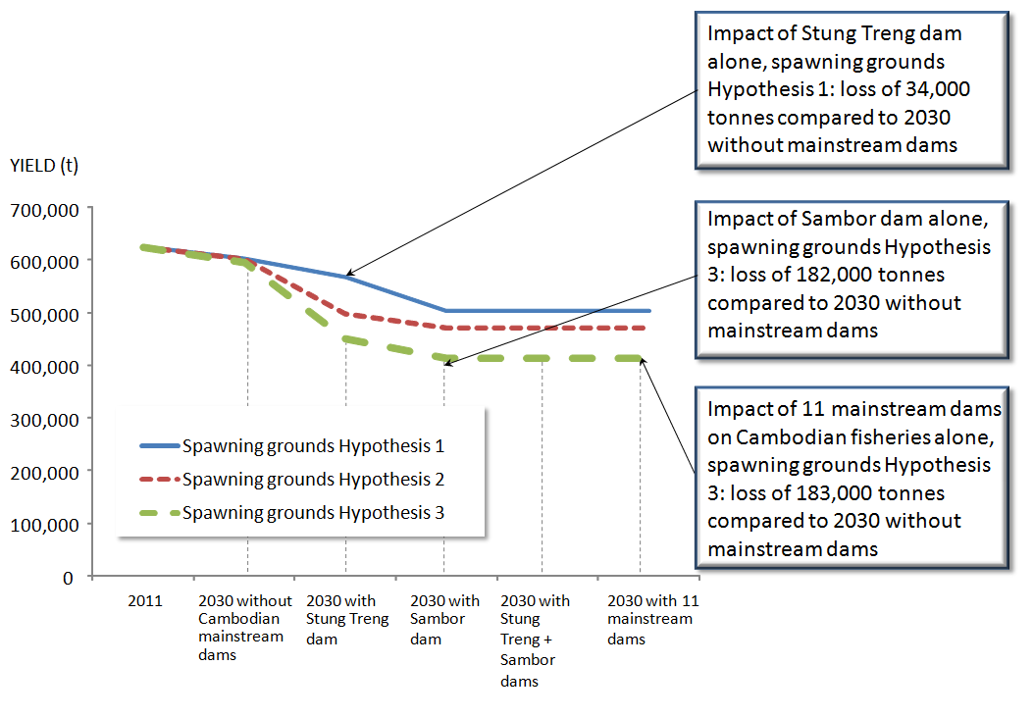

**Predicted annual yield of inland fish and other aquatic animals under each development scenario and hypothesized distribution of long distance migrants spawning habitat.**

**IMPACT OF MAINSTREAM DAMS ON THE FISH CONSUMPTION**

The model developed for the study integrates all the factors driving the production of overall aquatic resources (i.e. capture yields, aquaculture production, imports, exports and losses) and their trend by 2030.

When all the fish production factors and the population growth are integrated, the future consumption of aquatic resources per capita is expected to decline even in absence of dams.

In absence of mainstream dams, per capita supply of inland fish and OAA is expected to decline from approximately 63 kg per capita in 2011 to approximately 44 kg per capita by 2030.

However the construction of Cambodian mainstream dams would reduce this supply by a further 6 to 34% depending on the scenario considered. This would result in a fish consumption dropping down to 29-41 kg/person/year (as opposed to 63 kg/person/year in 2011).

**IMPACT OF MAINSTREAM DAMS ON FOOD SECURITY AND HEALTH**

The above results imply that after the construction of the mainstream dams there will be further reduction of the already low number of individuals who meet nutrient adequacies (RDA) for energy; for protein and iron.

A reduction of 34% of the available fish and fish products for consumption would have a dramatic impact on the proportion of the population living in the plains who meet their daily allowances (RDAs), and who are already considered as the least nutrient secure ecological zone.

A reduction in fish availability and specifically long distance migrants, which is important for the provision of iron, would have a strong detrimental impact to the rural population driving iron security even lower and posing a risk to public health.

Children, especially in rural areas will also be directly affected by the reduction of inland fish availability. School children could be considered as the most food insecure age group. The data on pregnant women’s nutrition shows that they are the most vulnerable group to protein reduction, with the lowest rate of protein RDA satisfaction.

Therefore, the predicted impacts of the reduction of per capita supply of inland fish and OAA are expected to result in:

* negative effects on public health and affect strongly some of the most vulnerable populations groups, such as those living in remote rural areas and school children;
* aggravation of existing malnutrition and lower rates of individuals meeting their recommended daily allowance for key nutrients, thus exposing an increasing number of the population to health risks.

# 1. INTRODUCTION

The ‘Food and Nutrition Security Vulnerability to Mainstream Hydropower Dam Development in Cambodia’ Project examined national food and nutrition vulnerability arising from the potential construction of Stung Treng (ST) and Sambor (SB) dams.

The Project was co-funded by: Fisheries Administration, World Wildlife Fund for Nature (WWF); Oxfam Australia and DANIDA. The research activities were coordinated by the Inland Fisheries Research and Development Institute (IFReDI), Fisheries Administration.

This project consisted of three components: i) an assessment of the food consumption in rural households nationwide ii) an assessment of the impacts of Cambodian mainstream dams on fish yield and iii) an assessment of the impacts of Cambodian mainstream dams on fish consumption and food security in Cambodia. The project was implemented from June 2011 to September 2012 by a multidisciplinary team (hydrological modeller, dam specialist, fishery scientists, nutritionists, surveyors) supervised by an external Technical Advisory Committee.

The Project took into consideration the five ecological zones of the country namely Phnom Penh; plains (*Kandal, Kampong Cham, Prey Veng, Svay Rieng and Takeo Provinces*); Tonle Sap (*BanteayMeanchey, Kampong Thom, Battambang, Pursat, Kampong Chhnang and Siem Reap Provinces*); Plateau/mountains (*Kampong Speu, Kratie, Pailin, Mondul Kiri, Otdor Meanchey, Preah Vihear, Ratanak Kiri, and Stung Treng Provinces*); and the coastal zone (*Kep, PreahSihanuk, Koh Kong, and Kampot Provinces*).

The household food consumption survey focused on household food consumption and other indicators of food security taking a representative sample survey of 1,200 households nationwide.

The Project builds upon previous studies by improving and updating estimates of fish consumption and yield for Cambodia and by disaggregating these estimates according to ecological zone and province, and by the three groups (guilds) of fish species (floodplain residents, short distance migrants and long distance migrants). The project also employed the latest hydrological and fisheries impact models available for the region.

This allowed for a more refined assessment of dam impacts on food and nutrition security in Cambodia accounting for the differences in both the impact vulnerability among the three major group types and included a first attempt to undertake a food consumption survey at the national level. These studies will provide valuable food and nutrition security data relevant to other development projects and programs both nationally and regionally.

The current report is a summary of the findings of the two main project reports:

* - Baseline Assessment of Diet and Nutrition in Cambodia 2011, and
* - Impacts of mainstream dams on fish yield and consumption in Cambodia

*FISH GROUPS IN THE MEKONG AND SENSITIVITY TO DAM DEVELOPMENT*

*Three main fish groups (or “guilds”) having very different migration patterns are to be distinguished.*

*The group of floodplain residents or “black fish” is made of species with limited lateral migrations and no longitudinal migrations; these tough fish do not leave floodplains and wetlands, and spend the dry season in local ponds. This group includes Channidae (Snakeheads), Clariidae, Bagridae or Anabantidae. It is not very sensitive to dam development.*

*The group of long distance migrants or “white fish” is made of species that undertakes long distance migrations, in particular between lower floodplains and the Mekong mainstream. This group includes many cyprinids (e.g. Henicorhynchus spp. and Cirrhinus sp.) but also most Pangasidae catfishes. This group is very sensitive to dam development, in particular on the mainstream.*

*The group of short distance migrants or “grey fish” group is made of species that are not grey in colour but ecologically intermediate between the two previous groups; this group corresponds to fishes that do not spend the dry season in floodplain ponds, but do not undertake long distance migrations either. When the flood recedes they leave the floodplain and tend to spend the dry season in local tributaries. This group is sensitive to dam construction on tributaries, but not on the mainstream,*

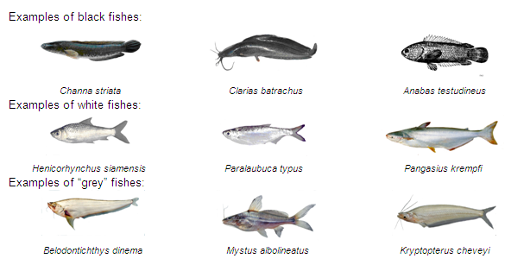

# MAIN FINDINGS

## IMPORTANCE OF FISH TO FOOD AND NUTRITION IN CAMBODIA

### The Cambodian diet - food consumption

The Cambodian diet is a combination of rice, fish and vegetable in order of consumption at both individual and household levels. The total average daily per capita[2] food consumption is 955 grams per person per day (Figure 1).

Fish and fish products intake (from both inland and marine origin, plus aquaculture and other aquatic animals) is the second largest dietary component at 172.5 grams per person per day, accounting for 18% of the total food intake.

Figure 1: Average one-day individual food intake (in grams) and percent of total food intake by groups: Cambodia, 2011

*Inland fish,* which includes floodplain residents, long distance migrants and short distance migrants, is consumed at 110.5 grams or 11.6% of the total food intake and two-thirds (64%) of the total consumption of fish and aquatic animals. Other freshwater aquatic animals represent 10.8 g/person/day or 6.3% of the total fish intake. In comparison, *marine fish* (including Other marine Aquatic Animals - OAAs) is consumed at 47.6 grams per person and per day or 5% of the total food intake and just over one-fourth (27.6%) of the total fish intake (Table 2). Therefore, inland fish is consumed in much larger quantities than marine fish.

Table 1: Consumption of aquatic products in Cambodia

|  |  |  |  |  |  |
| --- | --- | --- | --- | --- | --- |
| **Table 2: Average daily fish consumption (grams) per individual and percent of total food intake: Cambodia, 2011** | | | **Average (g/person/day)** | **% Total Food Intake** | **% Total Fish Intake** |
| Inland capture resources | Inland fish | Floodplain residents | *51.5* | 5.4 | 29.8 |
| Long distance migrants | *42.5* | 4.5 | 24.6 |
| Short distance migrants | *16.5* | 1.7 | 9.5 |
| Other inland aquatic animals | | *10.8* | 1.1 | 6.3 |
| Marine capture resources | Marine Fish | | 44.5 | 4.7 | 25.8 |
| Other marine aquatic animals | | *3.1* | 0.3 | 1.8 |
| Aquaculture | | | *3.7* | 0.4 | 2.1 |
| *Grand total* | | | *172.5* | *18.1* | *100* |
| **Daily food consumption (g/person/day)** | | | ***955*** | | |

Of the inland fish, *floodplain residents are* consumed more than any other type of fish at 51.5 grams per person and per day, which is 5% of the food intake and 30% of the total fish intake. This dominant category is followed by *long distance migrants* (42.5 g/person/day), *short distance migrants* (16.5 g/person/day) and *aquaculture fish* (3.7 g/person/day). One of the reasons for the higher consumption of *floodplain residents* is that it is available all year round, while *long distance migrants* are seasonal. While *floodplain residents* are consumed mainly fresh, long distance migrants are also largely processed into products such as fish sauce, fish paste, or fermented and/or smoked.

***Fish and fish products is the second largest dietary component at 173 grams per person per day;***

***Black fish is consumed more than any other type of fish, followed by white fish;***

***Aquaculture intake represents 2.1% of the total fish intake, which is lower than the contribution of any other fish or other aquatic animals group to food intake***

*Aquaculture fish* is the least consumed at 3.7 grams, which represents 0.4% of the total food intake and 2% of the total fish intake only. Intake of inland OAAs is higher than intake of aquaculture fish at 10.8 grams (Figure 2)

Figure 2: Average daily per capita consumption of fish per sub group

Figure 3 shows the percentage of each fish sub-group in terms of total fish consumption, clearly demonstrating the importance of inland fish and the proportion of both *floodplain residents* and *long distance migrants* as part of fish and fish products consumption.

Figure 3: Fish sub-groups as percentage of total fish intake

When these daily figures are reported to an annual basis, Cambodian people consume on average 63 kg of fish and aquatic products (fresh water fish, marine fish and other fish products) per person and per year. The consumption of *inland fish* amounts to 40.3 kg/person/year, while that of *marine fish* reaches 16.2 kg/person/year. The consumption of all inland capture resources (i.e. harvested freshwater fish and other freshwater aquatic animals) reaches 44.3 kg/person/year. The overall consumption of other aquatic animals (marine + freshwater) is substantial, at 5.1 kg/person/year, i.e. 8% of the consumption of all aquatic products, and is four times more important than the consumption of aquaculture products (1.3 kg/person/year only).

Table 3: Average annual fish consumption of fish per person and per year. Cambodia, 2011

|  |  |  |  |  |
| --- | --- | --- | --- | --- |
|  |  |  | **Annual intake in Fish and Fish Products (kg/person/year)** | |
| Inland capture resources | Inland fish | Floodplain residents | 18.8 | 40.3 |
| Long distance migrants | 15.5 |
| Short distance migrants | 6.0 |
| Other inland aquatic animals | | 3.9 | 3.9 |
| Marine capture resources | Marine Fish | | 16.2 | 17.4 |
| Other marine aquatic animals | | 1.1 |
| Aquaculture | | | 1.3 | 1.3 |
| ***Grand total*** | | | ***63*** | |

These results are very much in line with the results of the previous fish consumption studies in Cambodia:

* Ahmed et al. (1998[3]) found an average per capita consumption of *fresh inland fish* of 43.5 kg per year.
* Hortle (2007[4]) found 36.8 kg/person/year of inland fish and other inland aquatic animals while the current study finds 44.3 kg/person/year (i.e. 20.3% more). The difference can be explained by the fact that the Hortle figure includes a number of extrapolations for provinces not surveyed, whereas the present study has a national coverage.

#### Consumption of fish across ecological zones

Across all ecological zones fish and fish products are generally eaten more than any other of the body building foods such as meat or poultry. Higher consumption of all kinds of fish (i.e. marine + freshwater) is observed in the coastal area at 247.5 grams and Tonle Sap area due to near proximity to large fishing areas. The lowest consumption is observed in the *Mountains and Plateaus* at 143.2 grams per day (Figure 4).

***Across all ecological zones fish and fish products are generally eaten more than any other of the body building foods such as meat or poultry;***

Figure 4: Average daily per capita fish consumption desegregated between inland and marine fish

Consumption of **inland** fish including OAAs is higher than consumption of marine fish across all ecological zones except for the *Coastal* area. The highest consumption of inland fish and OAAs is in *Tonle Sap* at 147.9 grams/person/day while the lowest is in the *Mountain and Plateaus* at 89.4 grams per capita per day. Consumption is similar in *Phnom Penh* and *Coastal* areas at 104 and 105.1 grams per capita per day, respectively. High consumption of inland fish is also observed in the *Plains* at 134.6 grams per capita per day.

The breakdown of the composition of the inland fish consumed shows that *floodplain residents* are consumed the most in the Tonle Sap area (77.2 grams per capita per day), in the coastal zone (60.1grams per capita per day)and in Phnom Penh (45.2 grams per capita per day) areas. Long distance migrants are consumed more in the Plains (58.5 grams per capita per day) and the Mountains and Plateau areas (32.7 grams per capita per day). These differences reflect the fish consumption patterns, with floodplain residents eaten fresh or whole whereas long distance migrants are often processed. Mountain and other areas away from water bodies naturally consume more processed fish such as dried fish and fish paste (prahoc).

Aquaculture fish is consumed least across the different ecological zones and consumption of OAAs is higher than the consumption of aquaculture everywhere except in Phnom Penh (Figure 5).

Figure 5: Average daily consumption of fish per sub-group and ecological zone

Marine fish is naturally consumed more in the *Coastal* area at 134.8 grams per capita per day, followed by *Mountain and Plateau* areas at 51.8 grams per capita per day. *Phnom Penh* and *Tonle Sap area* feature almost similar consumption rates at 48.4 grams and 41.8 grams per capita per day, respectively. The lowest intake of *marine fish* is recorded in the *Plains* at 25.4 grams per capita per day.

Distance from the coast and purchasing power are among the main factors that influence accesses to marine fish, hence consumption of marine fish is higher in the larger urban areas such as Phnom Penh, Battambang and Seam Reap.

#### Consumption of fish according to urbanity

In *urban* areas the total average food intake is 962.3 grams per person per day of which 180.7 grams is fish*.* In *rural* areas the total average food intake per person per day is 909 grams, of which 164 grams is fish. In both cases, fish comprises about 18% of the total food intake.

***Fish comprises 18% of total food intake in both rural and urban areas***

Consumption of inland fish including aquaculture fish and OAAs is slightly higher in the *rural* area at 127.2 grams than in the *urban* area at 122.7 grams per capita per day.

Consumption of marine fish in the *urban* area is higher at 52.96 grams while in the *rural* area it is much lower at 35.7 grams per capita per day (Figure 6).

Figure 6: Average daily consumption of fish per urbanity

The breakdown of the composition of inland fish shows that consumption of floodplain residents is higher than any other fish both between and within urbanity, and is closely followed by the levels of long distance migrants consumption, especially in rural areas. The higher consumption of long distance migrants in rural areas could be at least partly attributed to the ability to store the processed long distance migrants for longer periods of time even in the absence of cold storage.

***Inland fish and whitefish in particular is consumed more in rural areas***

Aquaculture fish is the least consumed among inland fish in either the rural or urban areas at 2.9 grams and 4.5 grams per capita per day, respectively (Figure 7).

Figure 7: Average daily consumption of inland fish desegregated by sub-group and urbanity

#### Consumption of fish according to gender

In terms of weight, *males* consume marginally more fish at 180.4 grams per capita per day than females at 166 grams per capita per day (probably in proportion to body weight). However, fish and fish products account for a similar proportion in the diet of both genders (19% of total food intake for *females* and 18% for *males* respectively).Consumption of OAAs is higher than the consumption of aquaculture fish in both genders (Figure 8).

Figure 8: Average daily consumption of inland fish disaggregated by sub-group and gender

#### Consumption of fish according to age

Disaggregation by age group shows that across all ages, the majority of fish and fish products consumed by each of the age groups are from inland origin (Figure 9).

The 20-59 year olds are the biggest consumers of fish and fish products at 196.2 grams per day. Proportionately, pre-school children also have their fish intake dominated largely by inland fish and fish products. Pregnant women consume 190.7 grams of fish and fish products per day, 160.9 grams of which is from inland origin.

Figure 9: Average daily per capita fish consumption by age

In terms of consumption of the different inland fish-subgroups according to age, the data shows that *floodplain residents* dominate in the composition of inland fish and fish products consumption. However it is closely followed by the amount of *long distance migrants* consumed across all ages.(Figure 10). Generally speaking, the consumption pattern is the same for all age classes, only the quantity consumed varies.

Figure 10: Average daily per capita fish consumption by fish sub-group

Adolescents and pregnant women have more inland fish than any of the other age groups in terms of a percentage of their total food intake, which makes them more dependent on the availability of inland fish for their overall food security (Figure 11).

Figure 11: Fish as a percentage of total food intake

### The Cambodian diet – energy and nutrition

In the Cambodian diet, rice and fish are the most frequently eaten food groups. Rice is consumed almost three times a day and fish about twice to three times a day.

As the dominant food groups in the Cambodian diet, rice is the major energy contributor with about 1,095kcals or 60% of the total energy intake, followed by aquatic resources contributing about 12% to the total household energy intake in a day.

However, fish and fish products are the main contributors of *protein[5]* at 36.59% of total intake per capita, *fats* at 27.8% of total intake per capita, and *iron* at 37.3% of total intake per capita(Figure 12, Figure 13, Figure 14).

Rice is the second biggest contributor of protein at 35% of the total intake per capita, 17% of the fats, and 32% of the iron per capita.

***FISH AND FISH PRODUCTS CONTRIBUTE:***

***37% of total intake of PROTEINper person***

***28% of total FATS intake per person***

***37% of total IRON intake per person***

Figure 12: Percentage contribution of food groups to total intake of protein by individuals

Figure 13: Percentage contribution of food groups to total intake of fats by individuals

Figure 14: Percentage contribution of food groups to total intake of Iron by individuals

In terms of the contribution of different fish sub-groups to nutrition, the data shows that floodplain residents contribute 11.7% of the total daily household protein intake, followed by long distance migrants with 9.5% (Figure 15).

***Whitefish accounts for 12% of total household fat intake***

***Whitefish accounts for 21% of total household iron intake***

In addition, about one-fourth (27%) of the total household fat intake comes from fish consumption, with *long distance migrants* accounting for the largest share (11.8%).

Further to this, long distance migrants accounts for 20.9% of the total household iron intake almost one-third (34%) of which is contributed by fish.

This data demonstrates the importance of fish, and long distance migrants in particular, to the protein and especially fat and iron intake in the Cambodia diet.

Figure 15: Percentage contribution of fish sub-groups to total nutrition of households

Aquatic resources are the major contributor of animal intake[6]with more than three-fourths (76%) of the total animal intake. Meat and meat products together with poultry contribute less than one-fourth to the total animal intake with about 20% and 4%, respectively. Thus, as already established in the section above, fish is the main contributor of the macronutrients, protein, fats and the micronutrients especially iron.

Among the fish sources, inland fish contributes the most to animal intake, at 55%. Floodplain residents provide the highest percentage (about 23%) followed by long distance migrants (19%) while the aquaculture fish contributes the least with only about 2%.

The marine fish together with other aquatic animals from marine source contributes almost 21% (Figure 16 below).

Figure 16: Animal intake and breakdown of fish sub group contribution

In terms of the different ecological zones, and the contribution of fish to total animal intake varies. In Tonle Sap fish accounts for 76% to the total animal intake with inland fish accounting for 58% of the total fish intake. Those living in Mountains & Plateaus also consume more fish than other animal protein, with fish accounting for 70% of total animal intake, while meat and meat products contribute only 24%, and poultry6%. Along the Coast, marine fish accounts for 25% of the total fish intake.

In Phnom Pen, fish contributes relatively less to the animal intake, accounting for 66% of the total. This is due to the relatively higher intake of meat and meat products (26%) and poultry (8%) compared with those living in the other ecological zones.

The data on the role of fish in nutrition shows that fish is the major contributor to protein, fat and iron intakes in the Cambodian diet. In addition, it also provides 12% of the total energy intake by individuals (Table 3).

Table 4 Proportion contribution of fish to energy and nutrient intake: Cambodia, 2011

|  |  |
| --- | --- |
| **Energy and Nutrients** | **% Of Total Individual Intake** |
| Energy (Kcal) | 12% |
| Fats (g) | 28% |
| Protein (g) | 37% |
| Iron (g) | 37% |

The most important role of fish in meeting adequacy for food in terms of energy, is the fact that when energy needed by the body cannot be supplied by rice and other carbohydrate-rich foods, the body metabolizes the protein from fish to sustain its caloric needs for the proper functioning of the various physiological and biochemical processes such as digestion and metabolism of foods.

As the overall intake of fat in the Cambodian diet is very low, the fat and protein contributed by fish therefore is very important. The low fat intake of Cambodians is the reason for the low calorie levels, which result in protein-calories malnutrition (*marasmus*) and is the major reason for stunted growth and development in Cambodia.

***89% of the population meets PROTEIN recommended levels and aquatic resources represent 35% of this protein intake***

***Only 25% of the population meet ENERGY recommended levels and aquatic resources represent about 12% of this intake***

***Only 19% of the population meet IRON recommended levels and aquatic resources represents 37% of this intake***

Disaggregating by ecological zones, adequacy for energy is highest when intake of energy-giving foods, body-building food and fish is also high as in the case of Coastal areas where adequacy is met by about one-half (52%) of the households and therefore can be considered to be the most food secured.

Lower adequacy is met by households in other ecological areas with lower intakes of energy-giving foods and fish ranging from one-fifth (21%) to about more than one-fourth (28%). The least food secured is the area of Tonle Sap and the Plains where only one-fifth (21%) of individuals meet the adequacy for energy.

The nutrition survey data also shows that adequacy for protein is high with 89% of individual meeting the required levels. This high result reflects the impact of fish on nutrition, which outweighs by far any other protein-rich food, as fish contributes more than half (55%) to the total individual animal protein intake.

However, the data also shows that only 25% of the population meets the necessary levels for energy and only 19% meet the required levels for iron. There are no established levels for intake of fats in Cambodia however intake levels are recognized as low.

An analysis of the level of Recommended Daily Allowance (RDA) attainment by age and for pregnant women shows that in terms of energy, school children have the lowest rate of RDA satisfaction. For iron levels, the under 5 year olds and pregnant women are amongst the most deficient, and finally in terms of proteins pregnant women are the most vulnerable group (Figure 17).

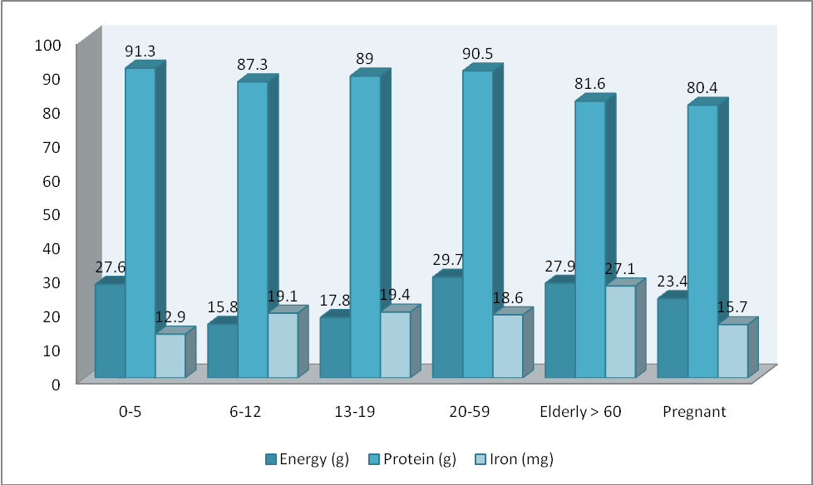

Figure 17 Proportion meeting recommended daily allowances by age groups and pregnant women (RDAs): Cambodia, 2011

Therefore, while the low adequacy levels for energy and iron are a concern, the intake of fats must also be highlighted. ‘Fats’ are an important dietary component, which in the context of the Cambodian diet is directly linked to the supply of fish. The fat of fish contains essential fatty acids such as linoleic acid (Omega 6), the precursor of arachidonic acid (ARA) and linoleic acid (Omega 3) the precursor of Docosahexaenoic acid (DHA). These nutrients are not synthesized by the body and must be obtained from food. DHA – ‘Smart fat’ is a key component of the phospholipids membranes of the eyes and brain and is essential for brain and eye development in infants and children; reduction of heart disease, lowering of blood pressure, and strengthens the immune system. DHA is essential for normal growth and development, healthy skin and reproduction.

## FISH CATCHES DERIVED FROM THE CONSUMPTION STUDY

According to the Cambodian National Institute for Statistics, the estimated population of Cambodia was 12,014,343 in 2000, expected to grow to 15,104,768 by 2015. This gives a figure of 14,095,147 people in 2011 (rounded up to 4,100,000). Total fish yield can be derived from above individual fish consumption figures multiplied by the total population (Table 4).

Thus the latest catch estimate, based on the current study, amounts to *570,000 tonnes of inland fish per year*. When complemented by other aquatic animals, this amounts to 625,000 tonnes of inland capture resources available for consumption each year.

These results are very much in line with previous estimates:

* In 2011 according to national statistics, the catch reached 490,000 tonnes (i.e. 16% difference only)
* According to Hortle (2007[7]), the average inland fish catch in Cambodia, estimated from other consumption studies, amounts to about 482,000 tonnes (and 587,000 tonnes when other aquatic animals are included). However, we must highlight that this includes conservative extrapolations for provinces not covered in Hortle’s review, and covered in the current study
* In their 2008 study encompassing the previously overlooked production of black fish (i.e. local resident fish species) in rainfed rice fields, Hortle et al.[8] came to the conclusion that the total fish production in Cambodia would range between 524,000 and 616,000 tonnes per year of fish + other aquatic animals.

Table 5: Annual fish catch estimated from the present fish consumption survey

|  |  |  |  |  |  |  |  |  |  |
| --- | --- | --- | --- | --- | --- | --- | --- | --- | --- |
|  |  |  | **Annual intake in Fish and Fish Products (kg/person/year)** | **Population** | **Annual yield (tons, rounded up)** | **Total inland fish (rounded up)** | **Total inland or marine capture catch** | **Total capture (inland + marine)** | **Grand total aquatic resources** |
| Inland capture resources | Inland fish | Floodplain residents | 18.8 | 14,100,000 | 265,000 | 570,000 | 625,000 | 870,000 | 889,000 |
| Long distance migrants | 15.5 | 219,000 |
| Short distance migrants | 6.0 | 85,000 |
| Other inland aquatic animals | | 3.9 | 56,000 |  |
| Marine capture resources | Marine Fish | | 16.2 | 229,000 |  | 245,000 |
| Other marine aquatic animals | | 1.1 | 16,000 |  |
| Aquaculture | | | 1.3 | 19,000 |  |  |  |

## ESTIMATED CHANGES OF THE SUPPLY /AVAILABILITY OF FISH AND OTHER AQUATIC ANIMALS UNDER CAMBODIAN DAM DEVELOPMENT SCENARIOS

### Modelling approach and hypotheses

In this study, the total quantity of fish and OAA available for consumption in Cambodia is estimated from the yield of fish and OAA from inland (*i*), marine (*m*) and aquaculture (*a*) adjusted for imports (*I*), exports (*E*), waste (*W*), other utilisation (*U*), using the following formula:



The study reviewed in detail the available figures and best available information for the current baseline and the 2030 possible forecasts for:

* Yield of inland fish and Other Aquatic Animals (Yi)
* Other sources and disposal of fish and OAA
* Yield of marine fish and OAA (Ym);
* Yield from aquaculture (Ya);
* Exports (E);
* Imports (I);
* Other utilisation (U);
* Waste (W)

in order to assess the amount of fish actually accessible to people for consumption. Thus the model does not only focus on river fish, but on all sources of fish (including marine fish and aquaculture fish) and other freshwater and marine aquatic animals.

The study also reviewed:

* dam development scenarios by 2030
* the baseline area of fish habitats (rivers, floodplains and rain-fed wetlands);
* the proportions of white, grey and black fish in the total fish yield (inland fish yield, imports and sources of disposal were disaggregated by the three main guilds of fish (i.e. white / grey / black fish) to account for differences in their response to dam development in the river system)
* estimates of dam reservoir fish production
* estimates of Cambodian human population size and growth

then modelled, for 2030 and the three hypotheses regarding the distribution of spawning sites basinwide (see below):

* - the impacts of each development scenario on fish habitat area and accessibility;
* the hydrological consequences of each dam development scenario and its impacts on the flood index (FI), flood timing and duration (these parameters were shown to be important to fish production)
* the yield crated by dam reservoirs

All these parameters were then integrated to the model in order to predict for each dam development scenario:

* the change in total fish yield in 2030 compared to the baseline;
* the total quantity of fish and OAA available for consumption, integrating predicted future quantities of fish and OAA from the aquaculture sector, imports and disposal (exports, utilisation for aquaculture feed and fertilizer, and post-harvest waste).

Three hypotheses concerning the distribution of *long distance migrants* spawning habitat in the main channel and its tributaries (excluding the Tonle Sap River and Lake) were considered in the assessment:

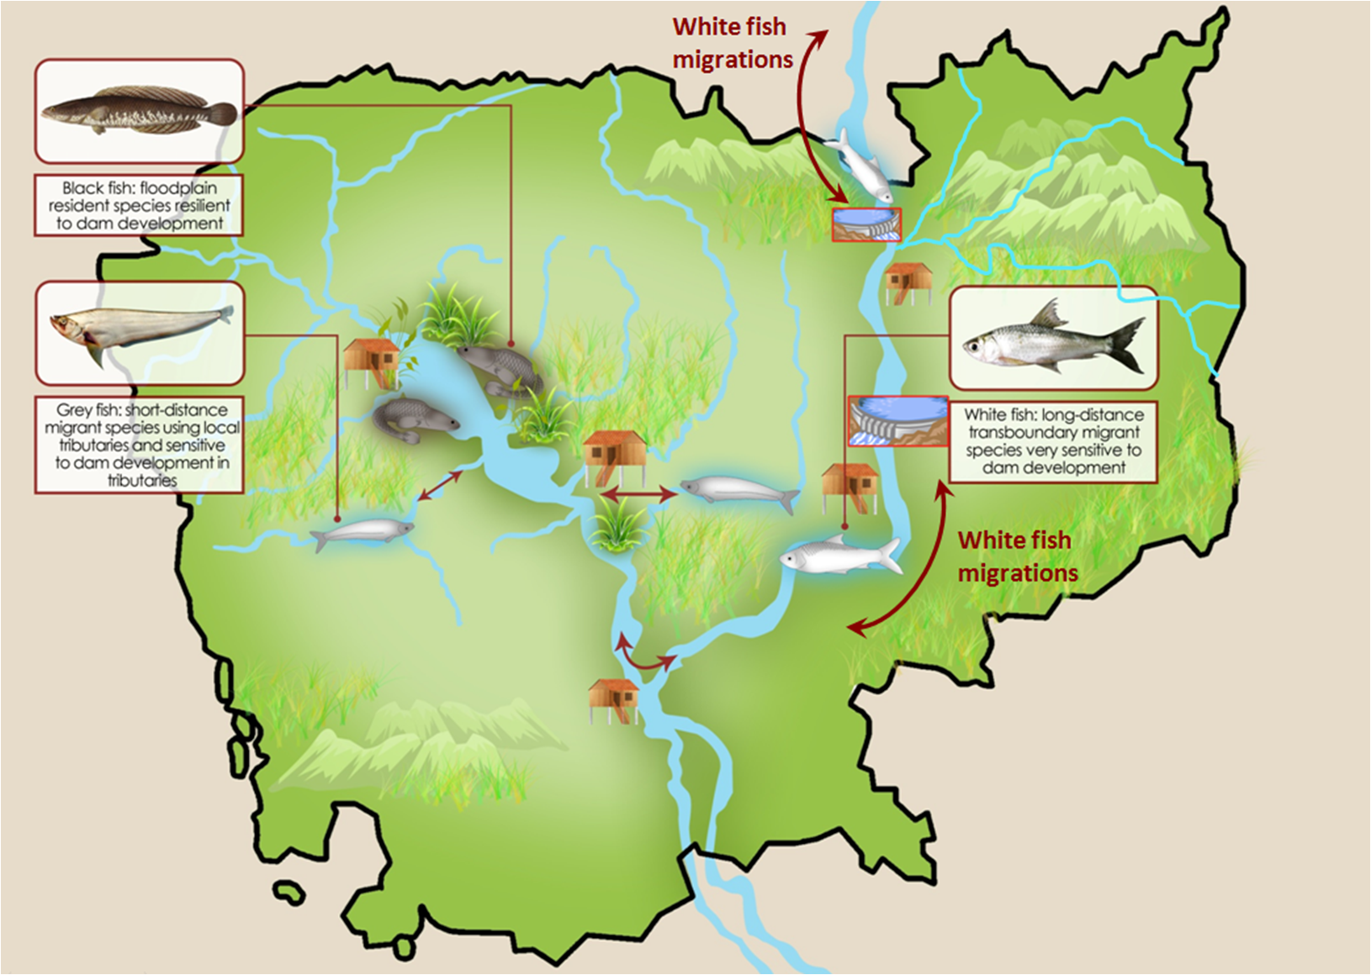

Figure 18: Fish groups, migrations and sensitiveness to dam development

**Hypothesis 1:** *All spawning habitat is uniformly distributed in main channels and tributaries of Cambodia (*low impact scenario*).*

Assuming that species of *long distance migrants* spawn only in river channels in Cambodia, the total area of river channels available for spawning under the baseline (1,310 km2) would decline by a maximum of almost 50%. Tributary dams would remove approximately 11% of the spawning area by 2030. An additional 10% of the channel area would be removed by the Stung Treng HPP, whilst Sambor would remove approximately 40% of the available area.

**Hypothesis 2:** *Spawning habitat is uniformly distributed in main channels and tributaries throughout the Lower Mekong Basin (*medium impact scenario*).*

Dams are expected to deny highly migratory *long distance migrants* access to upstream spawning and refuge habitat. Therefore, the aggregated yield of *long distance migrant* species is assumed to vary linearly with the available spawning habitat area (SHA).

***Dams will deny access to spawning grounds for long distance migratory fish***

***Yield of long distance migratory fish is in direct co-relation with the available spawning grounds***

Under the hypothesis that *long distance migrants* spawning habitat exists throughout the Lower Mekong Basin, approximately two-thirds of the spawning area would be lost if Sambor HPP is developed, compared to a 56% loss for Stung Treng HPP. Relatively minor losses (less than 10%) to spawning area would be expected from the development of tributary dams by 2030.

**Hypothesis 3:** *All spawning habitat is uniformly distributed in main channels and tributaries of the LMB above Kratie (*high impact scenario*).*

Under the hypothesis that all spawning habitat for *long distance migrant* species exists upstream of Kratie, modest (approximately 12%) reductions to baseline spawning habitat area would be expected from tributary dam development by 2030. However, the development of Stung Treng HPP would deny access to the majority (more than 80%) of spawning area, whilst the development of Sambor HPP would effectively remove all *long distance migrants* spawning area from the system.

The losses in habitat expected under each scenario are illustrated below.



Figure 19: Estimated spawning channel area (km2) accessible to *white fish* species under each development scenario and for each spawning habitat distribution hypothesis.

It is assumed that any fish ways, ladders or passes designed to mitigate the barrier impacts of dams on upstream migrations of *long distance migrants* would not be effective (i.e. zero passage of fish). Downstream passage impacts on *long distance migrants* were therefore not considered. Extinctions of *long distance migrants* including threatened species such as the highly migratory Mekong Giant Catfish (*Pangasianodon gigas*) are therefore likely under high development scenarios, particularly under Hypothesis 3. Passage impacts on *floodplain residents* and *short distance migrants* were assumed to be negligible due to their limited migrations and flexible behaviour.

### Predicted changes to capture fisheries yield

NOTE

In the Fisheries and impacts study, baseline fish yield is derived from initial unpublished fish consumption figures per person from the Nutrition study. However these figures were updated later on. Furthermore in the Fisheries and impacts study individual consumption figures are derived from household consumption divided by an assumed household size of 5 persons per household; however later analysis of the consumption survey data show ed that average household size was 4.2 individuals, not 5.

Subsequently, as stated in the report “Impacts of mainstream dams on fish yield and consumption in Cambodia” on page 51, the yield of inland fish and OAA was estimated to be approximately 850,000 tonnes “*in order to balance consumption”*, but consumption figures used were actually inadequate (the yield of inland fish and OAAs derived from the Consumption survey actually amounts to 624,000 tonnes of inland fish per year)

For these reasons IFReDI and scientists of the Technical Advisory Group decided not to reflect in the current synthesis *absolute fish yield modelled figures* from the Fisheries and impacts study, but to keep instead total fish yield figures derived from the field-based Consumption survey. What was kept from the Fisheries and impacts analysis was the *relative fish yield impact results* based on a thorough and transparent modelling approach.

In response to the likely development during the next 20 years in the form of new tributary dam irrigation projects and water abstraction in the Lower Mekong Basin, the yield of fish and other aquatic animals from inland capture fisheries is predicted to decline between approximately 4% and 5% or 24,000 – 29,000 from the 2011 baseline (i.e. 626,000 tonnes). This decline is irrespective of any mainstream dam development.

Table 6: Predicted loss of total yield in fish and other aquatic animals in absence of any dam development

|  |  |  |  |
| --- | --- | --- | --- |
| *Hypotheses about spawning of long distance migratory fishes* | *H1* | *H2* | *H3* |
| 2030 without mainstream dams (%) | -3.7 | -3.8 | -4.7 |
| 2030 without mainstream dams (tons) | -23,000 | -24,000 | -29,000 |

The model outputs give the current figures for the yield of fish and other aquatic animals (marine + freshwater + aquaculture) accessible to human consumption for each scenario in 2030 (Table 7):

Table 7: Losses in yield of inland fish and other aquatic animals for each scenario, by comparison with the absence of mainstream dams. Percentages.

|  |  |  |  |
| --- | --- | --- | --- |
|  | Loss of total yield in fish and other aquatic animals (%) compared to 2030 without mainstream dams | | |
| *Hypotheses about spawning of long distance migratory fishes* | *H1* | *H2* | *H3* |
| 2030 with Stung Treng dam | -6% | -17% | -23% |
| 2030 with Sambor dam | -16% | -21% | -29% |
| 2030 with Stung Treng + Sambor | -16% | -21% | -29% |
| 2030 with 11 mainstream dams | -16% | -21% | -29% |

This corresponds to the following losses related to the 2011 baseline:

Table 8: Losses in yield of inland fish and other aquatic animals for each scenario, by comparison with the absence of mainstream dams. Tonnes.

|  |  |  |  |
| --- | --- | --- | --- |
|  | Loss of total yield in fish and other aquatic animals (%) compared to 2030 without mainstream dams | | |
| *Hypotheses about spawning of long distance migratory fishes* | *H1* | *H2* | *H3* |
| 2030 with Stung Treng dam | -34,000 | -103,000 | -145,000 |
| 2030 with Sambor dam | -98,000 | -130,000 | -182,000 |
| 2030 with Stung Treng + Sambor | -98,000 | -130,000 | -182,000 |
| 2030 with 11 mainstream dams | -99,000 | -131,000 | -183,000 |

***Stung Treng HPP will reduce yields by 6-24% of 34,000 – 145,000 tonnes***

***Sambor HPP will reduce yields by 16-31% or 98,000 – 182,000 tonnes***

Thus the development of *Stung Treng dam* alone is predicted to reduce yields of fish and OAA by 6% to 24% or 34,000 – 145,000 tonnes.

*The Sambor dam* alone is predicted to reduce yields of fish and OAA by approximately 16% to 30 % or 99,000 – 183,000 tonnes compared to 2011 baseline values.

This reduction is almost as much as if all 11 mainstream dams were constructed, because the Sambor dam would alone, being the closest to Cambodian productive floodplains, would block access to spawning ground for all the long distance migratory fish found in these floodplains. Once access is blocked by Sambor, the other dams would have no additional impact on long-distance migratory fish harvested in Cambodia. However the other dams would naturally have an impact on the migratory species harvested in other countries and a local impact.

Given the strong migratory behaviour of about a third of fish biomass landed (38%, see Table 4), the vast majority of the predicted losses would be among species that belong to the highly migratory *long distance migrants* guild.

Predicted losses of Other Aquatic Animals by 2030 and in absence of dams would be minimal and mainly due to reductions in wetlands area, and mainstream dams would reduce the yields of OAAs by a further 4%.

Mainstream Cambodian dams are therefore predicted to reduce the supply of inland fish and OAA for consumption by between 34,000 to 183,000 tonnes from the baseline values depending mainly upon the hypothesised distribution of *long distance migrants* spawning habitat. This highlights the importance of new research on spawning areas in order to narrow this large uncertainty range.



Figure 20: Predicted annual yield of inland fish and other aquatic animals under each development scenario and hypothesised distribution of *long distance migrants* spawning habitat.

### Predicted changes to the supply of aquatic resources for consumption

Although the above sections focus on the becoming of inland aquatic resources, the section below details the actual supply of aquatic resources to the population. To do so, the model:

* combines the predicted future yields of inland fish and OAA above with the predicted future quantities from the aquaculture sector and from imports,
* deduces non-consumptive disposal (exports, utilisation for aquaculture feed and fertilizer, and post-harvest waste),
* integrates predicted changes in river hydrology and accessible wetland habitats, and
* integrates the population growth

for each development scenario and for each hypothesis about reservoir production yield.

**Conclusions**:

Population growth: by 2030 the human population of Cambodia is expected to grow from approximately 14 million in 2011 to 20 million by 2030 (+43 %), which has the heaviest impact on individual access to aquatic resources.

Aquaculture: Per capita consumption in Cambodia appears to have remained unchanged since year 2000 in spite of a 20% increase in population size from approximately 11.8 million to 14 million. This suggests that yields of fish and OAA from inland aquatic habitats and aquaculture production have grown in the recent past to meet increasing consumption demand. However in absence of mainstream dams and regardless of the population growth, the supply of inland fish and other aquatic animals available for consumption is predicted to remain relatively stable from 2011 until 2030. The increased output from the aquaculture sector and forecasted declines in exports will be balanced by losses experienced by capture fisheries in response to dam development *on tributaries* (not on the mainstream) and irrigation development in the lower part of the basin (i.e. loss of wetlands producing capture fish). The supply of fish and OAA for consumption appears relatively insensitive to the assumed level of aquaculture areal production from dam reservoirs. This implies that aquaculture would not compensate for losses to supply arising from Cambodian mainstream dam impacts.

***Aquaculture will not compensate for the fishery losses resulting from the mainstream dams***

Fishery losses due to dam construction: from -34,000 to -183,000 tonnes (see above sections).

The model indicates, due to the above reasons and in absence of mainstream dams, a loss of 30.6% in fish supply (in terms of kg of aquatic resources per person and per year) by 2030 compared to 2011.

In case of construction of mainstream dams, the model also indicates that the low impact hypothesis *(Spawning hypothesis H1, Stung Treng dam only),* the consequence due to dams construction would be a further 6% loss, while in case of High impact scenario *(Spawning hypothesis H3, Sambor + Stung Treng dam*s) the reduction would be a further 34% loss.

Table 9: Baseline situation and consequences of Cambodian mainstream dam construction on the availability and consumption of aquatic resources by 2030

|  |  |  |  |  |
| --- | --- | --- | --- | --- |
| 2011 | Absence of mainstream dams | *Total aquatic resources (baseline; tons)* | *889,000* | |
| 2011 population | 14,100,000 | |
| *Total aquatic resources per person and per year (kg)* | *63.0* | |
| 2030 | Absence of mainstream dams | 2030 population | *20,086,000* | |
| *Total aquatic resources per person and per year* | Loss of 30.6% | |
| *Total aquatic resources per person and per year (kg)* | 43.8 | |
| Construction of Cambodian mainstream dams |  | *Low impact hypothesis (Spawning hypothesis H1, Stung Treng dam only)* | *High impact hypothesis (Spawning hypothesis H3, Sambor + Stung Treng dams)* |
| Loss in % compared to baseline | *6* | *34* |
| *Total aquatic resources per person and per year (kg)* | *41.1* | *28.9* |
| *Loss in kg/person/year compared to 2011* | *22* | *34* |

Overall, when all factors driving the production of overall aquatic resources now and in the future are integrated, the model shows that the per capita supply of inland fish and OAA for consumption will decline significantly by 2030. In absence of mainstream dams, per capita supply of inland fish and OAA is expected to decline from approximately 63 kg per capita in 2011 to approximately 44 kg per person and per year by 2030. The construction of Cambodian mainstream dams would reduce this supply by an additional 6 to 34% depending on the scenario. This would result in a fish consumption dropping down to 29-41 kg/person/year.

Therefore, it is concluded that the construction of mainstream dams in Cambodia would aggravate the ongoing decline of the consumption by 6 to 34%. Aquaculture would not compensate losses to supply arising from Cambodian mainstream dam impacts and the total amount of inland fish available for consumption as well as the consumption per person would dramatically decline.

***Without dam construction inland fish consumption will be reduced in 2030 to 44 kg per person and per year***

***In the Best Case Scenario construction of mainstream dams can potentially reduce inland fish by further 6% to 41 kg per person***

***In the Worst Case Scenario construction of mainstream dams can potentially reduce inland fish by further 34% to 29 kg per person;***

***;***

## THE POTENTIAL IMPACT OF HYDROPOWER DAM DEVELOPMENT ON FOOD AND NUTRITION SECURITY IN CAMBODIA

The data on the importance of fish to nutrition and the Cambodian diet clearly demonstrates the dependency of the Cambodian population on fish. Fish is not only the second most consumed food group in terms of the composition of daily meals, but it is also the main source of key nutrients such as protein, fat and iron, establishing a direct link between fish intake and health.

***Reduction of the supply of fish will have direct implications for both nutrition and public health in the country***

On the basis of these findings, the reduction of the supply of fish will have direct implications for both nutrition and public health in the country.

Depending on the three hypotheses discussed in this document, the amount of fish and OAA available for consumption will be reduced to a varying degree.

In terms of nutrition, the above results would mean that in the *best-case scenario*, after the construction of the mainstream dams there will be further reduction of the already low number of individuals who meet nutrient adequacies (RDA) for energy; for protein and iron.In addition, there will also be a significant and important reduction in the intake of animal fats which is not reflected here as there are no RDA values for fat intake in Cambodia.

While this potentially dramatic reduction will affect the entire population and its food habits, there are particular segments of the population who will be more affected than others and whose nutrition adequacy will be greatly jeopardized.

### Ecological zone impact

The reduction of inland fish available for consumption will affect mostly the areas of the Tonle Sap and the Plains, which are the areas with the heaviest reliance on inland fish. The reduction of long distance migrants availability will particularly affect the population in the Plains who eat more long distance migrants than any other ecological zone. **A reduction of 34% (the worst case scenario) of the available fish and fish products for consumption will have a dramatic impact on the proportion of the population living in the plains who meet their daily allowances (RDAs), and who are already considered as the least nutrient secure ecological zone.**

### Urbanity impact

The urban areas have greater food security than the rural areas. Consumption of fish in urban areas is higher than in rural areas, with rural areas having a higher level of consumption of inland fish and a higher intake of long distance migrants. However, despite the current availability of long distance migrants, the poor overall nutrition in rural areas results in households and individuals in the rural areas being more nutrient insecure, with less than 20% of the individuals meeting the adequacies for iron. Therefore a reduction in fish availability and specifically long distance migrants, which is important for the provision of iron will have a strong detrimental impact to the rural population driving iron security even lower and posing a risk to public health.

### Gender impact

A reduction of the availability of inland fish for consumption will affect both sexes almost equally.

### Age groups and pregnant women impact

Highest adequacy for energy at close to one-third (29.7 %) was met by the adults (20-50 years old) and lowest by the school children (6 to 12 years old) at only about 15.8%. Thus, *school children* could be considered as the most food insecure age group, while *adults as* the most food secured. The data on pregnant women’s nutrition shows that they are the most vulnerable group to protein reduction, with the lowest rate of protein RDA satisfaction.

The survey data shows that pregnant women are the most dependent on inland fish and in particular on the availability of long distance migrants. Therefore any dramatic reduction of these sources of protein will aggravate the already low levels of protein RDA satisfaction rates and put at risk the health of mothers and their babies.

Further to this, a United Nation Children's Emergency Fund (UNICEF)/World Food Program (WFP) survey shows that fish is part of the daily diet of 74-80% of all children of over 11 months old, for whom the main source of protein in rural areas is Prahoc, which is the fermented fish paste made from long distance migrants. Thus children, especially in rural areas will also be directly affected by the reduction of inland fish availability.

# CONCLUSIONS

Based on the detailed technical studies summarized in this report, the following conclusions can be drawn:

The current per capita supply of inland fish is 63kg per person in 2011. The future supply of inland fish is predicted to change as follows:

* In absence of mainstream dams the per capita supply of inland fish and OAA available for consumption is expected to decline to approximately 44 kg per person by 2030due to increase in demand that cannot be compensated by supply;
* The construction of the Cambodian mainstream dams will decrease the supply of fish further by 6-34% down to to between 29-41 kg per person depending on the spawning habitat hypothesis and dam development scenario;
* Sambor dam would have a greater impact on supply compared to Stung Treng dam and, in Cambodia, an impact equivalent to that of all mainstream dams together.

As the important rates of energy, protein and iron adequacy are all highly dependent on fish the reduction of fish and fish products available for consumption will have a direct negative impact on the rates of individuals and households meeting the adequacy rates for these important nutrients and energy.

This will aggravate existing malnutrition and lower the rates of individuals meeting their recommended daily allowance for key nutrients, thus exposing an increasing number of the population to health risks. Reduction of fish consumption will have negative effects on public health and affect strongly some of the most vulnerable populations groups, such as those living in remote rural areas, school children and pregnant women.

1. all food of animal origin (for example: meat, eggs, dairy)
2. per capita = per person
3. Ahmed M., Hap Navy, Ly Vuthy, Tiongco M. 1998 Socioeconomic assessment of freshwater capture fisheries in Cambodia: report on a household survey. Mekong River Commission, Phnom Pennh, Cambodia. 186 pp
4. Hortle K.G. 2007 Consumption and the yield of fish and other aquatic animals from the Lower Mekong Basin. MRC Technical Paper No.16, Mekong River Commission, Vientiane, Lao P.D.R. 87pp.
5. Protein –from both animal and plant origin
6. all food of animal origin (for example: meat, eggs, dairy)
7. Hortle K.G. 2007 Consumption and the yield of fish and other aquatic animals from the Lower Mekong Basin. MRC Technical Paper No.16, Mekong River Commission, Vientiane, Lao P.D.R. 87pp.
8. Hortle K.G., Troeung R., S. Lieng 2008 Yield and value of the wild fishery of rice fields in Battambang Province, near the Tonle Sap Lake, Cambodia. MRC Technical Paper No. 18, Mekong River Commission, Vientiane, Lao PDR. 62pp.