Working Paper

Scale Up of the Management of Acute Malnutrition
December 2012
Draft prepared by UNICEF for:
Ministry of Health, National Maternal and Child Health Center, National Nutrition Program
Nutrition Working Group

Contents
Background 2
Strategic Targets, Monitoring and Evaluation 4
Targeted Hospitals 6
Supply - Equipment Needs 16
Costing of Future Needs 17
Next Steps 18

Background
This document focuses on treatment of severe acute malnutrition with therapeutic food provided by the public health sector. Treatment using locally prepared food is not implemented at scale in the country and the lack of operational structure for a community based programme is a major bottleneck to implementing such a programme. Treatment using locally prepared food is therefore not included in this scale-up plan. In addition, outpatient treatment from the health center level is currently in pilot phase. This plan does not address scale up of treatment at health center level. The focus of this scale up plan is increasing coverage at hospital level and maintaining current pilots at health center level.
Hospital
Hospital based management of acute malnutrition, in its current form with therapeutic feeding following WHO guidelines, started in the mid-2000’s with support from the Health Sector Support Project and UNICEF. By connecting child malnutrition treatment with HIV services in pediatric wards, UNICEF was able to support the National Nutrition Programme to start scaling up hospital-based management of acute malnutrition. By 2008, 15 hospitals had trained staff and were equipped with necessary supplies, including therapeutic food (F-75, F-100) and specialized oral rehydration solution (ReSoMal). From 2008 to 2012 the number of implementing hospitals has doubled and currently 43% of target hospitals (32 out of 73) in Cambodia provide treatment. Implementing hospitals have been trained with an adapted and translated version of the WHO Training and treatment is included in the 2011 MoH Interim Guidelines on the Management of Acute Malnutrition and the 2012 revision of the MoH Clinical Practice Guidelines.
While the programme has undoubtedly saved many lives since its introduction, program success has been hampered by a high percentage of children not completely recovering before being “lost to follow up.” These children were likely to become severely malnourished again and would probably suffer from irreversible stunting because they would not return to a normal growth pattern. The main reason for not completing treatment was that caretakers could not afford to stay in hospital for the required time and there was no take-home ration. The development of an appropriate take-home ration, ready-to-use therapeutic food (RUTF), was a potential solution. In 2009 the Clinton Foundation (CHAI) trialed the use of PlumpyNut, but the taste was found to be unacceptable. The following year UNICEF, Magna, and the NNP carried out an acceptability trial of BP-100, which was found to be acceptable and was introduced with support from UNICEF as a regular part of hospital based management of acute malnutrition in 2012. This year UNICEF also started direct transport support to caretakers for three follow up visits to receive a health check and the take home ration of BP-100. Monitoring reports show dramatic improvement in treatment completion as well as an increased number of cases. There is mounting anecdotal evidence that caretakers with children that have received malnutrition treatment are now promoting the service within their communities.
In 2012, only four new hospitals (all with Health Equity Funds) were added to the programme in order to focus more on quality and sustainable financing. Meanwhile, UNICEF continues to provide operational support, start-up equipment, therapeutic food and oral rehydration solution to all implementing hospitals through its support to pediatric HIV and from the UN Joint Programme on Children, Food Security and Nutrition. The increased costs for transport support and ready-to-use therapeutic food, along with necessary support to ensure the quality of the programme, makes the overreliance on UNICEF budget a major bottleneck to further scale-up of the programme. However, to address this, both URC and UNICEF successfully advocated for inclusion of all of the elements of malnutrition treatment in the HEF Standardized Benefits Package, including transport support for three follow up visits. Thus, provider payment and caretaker support from the Health Equity Fund will now allow quality scale-up of the program, but only if the treatment commodities are available and both providers and patients access support from Health Equity Fund. In 2012 indicators on malnutrition identification were included in Service Delivery Grant Contracts of a number of hospitals. This does not appear to have had an impact on programme coverage or quality.
Government budget is already used for malnutrition services, specifically for staff costs, storage/transport of supply, antibiotics and micronutrients. F75, F100, and ReSoMal are now included on the Essential Drugs List and the National Nutrition Program has requested procurement with government budget. The cost of commodities on the Essential Drugs List is not a barrier to scale-up and is small relative to the cost of ready-to-use therapeutic food, which is not on the Essential Drugs List. Further, the limited number of suppliers of an acceptable RUTF makes government procurement unlikely in the short term. If more suppliers are available and RUTF is included in the Essential Drugs List in 2014, government procurement could start in 2015. RUTF production in Vietnam is currently being certified and IRD (France) is exploring the possibility of production in Cambodia; these are both potential future suppliers.
Health Center
An acceptable RUTF also allows therapeutic feeding and treatment of severe acute malnutrition without complications from the health center OPD; globally 90% of severe acute malnutrition cases are thought to be without complications. UNICEF recommends implementing at the health center and community level when moderate and severe acute malnutrition rates are above 10%. In Cambodia it was decided to implement because acute malnutrition rates were not improving and the current rate is just above the cutoff, at 10.9%.
Under the UN Joint Programme on Children, Food Security and Nutrition piloting of treatment through HC OPD started in 2010 in 5 health centers in Kampong Speu. In 2011 and 2012 the pilot was expanded to 14 additional health centers in Kampong Speu, 5 health centers in Svay Rieng, and 23 health centers in NGOs RACHA (8) and MAGNA (15) target areas. All implementing health centers receive supply procured by UNICEF and distributed through the government system. Implementation has also included mass screenings at the community level to identify cases of acute malnutrition.
At the policy level HC OPD treatment of malnutrition is included in the 2011 Interim Guidelines on the Management of Acute Malnutrition and in the 2011 revision of the Integrated Management of Childhood Illnesses. It is also included in MPA 10. Treatment at the HC level has not been directly included in any provider payment schemes; most notably it is absent from the GAVI support to IMCI. Identification and treatment/referral are included under a case-based payment from Health Equity Fund to the health center, but this is expected to have limited impact as the rate of reimbursement is small and transport support to the health center is not provided (cost of transport is more of a barrier to accessing services at the health center level than the user fee) Community level identification is currently not included in Outreach Guidelines or the Community Participation Policy. The lack of identification at the community and in health center OPD limits the ability of hospitals to achieve high coverage. The National Nutrition Programme is starting to address this by training the OPD closest to implementing hospitals to identify and refer child malnutrition. The provider payment to the hospital may help to increase OPD screening; if the payment were for all cases of child malnutrition instead of only for the poor, it would likely have an even larger impact.
An evaluation of the pilots will be carried out in 2013 under the final evaluation of the Joint Programme; at that time government and development partners will need to decide on scale-up.

Strategic Targets, Monitoring and Evaluation
Indicators and targets for nutrition interventions in the health sector are included in the Health Strategic Plan and the National Nutrition Strategy. Treatment of child malnutrition does not appear in the Health Strategic Plan. In the National Nutrition Strategy the target to develop policy for malnutrition treatment was achieved with the endorsement of the 2011 Guidelines for the Management of Acute Malnutrition. The only other indicator related to malnutrition treatment is “the number of villages covered with community-based management of acute malnutrition”, referring to HC OPD treatment. There is no target for the number of hospitals implementing management of acute malnutrition in the National Nutrition Strategy.
Acute malnutrition is included in the Health Management Information System and this is the indicator used to monitor Service Delivery Grant contracts. The fact that malnutrition frequently is associated with other illnesses presents a problem for monitoring through the Health Management Information System because for every inpatient case the hospital needs to select one condition. It is not known how many cases of malnutrition are not reported due to selection of an associated illness. The National Nutrition Program has developed registers and data collection forms. This parallel reporting system includes indicators of coverage and quality, but quality indicators were only included in 2011. There is no database for the parallel reporting system (it is excel-based) and the system is not included in the web-based Health Information System. Monitoring data does show a steady increase in the number of children treated in hospital. The decrease in 2011 was mainly due to less cases at the National Pediatric Hospital. In 2012 cases at the National Pediatric Hospital returned to normal levels and it looks like more than 1400 children will receive treatment in the year.
Hospital based treatment of malnutrition was assessed in 2010, but the assessment did not cover many hospitals and was not robust enough to be considered an evaluation. The program is yet to have a comprehensive, external evaluation.
The National Nutrition Programme began hospital based treatment with funding from HIV projects. Initial implementation and scale-up has focused on hospitals providing Pediatric AIDS Care. By chance, nearly all of the hospitals currently implementing also have Health Equity Fund. In 2012, presence of Health Equity Fund was explicitly used as criteria for hospital selection; other criteria include Pediatric AIDS Care, sufficient and motivated staff, and sufficient pediatric cases. By the end of 2012 32 of 73 target hospitals have been trained and equipped, and are implementing. Sixteen hospitals are not included as target hospitals because they do not have normal pediatric services (N=5), there is a shortage of staff (N=4), or there is a lack of patients because of proximity to other hospitals (N=7). Assessments to determine target hospitals have been done in an ad-hoc manner and some hospitals are yet to be assessed. The National Pediatric Hospital serves as the training hospital for management of acute malnutrition. While refresher trainings are carried out, there is no formal system for ongoing, day-to-day technical support from NPH staff to staff of other hospitals. In 2012 Battambang PRH was also used as a training center because of a break in service at the NPH. The autonomous status of the NPH may create the need for alternative training centers in the future.
The map and table below provides the implementation status of all public sector hospitals in the country and by operational district.
Figure 1 Districts with Hospital Based Management of Acute Malnutrition in 2012
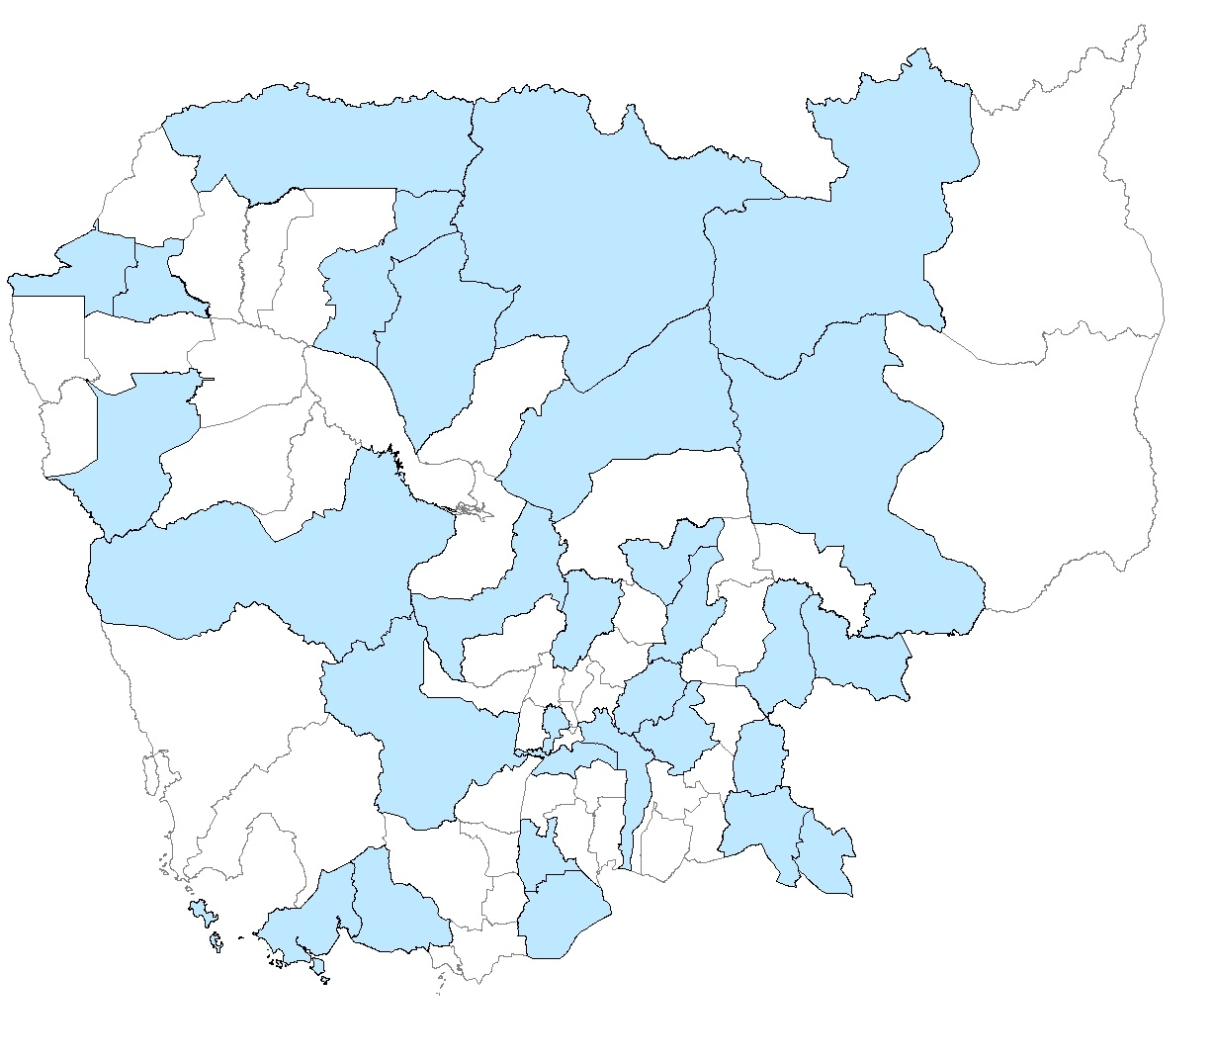.
While management of acute malnutrition service is widespread in the country, there are notable gaps in the remote areas of the northeast and southwest. These areas have high rates of malnutrition, but small populations. In the past there was limited capacity in the hospitals of these remote areas and a small caseload. This may have changed in recent years due to HEF and SDG; there is a need to assess the ability of these hospitals to implement MAM in order to reach the most vulnerable groups in the country.

Table 1 Implementation Status of Management of Acute Malnutrition Among Hospitals with Pediatric Services
Province | Health Operational District | Hospital Name | Service Level | Trained | Implement by 2012 | Training and Implement 2013 | HEF by 2014 | Notes
Green=implementing as of 2012
Orange=excluded from implementation
Yellow=targeted for implementation
White=not yet assessed
B. Meanchey | Mongkol Borei | Serei Sophon | CPA1 | 1 | 1 |  | 1 | Start q4 2012
B. Meanchey | Mongkol Borei | Cambodia-Japan Friendship PH | CPA3 | 1 | 1 |  | 1
B. Meanchey | Ou Chrov | Poipet | CPA2 | 1 | 1 |  | 1
B. Meanchey | Preah Net Preah | preah Net Preah | CPA1 |  |  |  | 1
B. Meanchey | Thma Puok | Thma Puok | CPA2 |  |  |  | 1
Battambang | Thmar Koul | Thmar Koul | CPA1 |  |  |  | 1
Battambang | Maung Russei | Maung Russei | CPA2 |  |  |  | 1 | Shortage of staff
Battambang | Sampov Luon | Sampov Loun | CPA1 |  |  |  | 1 | Have PAC
Battambang | Battambang | Battambang Provincial Hosp. | CPA3 | 1 | 1 |  | 1
K. Cham | Chamkar Leu - Stueng Trang | Chamkar Leu | CPA1 | 1 | 1 |  | 1
K. Cham | Choeung Prey - Batheay | Choeung Prey | CPA1 | 1 | 1
K. Cham | Choeung Prey - Batheay | Batheay | CPA1
K. Cham | Kampong Cham - Kg. Siem | Kampong Cham Prov. Hosp. | CPA3 | 1 | 1 |  | 1
K. Cham | Kroch Chhmar - Stung Trang | Kroch Chhmar | CPA1 |  |  |  | 1
K. Cham | Memut | Memut | CPA2 | 1 | 1 |  | 1
K. Cham | O Reang Ov - Koh Soutin | O Reang Ov | CPA1 |  |  |  | 0
K. Cham | Ponhea Krek - Dambae | Ponhea Krek | CPA1 | 1 | 1 |  | 1
K. Cham | Prey Chhor - Kang Meas | Prey Chhor | CPA1 |  |  |  | 1
K. Cham | Srey Santhor - Kang Meas | Srey Santhor | CPA1 |  |  |  | 1
K. Cham | Tbong Khmum - Kroch Chhmar | Tbong Khmum | CPA2 |  |  |  | 1 | Have PAC
K. Chhnang | Kampong Chhnang | Kampong Chhnang_Prov Hosp | CPA3 | 1 | 1 |  | 1
K. Chhnang | Kampong Tralach | Kampong Tralach | CPA1 |  |  |  | 1
K. Chhnang | Boribo | Boribo | CPA1 |  |  |  | 1
K. Speu | Kampong Speu | Kampong Speu Prov. Hosp. | CPA3 | 1 | 1 |  | 0
K. Speu | Kong Pisey | Kong Pisey | CPA2 |  |  |  | 1
K. Speu | Ou Dongk | Ou Dong | CPA2 |  |  |  | 1
K. Thom | Baray and Santuk | Baray and Santuk | CPA2 |  |  |  | 1
K. Thom | Kampong Thom | Kampong Thom Prov. Hosp. | CPA3 | 1 | 1 |  | 1
K. Thom | Stong | Stong | CPA2 |  |  |  | 1
Kampot | Angkor Chey | Angkor Chey | CPA2 |  |  |  | 0
Kampot | Chhouk | Chhouk | CPA2 |  |  |  | 0
Kampot | Kampong Trach | Kampong Trach | CPA2 |  |  |  | 0 | Have PAC
Kampot | Kampot | Kampot Prov. Hosp. | CPA3 | 1 | 1 |  | 1
Kandal | Kean Svay | Kean Svay | CPA1 | 1 | 1 |  | 1 | Few patients, No HEF
Kandal | Koh Thom | Koh Thum | CPA2 |  |  |  | 0 | PAC
Kandal | Ksach Kandal | Khsach Kandal | CPA1 |  |  |  | 0
Kandal | Muk Kam Poul | Bunrani Hun Sen Rokakong | CPA1 |  |  |  | 0
Kandal | Saang | Hopital saang | CPA1 |  |  |  | 0
Kandal | Takhmao | Cheychumnash Hosp. | CPA3 | 1 | 1 |  | 0 | NGO support, No HEF
Koh Kong | Smach Mean Chey | Koh Kong Prov. Hosp. | CPA3 |  |  | 1 | 1 | PAC
Koh Kong | Srae Ambel | SraeAmbel | CPA1 |  |  |  | 1 | pac
Kratie | Chhlong | Chhlong | CPA2 |  |  |  | 1
Kratie | Kratie | Kratie Prov. Hosp. | CPA3 | 1 | 1 |  | 1
Kratie | Kratie | Snoul | CPA1 |  |  |  | 0
Mondulkiri | Sen Monorom | Mondul Kiri Prov Hosp. | CPA2 |  |  | 1 | 1
PP | Cheung | Samdech Ov Hospital | CPA1 |  |  |  | 0 | Lack of patients
PP | Kandal | Municipal Hospital | CPA3 |  |  |  | 1 | Lack of patients
PP | Kandal | Chamkar Morn Hospital | CPA1 |  |  |  | 1 | Lack of patients
PP | Lech | Pochentong Hospital | CPA1 | 1 | 1 |  | 1 | Only opd
PP | Tbong | Mean Chey Hospital | CPA1 |  |  |  | 1 | Lack of patients
PP |  | Ang Duong | Specialized HF |  |  |  | 0 | No pediatric ward
S. Reap |  | Angkor Pediatric Hospital | Specialized HF | 1 | 1 |  | 0 | NGO support
PP |  | Calmette | Specialized HF |  |  |  | 0 | No pediatric ward
PP |  | CENAT | Specialized HF |  |  |  | 0 | No pediatric ward
S. Reap |  | JaYa 7 | Specialized HF |  |  |  | 0
PP |  | Khmer-Soviet Friendship | Specialized HF | 1 | 1 |  | 0
PP |  | Kossamak | Specialized HF |  |  |  | 0 | No pediatric ward
PP |  | Kantha Bopha | Specialized HF |  |  |  | 0
PP |  | MCH | Specialized HF |  |  |  | 0 | No pediatric ward
PP |  | National Pediatric | Specialized HF | 1 | 1 |  | 0 | Training Center, No HEF
P. Vihear | Tbeng Meanchey | P Vihear 16 Makara Prov Hos | CPA1 | 1 | 1 |  | 1
P. Veng | Kamchay Mear | Kamchay Mear | CPA1 |  |  |  | 0
P. Veng | Kampong Trabek | Kampong Trabek | CPA2 |  |  |  | 0
P. Veng | Mesang | Mesang | CPA1 |  |  |  | 0
P. Veng | Neak Loeung | Neak Loeung Hospital | CPA2 |  |  |  | 1 | pac
P. Veng | Pearaing | Peareang | CPA2 | 1 | 1 |  | 1 | Start q4
P. Veng | Preah Sdach | Preah Sdach | CPA1 |  |  |  | 1 | Shortage of staff
P. Veng | Svay Antor | Prey Veng Prov. Hosp. | CPA3 | 1 | 1 |  | 1 | No HEF
Pursat | Bakan | Bakan | CPA2 |  |  |  | 1
Pursat | Sampov Meas | Pursat Prov. Hosp. | CPA3 | 1 | 1 |  | 1
Ratanakiri | Banlong | Ratanakiri Prov Hos | CPA2 |  |  | 1 | 1
Siem Reap | Kralanh | Kralanh | CPA2 |  |  |  | 1 | Lack of patients
Siem Reap | Siem Reap | Siem Reap Prov. Hosp. | CPA3 |  |  |  | 1 | Lack of patients
Siem Reap | Sot Nikum | Sotr Nikum | CPA2 | 1 | 1 |  | 1 | Ngo support
Siem Reap | Ankor Chhum | Angkor Chum | CPA1 |  |  |  | 1 | Lack of patients
Sihanoukville | Preah Sihanouk | Preah Sihanouk Prov. Hosp | CPA3 | 1 | 1 |  | 1
S. Treng | Steung Treng | Stung Treng Prov. Hosp. | CPA3 | 1 | 1 |  | 1
S. Rieng | Chi Phu | Chi Phu | CPA1 |  |  |  | 0
S. Rieng | Romeas Hek | Romeas Hek | CPA2 | 1 | 1 |  | 0 | No HEF
S. Rieng | Svay Rieng | Svay Rieng Prov Hosp. | CPA3 | 1 | 1 |  | 1
Takeo | Ang Rokar | AngRoka | CPA1 |  |  |  | 1 | Shortage of staff
Takeo | Bati | Bati | CPA1 |  |  |  | 1
Takeo | Daun Keo | Takeo Prov Hospital | CPA3 | 1 | 1 |  | 1
Takeo | Kirivong | Kirivong | CPA2 | 1 | 1 |  | 1 | Start in q4
Takeo | Prey Kabass | Prey Kabass | CPA1 |  |  |  | 0
O. Meanchey | Samraong | Oddor Meanchey Prov Hosp | CPA2 | 1 | 1 |  | 1
O. Meanchey | Samraong | Anlong Vaeng | CPA1 |  |  |  | 1
Kep | Kep | Kep Prov. Hosp. | CPA1 |  |  |  | 1 | Shortage of staff
Pailin | Pailin | Pailin Prov. Hosp. | CPA2 |  |  |  | 0 | pac

Supply - Equipment Needs

Therapeutic food, micronutrients, antibiotics, and specialized oral rehydration solution are referenced in the background. In addition to these supplies, the Guidelines for the Management of Acute Malnutrition include all of the necessary print materials, supplies for cooking demonstrations, and supplies for measuring (see table below). The importance of playgrounds is referred to in the guidelines, but equipment is not included in the guidelines. Playgrounds and building renovations were included as a part of start-up supplies for hospitals that started implementation early. As the programme expands and the recurring operational costs grow, it is more difficult for UNICEF to finance renovations.
Equipment and Supplies | Reference Sheets and Protocols
See WHO training modules – Course Director Guide for all supplies needed to inpatient treatment of severe malnutrition but main items include:  - F-75  - F-100  - BP-100  - ReSoMal  - Weighing scales (UNISCALE)  - Glucometer and strips  - Height board/Microtoise  - MUAC tapes  - Weighing scales appropriate for infants <6 months (10g divisions)  - Medical supplies and equipment  - Folic Acid (only 5 mg but need 1 mg)  - Iron (only IFA) | Follow WHO training modules  - W/H charts (See Job Aid 3.1a)  - Table target weight gain for discharge (15%) (See Job Aid 3.1r)  - Critical Care Pathway (CCP) (See Job Aid 3.1h)  - Admission and discharge criteria (Table 2&4)  - Dosage of F-75 (See Job Aid 3.1l), F-100 (See Job Aid 3.1n), BP-100 (See Annex 3 or Job Aid 3.1o) and ReSoMal (See Job Aid 3.1k)  - Antibiotics and routine medicine protocol for inpatient care (See Annex 1 or Job Aid 3.1i)  - Referral slips (See Job Aid 3.1b&3.1c)  - Monthly report form (See Annex 4 or Job Aid 4.1)  - IYCF promotion materials, including cooking demonstration guidelines (NNP) (See Job Aid 3.1q) and BFCI Flipchart  - List of health centres offer outpatient management of severe acute malnutrition without medical complications

Costing of Future Needs

The following costs are not included in the overall costing:
- In the past UNICEF provided salary top-ups to hospital staff to treat child malnutrition. As of 2013 these incentives will be discontinued in HEF hospitals and replaced with a case-based quality payment. In non-HEF hospitals UNICEF will also discontinue salary top-ups and will provide financing aligned with the HEF Standard Benefits Package. Total cost is estimated at USD 60,500 for 2013.
- UNICEF continues to support weekly cooking demonstrations to provide caretakers with the ability to prepare nutritious meals for their children from locally available foods. Total cost is estimated at USD 27,000 for 2013. Cooking demonstrations can be supported by Pooled Fund, but were not included in 2013 AOPs.
- In the past UNICEF has financed hospital renovations to provide kitchen services for cooking demonstrations and playgrounds.
- The Standard Benefits Package of Health Equity Fund and the Service Delivery Grant contracts include financing of activities related to hospital based management of acute malnutrition.
- Antibiotics, micronutrients and staff costs are paid for by government.
It is estimated that increased coverage of hospitals along with increased OPD screening will nearly double the number of annual cases treated in hospital to 2,870 by 2015. Additional costing assumptions are detailed under each heading and all costs are presented in USD. Total costs presented in the figure below show an annual need of nearly $400,000 by 2015. The majority of the cost is the ready-to-use therapeutic food.
Figure 2 Estimated recurrent annual costs of treatment of acute malnutrition, 2013-2015

Training
Training of one hospital costs approximately $1,000. In 2013 the National Nutrition Programme has requested ~30,000 from Pooled Fund for a refresher training of all implementing hospitals and ~16,000 for training of new hospitals. This latter training will add 16 hospitals. An additional 5 hospitals can be trained for $5,000 in 2014 with another refresher in 2015 costing ~$53,000. This will bring the total number of implementing hospitals to 53 by 2015.
- 2013: 46,000
- 2014: 5,000
- 2015: 53,000

Coordination and Supervision
Every year the National Nutrition Programme brings together all of the hospitals implementing MAM to share lessons learned and discuss operational constraints. For 2013 they have requested $13,000 for this activity. In addition they have requested $10,000 for supervision of the activity. At the subnational level more coordination and supervision is needed. 2013 AOPs have not included coordination/supervision at the subnational level and the activity will be financed by UNICEF. Costs are based on 32 implementing hospitals in 2013, 48 in 2014, and 53 in 2015.
- 2013: 23,000; 20,000 sub nat’l
- 2014: 34,500; 30,000 sub nat’l
- 2015: 40,000; 33,100 sub nat’l

Supply
The commodities used for the treatment of acute malnutrition that are not used for other health services include ReSoMal, F-75, F-100, and ready-to-use therapeutic food. Based on 2013 cost estimates for these commodities the average cost per child for treatment is USD 74.3. The cost of RUTF represents 91% of the total. Annual costs are based on maintaining treatment of 624 children per year through outpatient services and increasing total number of cases from 2,357 in 2013, to 3,233 in 2014, and to 3,494 by 2015.
- 2013: 175,125
- 2014: 240,211
- 2015: 259,604

Target areas include Kampong Speu, Kandal, Takeo, Siem Reap, Pursat, Banteay Mean Chey, and Prey Veng

