CAMBODIA EQUITY ANALYSIS

Maternal, Newborn and Child Health and Nutrition

Cambodia Demographic and Health Surveys: 2000, 2005 and 2010

UNICEF Cambodia

September 2012
CONTENTS

FIGURES AND TABLES iii
ACRONYMS v
EXECUTIVE SUMMARY vi
INTRODUCTION 1
METHODOLOGY 2
SECTION I: CHILDREN AGED 0–59 MONTHS 6
1. CHILDHOOD MORTALITY OVERVIEW 6
2. CHILD OUTCOMES 9
2.1 Underweight (WHO 2006 Growth Standards) 11
2.2 Stunting (WHO 2006 Growth Standards) 12
2.3 Wasting (WHO 2006 Growth Standards) 13
2.4 Anaemia 14
2.5 Diarrhoea 15
2.6 Acute Respiratory Infection 16
2.7 Comparability of Child Outcome Indicators 17
3. CHILD PREVENTIVE SERVICES 18
3.1 Immunization 19
3.2 Vitamin A & Deworming Supplementation 24
3.3 Comparability of Child Preventive Services Indicators 25
4. CHILD CURATIVE SERVICES 26
4.1 Diarrhoea: Health Seeking/ORS 27
4.2 ARI: Health Seeking/Antibiotics 29
4.3 Comparability of Child Curative Services Indicators 30
5. INFANT AND YOUNG CHILD FEEDING BEHAVIOURS 31
5.1 Ever Breastfed and Early Initiation 32
5.2 Exclusive Breastfeeding 33
5.3 Continued Breastfeeding 34
5.4 Timely Introduction of Complementary Foods 35
5.5 Comparability of IYCF Behaviours Indicators 36
SECTION II: WOMEN AGED 15–49 YEARS 37
6. WOMEN OUTCOMES 37
6.1 Women: Low BMI (<18.5) 38
6.2 Women: Anaemia 39
6.3 Comparability of Women Outcome Indicators 39
7. WOMEN BEHAVIOUR & KNOWLEDGE 40
7.1 Contraceptive Prevalence Rate (Modern) 41
7.2 PMTCT Knowledge 42
7.3 Comparability of Women Behaviour & Knowledge Indicators 43
8. MATERNAL HEALTH SERVICES 44
8.1 ANC: Skilled Provider (1+ visits) 46
8.2 ANC: Any Provider (4+ visits) 47
8.3 ANC: 3 Basic Components 48
8.4 HIV Testing during Pregnancy 49
8.5 Tetanus Toxoid: 2+ Injections during last Pregnancy 50
8.6 Tetanus Toxoid: Last Birth Protected 51
8.7 Delivery Location: Health Facility 52
8.8 Delivery Assistance: Skilled Provider 53
8.9 Postnatal Check-up 54
8.10 Comparability of Maternal Health Services Indicators 54
REFERENCES & RESOURCES 55
APPENDIX 1. INDICATOR DEFINITIONS 56
APPENDIX 2. DATA TABLES 59

FIGURES AND TABLES

 |  |  | Page
SECTION I
Figure 1 | Childhood Mortality: Difference in Rate by Socioeconomic Characteristics....... |  |  | 6
Figure 2 | Trends in Childhood Mortality............................................................................. |  |  | 7
Figure 3 | Neonatal Mortality by Socioeconomic Characteristics........................................ |  |  | 8
Figure 4 | Infant Mortality by Socioeconomic Characteristics............................................. |  |  | 8
Figure 5 | Under-five Mortality by Socioeconomic Characteristics...................................... |  |  | 9
Figure 6 | Child Outcomes: Difference in Prevalence by Equity Groups.............................. |  |  | 9
Figure 7 | Underweight Prevalence by Equity Groups......................................................... |  |  | 11
Figure 8 | Stunting Prevalence by Equity Groups................................................................. |  |  | 12
Figure 9 | Wasting Prevalence by Equity Groups................................................................. |  |  | 13
Figure 10 | Anaemia Prevalence by Equity Groups................................................................ |  |  | 14
Figure 11 | Diarrhoea Prevalence by Equity Groups.............................................................. |  |  | 15
Figure 12 | ARI Prevalence by Equity Groups........................................................................ |  |  | 16
Figure 13 | Child Preventive Services: Difference in Prevalence by Equity Groups............... |  |  | 18
Figure 14 | Vaccination Card Ownership by Equity Groups................................................... |  |  | 19
Figure 15 | BCG Vaccination by Equity Groups..................................................................... |  |  | 20
Figure 16 | DPT3 Vaccination by Equity Groups.................................................................... |  |  | 20
Figure 17 | Measles Vaccination by Equity Groups................................................................ |  |  | 21
Figure 18 | All Basic Vaccinations by Equity Groups.............................................................. |  |  | 21
Figure 19 | Vitamin A Supplementation Coverage by Equity Groups.................................... |  |  | 24
Figure 20 | Deworming Coverage by Equity Groups.............................................................. |  |  | 24
Figure 21 | Child Curative Services: Difference in Prevalence by Equity Groups.................. |  |  | 26
Figure 22 | Diarrhoea: Health Seeking by Equity Groups....................................................... |  |  | 27
Figure 23 | Diarrhoea: Received ORS by Equity Groups....................................................... |  |  | 27
Figure 24 | ARI: Health Seeking by Equity Groups................................................................ |  |  | 29
Figure 25 | ARI: Received Antibiotic by Equity Groups.......................................................... |  |  | 29
Figure 26 | IYCF Behaviours: Difference in Prevalence by Equity Groups............................ |  |  | 31
Figure 27 | Ever Breastfed by Equity Groups......................................................................... |  |  | 32
Figure 28 | Early Initiation of Breastfeeding by Equity Groups.............................................. |  |  | 32
Figure 29 | Exclusive Breastfeeding (0–5mos) by Equity Groups.......................................... |  |  | 33
Figure 30 | Continued Breastfeeding (1yr) by Equity Groups................................................ |  |  | 34
Figure 31 | Timely Introduction of Complementary Foods by Equity Groups....................... |  |  | 35
SECTION II
Figure 32 | Women Outcomes: Difference in Prevalence by Equity Groups......................... |  |  | 37
Figure 33 | Women: Low BMI by Equity Groups.................................................................... |  |  | 38
Figure 34 | Women: Anaemia by Equity Groups.................................................................... |  |  | 39
Figure 35 | Women Behaviour & Knowledge: Difference in Prevalence by Equity Groups.... |  |  | 40
Figure 36 | Contraceptive Prevalence Rate (Modern) by Equity Groups............................... |  |  | 41
Figure 37 | PMTCT Knowledge by Equity Groups.................................................................. |  |  | 42
Figure 38 | Maternal Health Services: Difference in Prevalence by Equity Groups............... |  |  | 44
Figure 39 | ANC: Skilled Provider (1+) by Equity Groups....................................................... |  |  | 46
Figure 40 | ANC: Any Provider (4+) by Equity Groups........................................................... |  |  | 47
Figure 41 | ANC: 3 Basic Components by Equity Groups...................................................... |  |  | 48
Figure 42 | HIV Testing during Pregnancy by Equity Groups................................................. |  |  | 49
Figure 43 | TT: 2+ Injections last Pregnancy by Equity Groups............................................. |  |  | 50
Figure 44 | TT: Last Birth Protected against Neonatal Tetanus by Equity Groups................. |  |  | 51
Figure 45 | Delivery Location: Health Facility by Equity Groups............................................ |  |  | 52
Figure 46 | Skilled Birth Attendance by Equity Groups........................................................... |  |  | 53
Figure 47 | Postnatal Check-up for Mother by Equity Groups............................................... |  |  | 54
APPENDIX 1
Table 1 | MNCH Indicator Definitions................................................................................. |  |  | 56
APPENDIX 2
Table 2 | Underweight........................................................................................................ |  |  | 59
Table 3 | Stunting............................................................................................................... |  |  | 59
Table 4 | Wasting................................................................................................................ |  |  | 60
Table 5 | Anaemia............................................................................................................... |  |  | 60
Table 6 | Diarrhoea............................................................................................................. |  |  | 61
Table 7 | ARI........................................................................................................................ |  |  | 62
Table 8 | Immunization....................................................................................................... |  |  | 63
Table 9 | Vitamin A & Deworming...................................................................................... |  |  | 64
Table 10 | Ever Breastfed..................................................................................................... |  |  | 65
Table 11 | Exclusive Breastfeeding....................................................................................... |  |  | 66
Table 12 | Continued Breastfeeding..................................................................................... |  |  | 66
Table 13 | Timely Introduction of Complementary Foods.................................................... |  |  | 67
Table 14 | Women: Low BMI................................................................................................ |  |  | 68
Table 15 | Women: Anaemia................................................................................................ |  |  | 68
Table 16 | Contraceptive Prevalence Rate (Modern)........................................................... |  |  | 69
Table 17 | PMTCT Knowledge.............................................................................................. |  |  | 69
Table 18 | Antenatal Care..................................................................................................... |  |  | 70
Table 19 | HIV Testing........................................................................................................... |  |  | 71
Table 20 | Tetanus Toxoid.................................................................................................... |  |  | 72
Table 21 | Delivery Location................................................................................................. |  |  | 73
Table 22 | Skilled Birth Attendant......................................................................................... |  |  | 73
Table 23 | Postnatal Check-up.............................................................................................. |  |  | 74

ACRONYMS

ANC Antenatal Care
ARI Acute Respiratory Infection
BCG Tuberculosis Immunization Coverage
CDHS Cambodia Demographic and Health Survey
CMDG Cambodia Millennium Development Goal
IYCF Infant and Young Child Feeding
MNCH Maternal, Newborn and Child Health
ORS Oral Rehydration Salts
PMTCT Prevention of Mother to Child Transmission
RGC Royal Government of Cambodia

EXECUTIVE SUMMARY

Major improvements occurred in health outcomes for children and women in Cambodia from 2000 to 2010, as seen in the Cambodia Demographic and Health Survey (CDHS) every five years. But the gap in some outcomes remains wide, and for some, that gap is increasing. A comprehensive equity analysis was undertaken to assess the trends in Maternal Newborn and Child Health (MNCH) outcomes and access to interventions between 2000 and 2010, to identify those sectors of the population in which progress has or has not been equitably realized. Using data from the 2000, 2005 and 2010 CDHSs, MNCH indicators with the largest equity gaps, and those with negative trends or no progress, were highlighted to assist the targeting of programmes to redress these inequities in healthcare access, quality and utilization. The findings are intended to inform health sector strategies, programmes and other relevant reforms of the Royal Government of Cambodia (RGC). The figures below summarize some of the key findings.
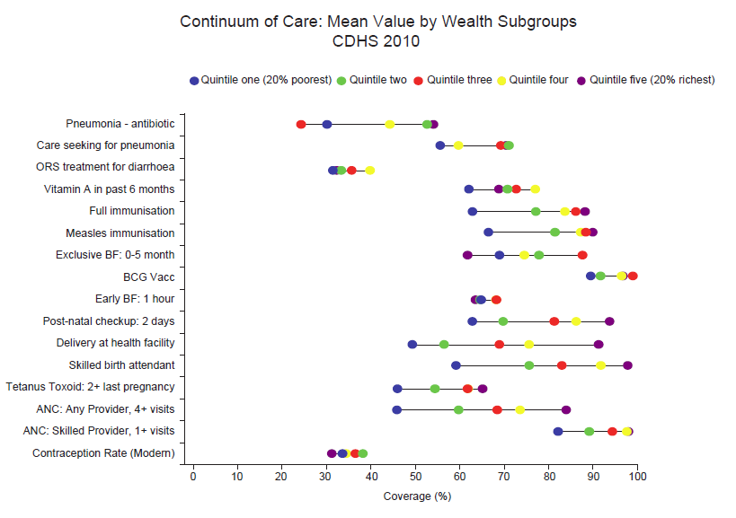
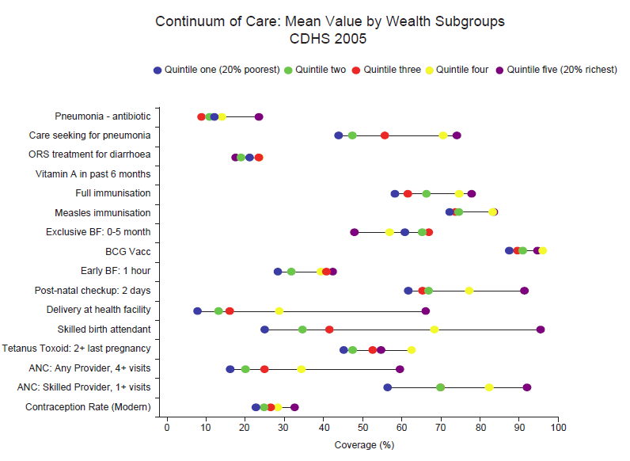

While good equitable progress is evident along the MNCH continuum of care, disparities in outcomes are most pronounced in indicators dependent upon continuity of access. This suggests that there are opportunity costs for sustained/repeated contact with the public health system for the lowest wealth groups, and this barrier appears to have increased (in relative and absolute terms) since 2005. As such, indicators such as one antenatal care (ANC) visit or a (one-time) BCG vaccination show more equitable progress than others requiring repeat visits, such as full immunization or four-or-more ANC attendance. This trend is corroborated by improvements observed in behavioural uptake associated with economic incentives facing poor women (for example, breastfeeding which is lower cost). Another strong factor appears to be the quality of care accessed by the different wealth populations. For example, while there is fairly good equitable care seeking behaviours for pneumonia, antibiotic treatment for pneumonia is less equitable.

Childhood Mortality

Cambodia experienced remarkable improvements in childhood mortality rates between 2000 and 2010. Over the last decade, neonatal mortality decreased by 29 per cent for all children. In 2000, 1 in 26 children did not survive the first month of life; by 2010, that rate was 1 in 37 children. The infant mortality rate followed a similar trend, decreasing between 2000 and 2010 from 95/1,000 live births to just 45/1,000 live births. Overall, the under-five morality rate decreased such that in 2000, 1 in 8 children born in Cambodia did not survive to their fifth birthday, while by 2010, the rate had improved to just 1 in 19 children.

Large gaps remain in how different demographic and socioeconomic groups experience childhood death. The largest predictor of neonatal morality in 2010 was residence, such that 1 in 29 children born to mothers living in rural areas did not survive the first month of life, compared to just 1 in 91 children born to mothers living in urban areas. The largest absolute rate gap observed for under-five mortality was household wealth: in 2010, 1 in 33 children born into the richest households did not survive to their fifth birthday, compared to just 1 in 11 children born into the poorest households. Interesting patterns were also observed in how the gains in childhood mortality were distributed. For example, while the overall trend for neonatal mortality was positive, the likelihood of a child born to a mother living in the poorest households dying during the first seven days actually increased between 2005 and 2010, from 34/1,000 to 39/1,000 live births.

Child Outcomes

After children from all equity groups experienced improvement in underweight and stunting prevalence between 2000 and 2005, the only group to experience continued improvement from 2005 to 2010 were children living in urban areas. In 2010, children living in the poorest households were 2.1 times more likely to be stunted and underweight than those living in the richest households.

The prevalence of anaemia among children aged 6–59 months decreased by 8 percentage points between 2000 and 2010, from 63 to 55 per cent. In 2010, children living in the poorest households were 1.4 times more likely to be anaemic than those living in the wealthiest households. The largest equity gap improvement for anaemia was observed according to maternal education: in 2000, children whose mothers had no education were 35 per cent more likely to have anaemia than those whose mothers had secondary or higher education; in 2010, the maternal education gap was no longer significant.

Child Preventive Services

The coverage rates for BCG, measles and all basic vaccinations, as well as vaccination card ownership, increased overall among children aged 12–23 months between 2000 and 2010. The patterns within various equity groups highlight the different underlying forces that are driving improvement in these preventive service indicators. The wealth and maternal education equity gaps narrowed significantly for BCG from 2000 to 2005; by comparison, the maternal education equity gap for measles did not improve from 2005 to 2010, and the wealth equity gap actually widened from 2005 to 2010, suggesting that there remain opportunity costs for sustained/repeated contact with the public health system for the lowest wealth groups, and this barrier appears to have increased (in relative and absolute terms) since 2005.

When the equity trends for vaccination card ownership and coverage of all basic vaccinations are viewed together, the data seem to support an interpretation that children of mothers with high education and those living in the wealthiest households are accessing child preventive services from private facilities more and more. Vaccination card ownership for these children did not increase between 2005 and 2010 (an item that is more likely to be obtained from public facilities), yet the proportion of these children receiving all basic vaccinations did increase significantly over this same period.

Coverage of Vitamin A supplementation among children aged 6–59 months increased by nearly 40 percentage points between 2000 and 2010, from 32 to 70 per cent; likewise, the coverage of deworming among children aged 12–59 months more than doubled, from 30 to 61 per cent between 2005 and 2010. The equity gap patterns for deworming coverage among children aged 12–59 months in 2010 were very similar to those observed for Vitamin A supplementation.

Child Curative Services

Trends in care seeking for diarrhoea among children aged 0–5 years improved dramatically between 2000 and 2010 (37 percentage points); improvements in health seeking for acute respiratory infection (ARI) were more modest, increasing 12 percentage points between 2005 and 2010. In general, mothers were more likely to have sought treatment for ARI than diarrhoea. During this time, the maternal education, residence and wealth equity gaps narrowed for diarrhoea and ARI health seeking. However, the health-seeking gaps reduced, in absolute terms, more overall for ARI from 2005 to 2010, perhaps because the ARI equity gaps in 2005 were considerably higher than those observed for diarrhoea.

Treatment of diarrhoeal episodes with oral rehydration salts (ORS) also increased from 2000 to 2010 from 18 to 34 per cent, the wealth and maternal education equity gaps that existed for ORS treatment in 2000 were by 2010 completely eliminated. In contrast, while the treatment of ARI with antibiotics also improved from 2005 to 2010, the patterns observed by equity group were quite different. For example, the residence and wealth equity gaps for ARI treatment with antibiotics widened considerably between 2005 and 2010.

The disparate equity gap patterns observed for ORS treatment of diarrhoea and antibiotic treatment of ARI reflect some underlying differences between the public and private health systems in Cambodia, and the populations accessing them. Increased use of ORS across all equity groups from 2005 to 2010 suggests that the item is readily available to all households; by comparison, the increasing equity gap for antibiotic treatment among the richest households and those living in urban areas supports the narrative that accessing antibiotics currently requires access to the private health system. This finding, whereby indicators largely dependent upon effective service delivery (e.g. via outreach) show more equity than those reflecting greater opportunity costs (i.e. travel expenses and time), was observed within most of the MNCH indicators assessed in the equity analysis.

Infant and Young Child Feeding Behaviours

The proportion of Cambodian children ever breastfeed remained nearly universal between 2000 and 2010, though a gap appeared to be forming between children living in the poorest and wealthiest households. Early initiation of breastfeeding (i.e. within the first hour), however, increased dramatically over this same period, from 11 per cent in 2000 to 66 per cent in 2005. In 2010, the only significant predictor of early initiation was the sex of the child; mothers were more likely to begin breastfeeding their daughters within the first hour than their sons.

Continued breastfeeding at one year decreased by 5 percentage points between 2000 and 2010. The decrease occurred exclusively between 2005 and 2010 and only among certain equity groups. The infant and young child feeding (IYCF) equity gap patterns suggest that mothers in the highest equity groups (i.e. wealthier, more educated and urban) are beginning to disregard standard infant feeding advice. As the wealth gap in Cambodia accelerates, it is likely that the IYCF equity patterns observed between 2005 and 2010 will become more pronounced.

Women Outcomes

The prevalence of low body mass index (BMI) (kg/m² < 18.5) among women aged 15–49 years remained unchanged over the period from 2000 to 2010 at approximately 20 per cent. The prevalence of low BMI among older women decreased between 2000 and 2010 by roughly half, whereas it deteriorated slightly among young women. The largest equity gap observed in 2010 was according to a woman’s age, such that women aged 15–19 years were 1.9 times more likely to be thin according to BMI than those aged 35–49 years.
Considerable improvements were observed in anaemia rates among women aged 15–49 years between 2000 and 2010. The trends observed within various equity groups give a mixed picture about the underlying forces driving these improvements. As with BMI, women aged 35–49 years showed large, consistent absolute improvements in their prevalence of anaemia (25 per cent decrease); women living in urban areas experienced the greatest absolute improvement in anaemia prevalence (30 per cent decrease).

Women Behaviour & Knowledge

The proportion of women aged 15–49 years currently married or in a union using a modern contraceptive method nearly doubled between 2000 and 2010, from 19 to 35 per cent. Women in all equity subgroups saw improvements in the modern contraceptive prevalence rate, with the biggest absolute gains occurring among those living in the lowest three wealth quintiles (+ 20 percentage points). By 2010, the largest equity gap observed was according to age, such that women aged 35–49 years were 1.7 times more likely to currently be using a contraceptive method than those aged 15–19 years.

Maternal Health Services

Access to antenatal care from a skilled provider by women aged 15–49 years doubled between 2000 and 2010, from 46 to 92 per cent. From 2000 to 2010 the equity situation improved significantly according to household wealth, education, and residence. In 2010, women with secondary or higher education were 1.2 times more likely to have accessed ANC services from a skilled provider at least once during their last pregnancy, than those with no education.

The proportion of women aged 15–49 years delivering their baby at a health facility during their last pregnancy improved more than six-fold (56 percentage points) between 2000 and 2010. From 2000 to 2010 the equity situation remained significantly unchanged for all equity groups, though a significant improvement did occur between 2005 and 2010 according to household wealth. The largest equity gap observed in 2010 was according to household wealth, such that women living in the wealthiest households were 1.9 times more likely to have delivered their last baby in a health facility than those living in the poorest households.

Finally, the proportion of women with a skilled assistant during delivery more than doubled (45 percentage points) between 2000 and 2010 from 34 to 79 per cent. From 2000 to 2010 the equity situation improved significantly according to education status and household wealth, such that women with no education and those in the poorest households were disproportionately more likely to have delivered with skilled assistance in 2010 than they were in 2000. As with delivery location, household wealth was the largest predictor of delivery with skilled assistance in 2010.

Conclusion

Because the values of many MNCH outcomes ranged widely, these finding suggest that, moving forward, achieving improvements in MNCH outcomes in Cambodia will increasingly depend on successfully redressing these inequities in healthcare access, quality and utilization. This can only occur if partners prioritize identifying the sectors of the population that are failing to improve quickly enough, or indeed regressing, and targeting innovative strategies to solve the underlying problems.
INTRODUCTION

BACKGROUND

While considerable efforts have been made in recent years to improve access to important public health interventions across Cambodia, significant disparities persist among MNCH outcomes. Specifically, evidence suggests that disparities in MNCH outcomes are most pronounced according to dimensions of programmatic interest to UNICEF and its partners—household wealth, maternal education, residence (urban/rural), child’s sex, and mother’s age at birth, among others. For example, the 2010 CDHS indicated that health and nutrition outcomes among children under-five were considerably better for those living in the wealthiest households, living in urban areas, and whose mother’s had a secondary or higher education. Moreover, access to and utilization of key child health and nutrition interventions appeared to follow similar inequitable patterns.

Because the values of many MNCH outcomes ranged widely, these finding suggest that, moving forward, achieving improvements in MNCH outcomes in Cambodia will increasingly depend on successfully redressing these inequities in healthcare access, quality and utilization. This can only occur if partners prioritize identifying the sectors of the population that are failing to improve quickly enough, or indeed regressing, and targeting innovative strategies to solve the underlying problems.

OBJECTIVES

The primary goal of this equity analysis was to assess the trends in MNCH outcomes and access to interventions between 2000 and 2010, to identify those sectors of the population in which progress has not been equitably realized according to the dimensions of interest to UNICEF. Access to key MNCH interventions were to be described along the life cycle: pregnancy, delivery, postpartum period, infancy and early childhood. MNCH indicators with the largest equity gaps and those with negative trends or no progress were to be highlighted along this continuum. To achieve this, three different analyses were conducted and combined:

- Determine whether the equity gaps in MNCH outcomes and access to interventions according to dimensions of interest were meaningful for each survey year;
- Determine whether the observed trends in MNCH outcomes and access to interventions from 2000 to 2010 were meaningful for each dimension of interest;
- Determine whether the differences in equity gap changes over time for each dimension were meaningful.

METHODOLOGY

SELECTION OF INDICATORS

The indicators examined were chosen to give a comprehensive overview of the most important measures of maternal, newborn, and child health and nutrition along the continuum of care. The set of indicators draws heavily, though not exclusively, from those monitored as part of the Countdown to 2015 [1]. The report presents the analyses of these indicators in rough groupings according to their level of intervention.

DATA PREPARATION

Each MNCH indicator was first re-created within each of the raw women’s and children’s datasets (see Appendix 1). Every attempt was made to ensure comparability of indicators across the three surveys. Where differences in questionnaire design made this impossible, these have been noted in the results. In addition to the equity objectives stated above, this report provides statistical tests of national level coverage and prevalence trend estimates that are not biased by survey changes.

To assess the extent to which the MNCH indicators displayed inequality within various equity subgroups, equity variables were created for each dimension of interest that was assumed to capture the areas where inequalities were most likely to be observed:

Children aged 0–59 months: Child’s sex, orphan status, maternal education, residence (urban/rural), and household wealth
Women aged 15–49 years: Age at birth, current age, education, residence (urban/rural), and household wealth

The wealth index in newer DHS surveys is constructed using socioeconomic characteristics not found in older surveys. As a result, a new household wealth indicator was created using characteristics available in all three surveys and merged into the women and child datasets to ensure that this variable was comparable across time.

In addition to these equity variables, timeframe variables were created so that differences in MNCH indicators over time could be assessed.

Finally, a new dataset was developed, one each for women and children that included the re-created MNCH indicators and equity and timeframe variables. These data sets were used in the final equity analyses.

EQUITY ANALYSES

Indicator Prevalence by Equity Subgroup and Year

Before conducting statistical tests to understand the changes within equity groups over time, the basic prevalence of all indicators was calculated for each equity subgroup and survey (i.e. 2000, 2005 and 2010). This information was calculated to give the reader a basic understanding of the indicator in question, information which in many cases was never reported in the CDHS reports (see example below).

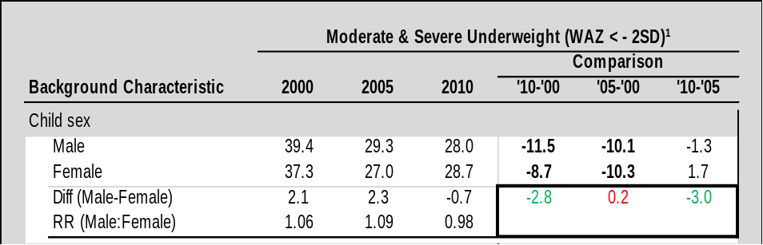

MNCH Indicator Differences by Equity Subgroup, within Year

Following the estimation of MNCH indicator prevalence for each equity subgroup and survey under investigation, linear regressions were run to determine whether, for each timeframe, the absolute prevalence differences observed in each equity subgroup were statistically significant. The significance of these differences was estimated using:

Y = α_{h} + βE + ε | Y: MNCH indicator difference
Y = α_{h} + βE + ε | E: binary equity subgroup variable
Y = α_{h} + βE + ε | α: constant term (prevalence of equity subgroup variable for timeframe h)
Y = α_{h} + βE + ε | β: change in MNCH indicator by equity subgroup
Y = α_{h} + βE + ε | ε: error term

Differences that were significant were highlighted in bold in the tables (p < 0.05). In the example below none of the differences between male and female for underweight prevalence for each year were statistically significant, and so the numbers do not appear in bold.

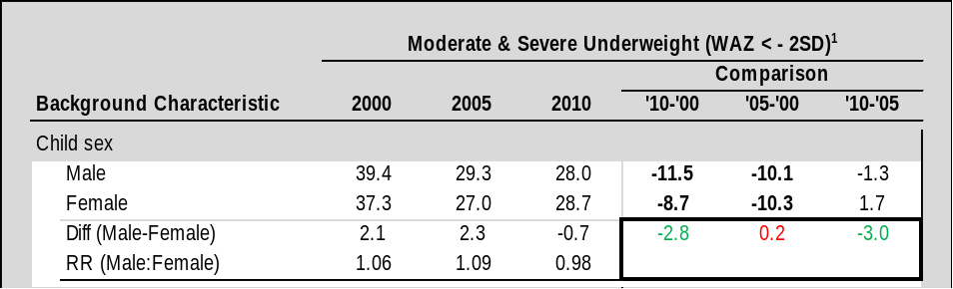

Relative risk (RR) measures the same difference between equity subgroups. In the example above, the prevalence of underweight for males in 2000 is 2.1 percentage points higher than females, and the relative risk is 1.06. Males were 1.06 times more likely to be underweight than females in 2000.

MNCH Indicator Differences by Year, within Equity Subgroup

Another round of linear regressions were run to determine whether, for each equity subgroup, the absolute prevalence differences observed over each timeframe were statistically significant. The significance of these differences was estimated using:

Y = α_{i} + δT + ε | Y: MNCH indicator difference
Y = α_{i} + δT + ε | T: binary timeframe variable
Y = α_{i} + δT + ε | α: constant term (prevalence of timeframe variable for equity subgroup i)
Y = α_{i} + δT + ε | δ: change in MNCH indicator by timeframe
Y = α_{i} + δT + ε | ε: error term

Differences that were significant were highlighted in bold in the tables (p < 0.05). In the example below, four of the six comparisons are statistically significant and so, appear in bold. The numbers that are not bold show that from 2000 to 2005 there was no significant difference in the prevalence of underweight for male or female.

Difference of Differences

Finally, linear regressions were run to determine whether the absolute prevalence differences observed within equity groups over each timeframe were statistically significant. This significance of this difference of differences was estimated using:

Y = α_{i,h} + βE + δT + γE•T + ε | Y: change in
Y = α_{i,h} + βE + δT + γE•T + ε | E: binary equity subgroup variable
Y = α_{i,h} + βE + δT + γE•T + ε | T: binary timeframe variable
Y = α_{i,h} + βE + δT + γE•T + ε | E•T: interaction term (product of equity subgroup and timeframe variables)
Y = α_{i,h} + βE + δT + γE•T + ε | α: constant term (prevalence of equity subgroup i for timeframe h)
Y = α_{i,h} + βE + δT + γE•T + ε | β: change in MNCH indicator by equity subgroup
Y = α_{i,h} + βE + δT + γE•T + ε | δ: change in MNCH indicator by timeframe
Y = α_{i,h} + βE + δT + γE•T + ε | γ: difference in changes in MNCH indicator by equity subgroup and timeframe
Y = α_{i,h} + βE + δT + γE•T + ε | ε: error term

Difference in differences that were significant were highlighted in bold in the tables (p < 0.05); figures that represent improvements in equity were further coloured in green, while those representing a deterioration in the equity situation were coloured in red. In the example below, the red number shows that from 2000 to 2005 the gap between male and female for underweight prevalence grew slightly, but it is not a statistically significant difference and so, does not appear in bold. From 2005 to 2010, the opposite trend is seen; the gap between male and female becomes smaller, to the point that females are more likely to be underweight. From 2005 to 2010 and from 2000 to 2010 there was a statistically insignificant narrowing of the difference in underweight prevalence between male and female, and so the numbers appear in green and are not bold.

STATISTICAL ANALYSIS

The MNCH equity analysis used the most recently available CDHS datasets from 2000, 2005 and 2010. All of the equity analyses were carried out using Stata MP v. 11. The complex sampling design of demographic and health surveys was accounted for throughout the project using Stata’s svyset function. Variance estimations with one or more missing PSUs were centred. Sub-population variables were created for every linear regression in accordance with the unconditional approach [2].

SECTION I: CHILDREN AGED 0–59 MONTHS

1. CHILDHOOD MORTALITY OVERVIEW

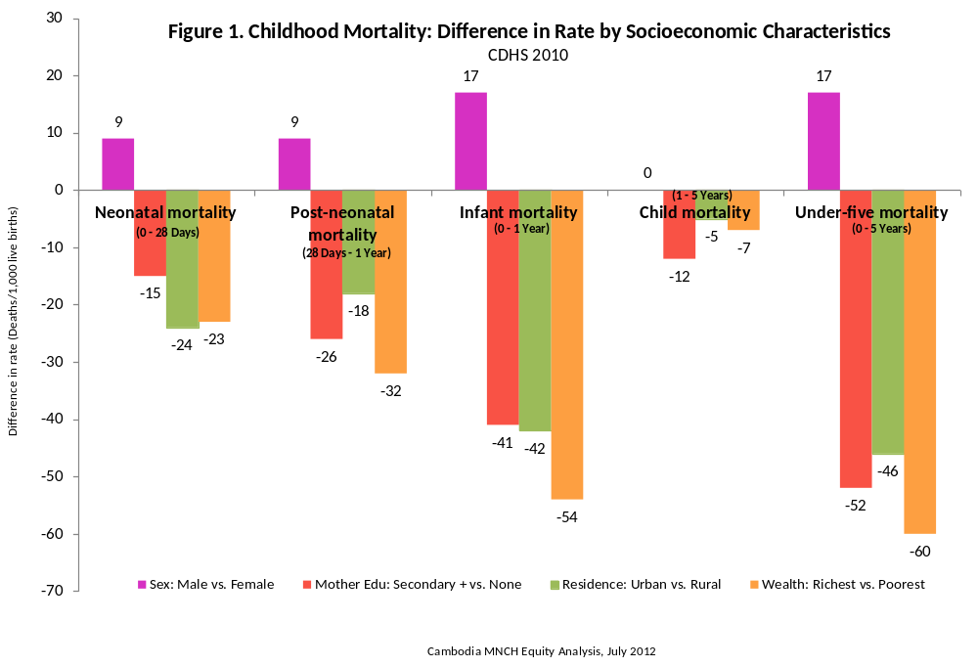

Summary

Cambodia witnessed marked improvements in childhood mortality rates between 2000 and 2010. Over the last decade, neonatal mortality decreased by 29 per cent for all children. In 2000, 1 in 26 children did not survive the first month of their life; by 2010, that rate was 1 in 37 children. The likelihood that a child will die after the first month of life, but before his or her first birthday, also decreased dramatically: this post-neonatal mortality rate was 58/1,000 live births in 2000, and was reduced to just 18/1,000 live births by 2010. The infant mortality rate, which is a combination of the neonatal and post-neonatal rates, followed a similar trend, decreasing between 2000 and 2010 from 95/1,000 live births to just 45/1,000 live births. The likelihood of a child dying after the first birthday, but before his or her fifth birthday (child mortality), also decreased according to this overall trend, though even in 2000 this rate was much lower compared to the under-one indicators. Overall, the under-five morality rate, which is a composite measure of infant and child mortality rates, decreased such that in 2000, 1 in 8 children born in Cambodia did not survive to their fifth birthday, while by 2010, the rate had improved to just 1 in 19 children.
Even though there were considerable improvements among childhood mortality indicators between 2000 and 2010, there currently remain large gaps in how different demographic and socioeconomic groups experience childhood death. In 2010, the neonatal mortality rate was markedly lower for girls, children whose mothers had a secondary or higher education, those born to mothers living in urban areas, and the wealthiest households. Indeed, the largest predictor of neonatal morality in 2010 was residence, such that 1 in 29 children born to mothers living in rural areas did not survive the first month of life, compared to just 1 in 91 children born to mothers living in urban areas. The same demographic and socioeconomic groups had lower infant mortality rates as well. Household wealth was the largest predictor of a child dying before his or her first birthday in 2010: 1 in 13 children born to mothers living in the poorest households did not survive this period compared to just 1 in 43 born to women living in the richest households. As expected, the largest absolute rate gap was observed for under-five mortality, where in 2010, 1 in 11 children born into the poorest households did not survive to their fifth birthday, compared to just 1 in 33 children born into the wealthiest households.

While the overall trends observed for childhood mortality indicators between 2000 and 2010 are quite remarkable, they do mask some interesting patterns in how those gains were distributed among different demographic and socioeconomic groups. For example, between 2000 and 2010, the gap in absolute neonatal mortality rates between children born to mothers in the poorest and richest households nearly doubled from 12/1,000 to 23/1,000 live births. The likelihood of a child born to a mother living in the poorest households dying in the first month actually increased between 2005 and 2010 from 34/1,000 to 39/1,000 live births. The gap observed for neonatal mortality by residence also increased considerably, though this resulted from a much better than expected improvement for children born to mothers in urban areas from 2005 to 2010. During this period, the likelihood of a newborn born to these women dying in the first month decreased from 1 in 34 to 1 in 91. This better than expected improvement among children born to women in urban areas between 2005 and 2010 was observed for infant and under-five mortality rates as well. However, unlike neonatal mortality, the gaps seen in 2000 for infant and under-five mortality according to maternal education and household wealth narrowed considerably over the last decade.

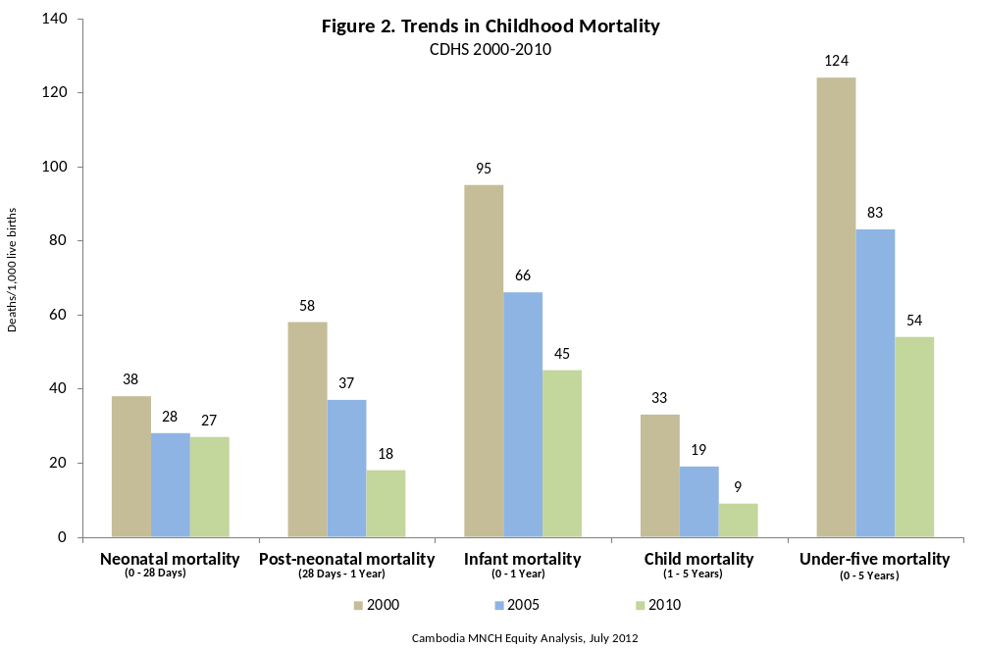

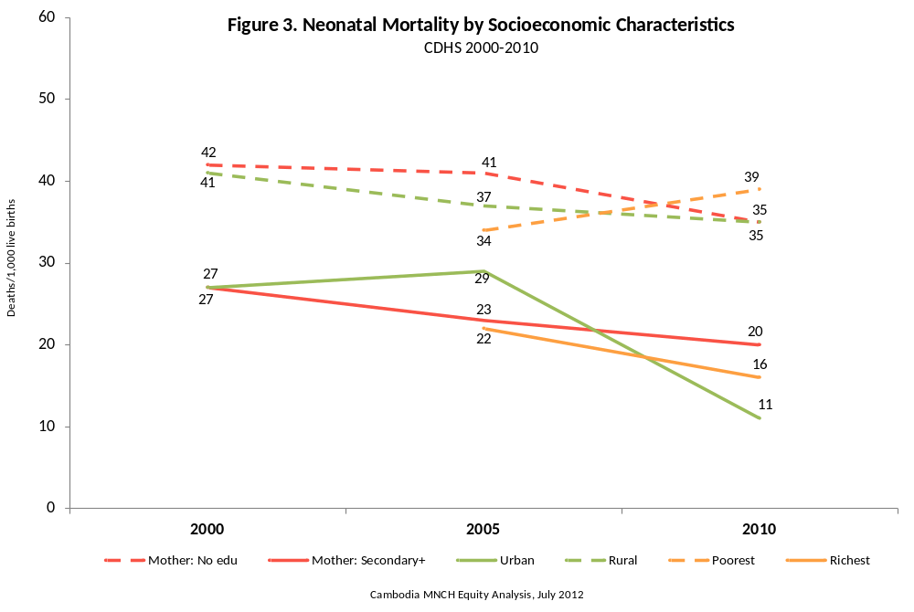

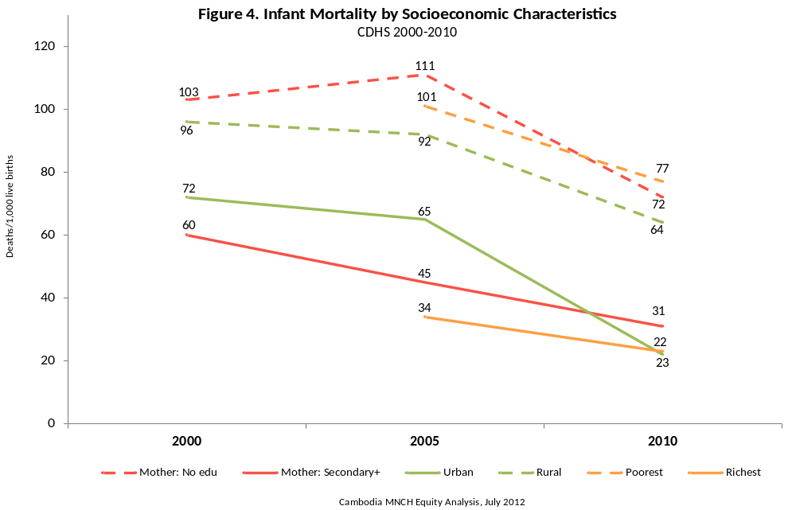

2. CHILD OUTCOMES
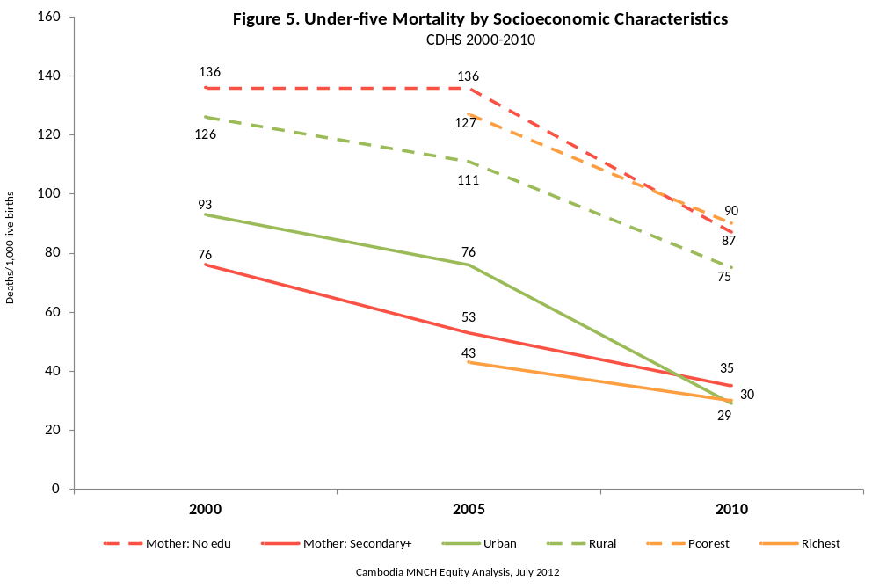
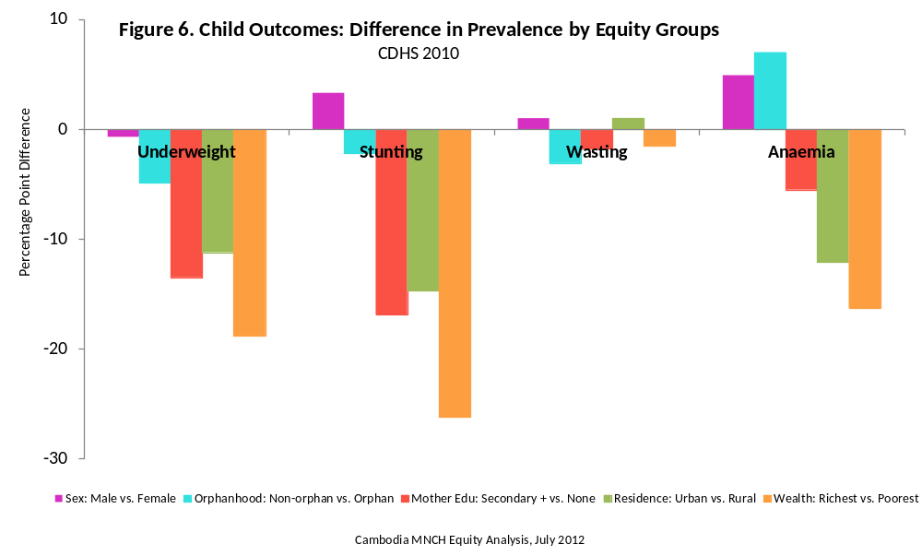

Summary

After children from all equity groups experienced improvement in underweight prevalence from 2000 to 2005, the only group to experience continued improvement from 2005 to 2010 were children living in urban areas. Likewise, the prevalence of stunting only improved from 2005 to 2010 among children living in urban areas. The largest consistent predictor of underweight and stunting (among the four studied) was household wealth: in 2010, children living in the poorest households were 2.1 times more likely to be stunted and underweight than those living in the richest households. Children living in rural areas and those whose mothers had no education were 1.5 times more likely to be underweight and stunted than their peers in comparatively higher equity groups.

The largest predictor of child anaemia in 2010 was household wealth, such that children living in the poorest households were 1.4 times more likely to be anaemic than those living in the wealthiest households. Overall, the absolute and relative equity gaps observed for child anaemia were smaller than those observed in underweight and stunting. Boys were roughly 10 per cent more likely to be anaemic than girls, and this persisted from 2000 to 2010; they were also significantly more likely to have had diarrhoea over that time period, which seems to support the important role that disease plays in anaemia. The overall improvement in anaemia rates mostly occurred from 2005 to 2010 across all equity groups; the largest improvements were realized by children living in the poorest households (8 per cent), those whose mothers had no education (11 per cent), and those living in urban areas (15 per cent).

Diarrhoea and ARI prevalence both decreased by about 25 per cent from 2005 to 2010, and these improvements were observed across all equity groups. The largest equity gap for child morbidity in 2010 was found within household wealth (children living in the poorest households were 2.3 times more likely to have ARI than those in the richest households). Household wealth was the only significant equity gap to improve: children living in the poorest households were significantly less likely to have ARI in 2010 compared to 2005 (no significant change was observed for the wealthiest households); no improvement in equity was observed for diarrhoea. Children living in urban areas experienced the most improvement in diarrhoea prevalence from 2005 to 2010, and the data suggest that the gap between urban and rural may be getting wider. A child’s sex remained a significant predictor of diarrhoea prevalence between 2000 and 2010; one explanation for this finding might be that boys have higher exposure to dirty environmental conditions than girls, though this requires further investigation.

2.1 Underweight (WHO 2006 Growth Standards)

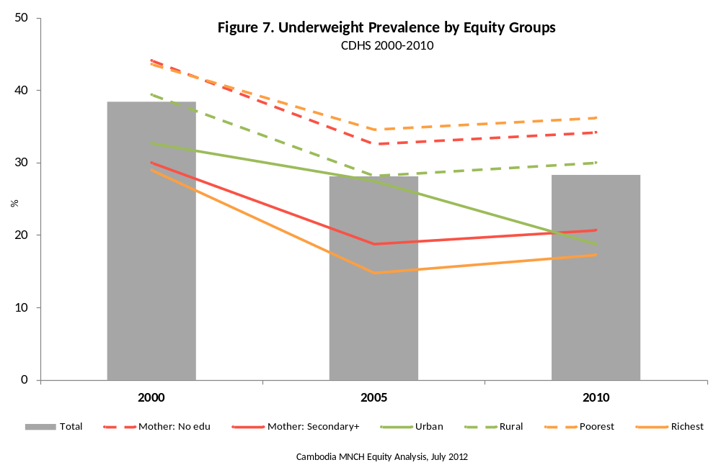

Prevalence Trend

- Underweight decreased by 10 percentage points in the last decade, going from 38 to 28 per cent.
- All of the improvement observed in child underweight occurred from 2000 to 2005; the national prevalence remained unchanged from 2005 to 2010.

Current Equity Situation

- There was no significant equity gap according to gender for underweight prevalence in 2010.
- The largest equity gap was observed in household wealth. In 2010, children living in the poorest households were 2.1 times more likely to be underweight than those in the richest households. The relationship between underweight and household wealth appeared linear.
- Children living in rural areas and children whose mothers had no education were 1.6 times more likely to be underweight in 2010. The relationship between underweight and maternal education also appeared linear.

Equity Trend

- From 2000 to 2005 improvement occurred among all equity groups. There does appear to be more improvement among wealthier households, but it is not statistically significant.
- From 2005 to 2010 the equity gap between urban and rural households grew by 10 percentage points owing to a large prevalence decrease in urban areas and no change in rural areas.

2.2 Stunting (WHO 2006 Growth Standards)

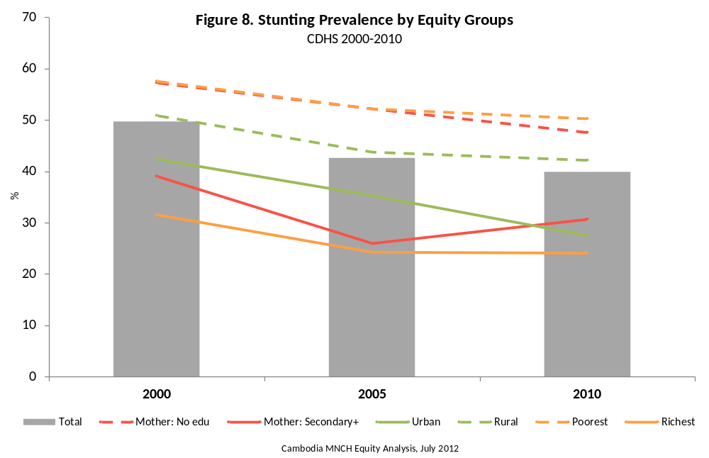

Prevalence Trend

- Stunting decreased by 10 percentage points from 2000 to 2010, going from 50 to 40 per cent.
- Most of the improvement in stunting (72 per cent) was realized from 2000 to 2005; the improvement from 2005 to 2010 was not found to be significant.

Current Equity Situation

- The largest equity gaps observed for stunting were according to household wealth. In 2010, children living in the poorest households were 2.1 times more likely to be stunted than those living in the wealthiest households.
- In 2010, children living in rural areas and those whose mothers had no education were 1.5 times more likely to be stunted than those in the comparative equity groups.
- No equity gap according to gender was observed for stunting.

Equity Trend

- Although the equity gap between children living in the richest and poorest households has not changed over time, the gap between the richest and middle/fourth quintiles did decrease, as these households saw continued improvement from 2005 to 2010.
- Improvements in stunting within urban and rural areas from 2000 to 2005 were comparable; however, from 2005 to 2010, stunting rates among children living in rural areas did not improve, while rates continued to improve in urban areas. Thus the data seem to suggest that this equity gap is getting wider, though the change in this gap was not found to be statistically significant.
- From 2000 to 2005, the equity gap for stunting between children whose mothers had no education, and secondary or higher education, appeared to widen significantly; this gap then reverted back to the level observed in 2000 by 2010.

2.3 Wasting (WHO 2006 Growth Standards)

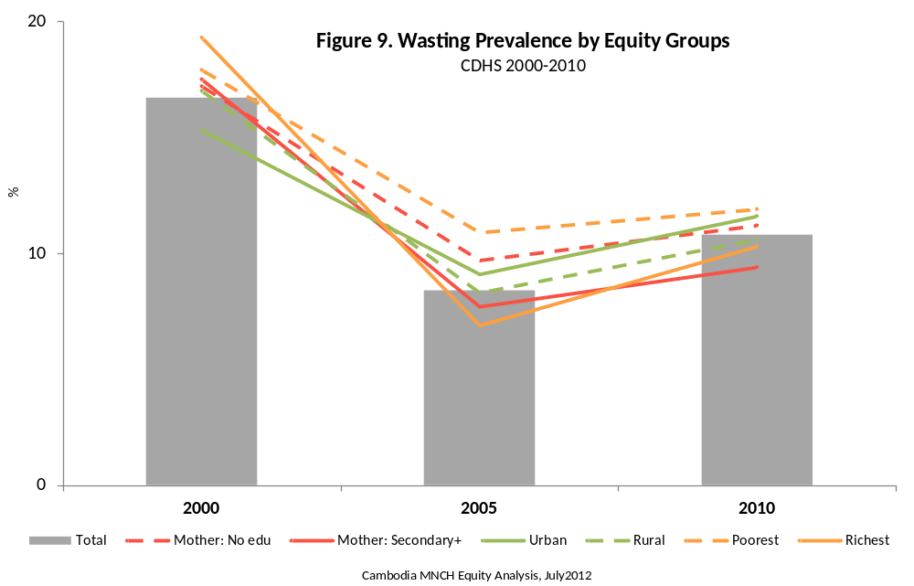

Prevalence Trend

- Wasting decreased by 6 percentage points between 2000 and 2010, from 17 to 11 per cent.
- From 2000 to 2005, wasting decreased by 8 percentage points to 8 per cent; from 2005 to 2010, a small but significant increase was observed (2.4 percentage points).

Current Equity Situation

- In 2010, no statistically significant equity gap was observed for wasting.

Equity Trend

- Over the period 2000 to 2010, the equity gap in wasting prevalence for all groups did not significantly change.

2.4 Anaemia

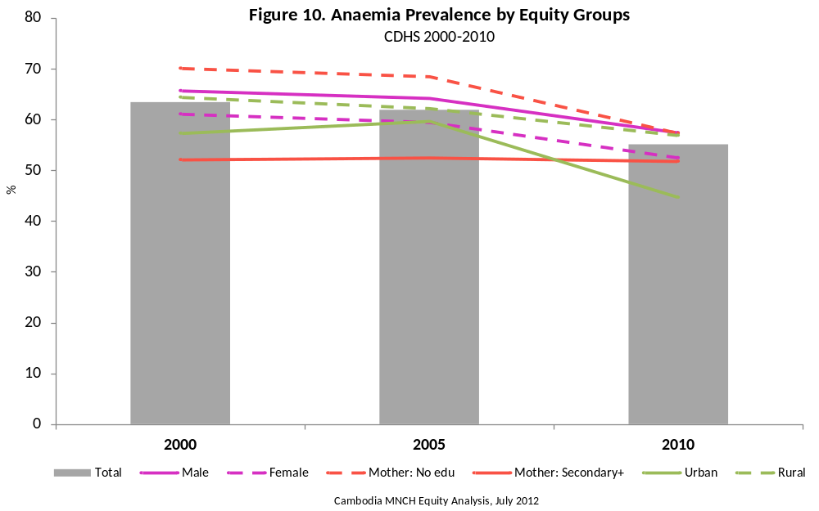

Prevalence Trend

- Prevalence of anaemia dropped by 8 percentage points from 2000 to 2010, going from 63 to 55 per cent.
- Most of this improvement (80 per cent) was realized from 2005 to 2010.

Current Equity Situation

- The largest equity gaps for child anaemia were according to household wealth and residence: in 2010, children living in the poorest households were 1.4 times more likely to be anaemic and those living in rural areas were 1.3 times more likely to be anaemic than children in the comparative equity group.
- Boys were 1.1 times more likely to be anaemic than girls in 2010.
- No significant difference in child anaemia prevalence was observed according to maternal education.

Equity Trend

- The largest equity gap improvement for anaemia was observed according to maternal education: in 2000, children whose mothers had no education were 35 per cent more likely to have anaemia than those whose mothers had secondary or higher education; in 2010, the maternal education gap was no longer significant.
- From 2005 to 2010, the rate of improvement in anaemia was 10 percentage points greater among children living in urban areas than those living in rural areas (technically speaking, though this difference was not significant, it represents an important trend seen among other outcome indicators).

2.5 Diarrhoea

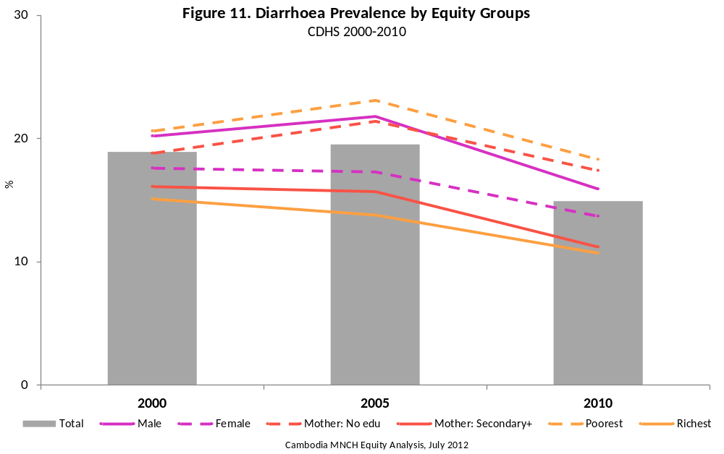

Prevalence Trend

- Prevalence of diarrhoea decreased by 4 percentage points over 2000 to 2010 (from 19 to 15 per cent), and all of this improvement was realized from 2005 to 2010.

Current Equity Situation

- In 2010, the largest equity gaps observed in diarrhoea prevalence were within household wealth, maternal education, and residence. Children living in the poorest households were 76 per cent more likely to have diarrhoea than those living in the wealthiest households; likewise, children of mothers with no education were 55 per cent more likely to have suffered diarrhoea in the two weeks prior to the survey than those whose mothers had secondary or higher education.
- Boys were 1.2 times more likely to have diarrhoea than girls in 2010.

Equity Trend

- Over the period 2000 to 2010, the equity gap in diarrhoea prevalence for all groups did not significantly change.

2.6 Acute Respiratory Infection

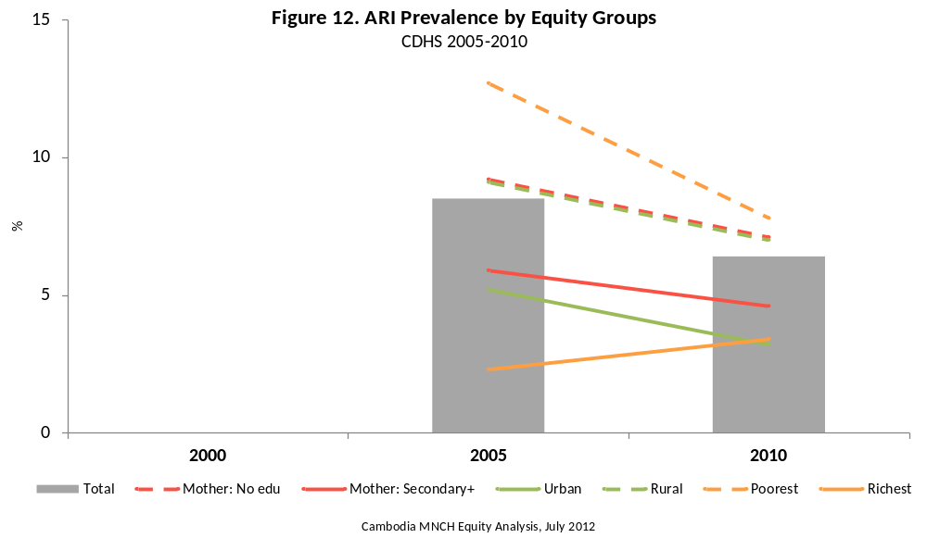

Prevalence Trend

- The prevalence of symptoms of ARI decreased from 2005 to 2010 by 2 percentage points (8.5 to 6.4 per cent).

Current Equity Situation

- While the overall prevalence of ARI in 2010 was low, significant differences did appear in prevalence, according to various equity measures. Children living in the poorest households were 2.3 times more likely to have had symptoms of ARI in the two weeks prior to the survey than those living in the wealthiest households (7.8 per cent vs. 3.4 per cent). Likewise, children living in rural areas were also significantly more likely to have had ARI compared to those living in urban areas (7.0 per cent vs. 3.2 per cent), as were those whose mother had no education (7.1 per cent vs. 4.6 per cent).

Equity Trend

- The only change in equity gaps over time was observed within household wealth, where the poorest moved from being 5.5 times more likely to have ARI in 2005 to just 2.3 times more likely in 2010. This gap narrowed because the poorest quintile was the only quintile to see significant improvement in ARI prevalence over that time period.

2.7 Comparability of Child Outcome Indicators

ARI data from 2000 CDHS is not directly comparable with 2005 and 2010 data, as that survey did not use the standard definition of ARI used today for international monitoring (i.e. cough accompanied by rapid or difficult breathing that was chest-related).

3. CHILD PREVENTIVE SERVICES

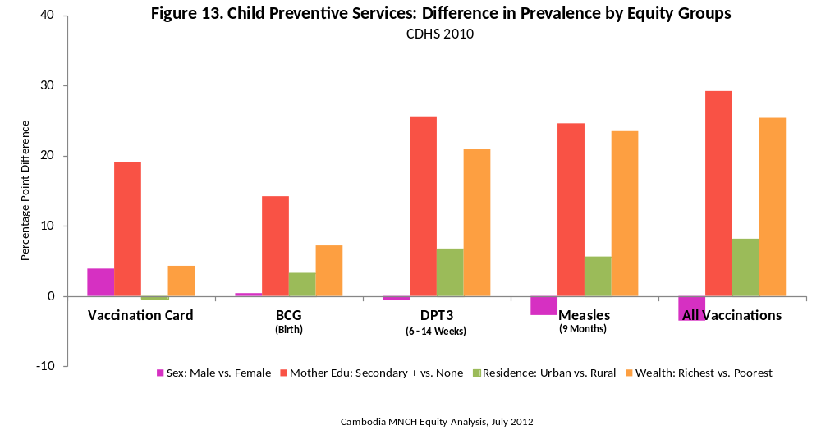

Summary

The wealth equity gap improved significantly for all vaccination-related indicators from 2000 to 2005. There were no significant improvements in the wealth equity gap from 2005 to 2010, though this gap widened for measles and all basic vaccinations during that time (significantly so for measles).

Vaccination card ownership, and the associated wealth equity gap, dramatically improved from 2000 to 2010, though the trend appears to have tapered off from 2005 to 2010. Indeed, maternal education is the only equity gap that remained significant in 2010; children living in the richest households are no longer more likely to have a vaccination card than those living in the poorest households.

That the wealth and maternal equity gaps improved significantly for BCG from 2000 to 2005 suggests that basic access to the public health system improved for the lowest equity groups during this period (since this requires a one-time visit at the time of birth). Thus, one way of improving immunization coverage among the lowest equity households is to reduce access barriers by improving outreach activities and national campaigns (which occurred for measles in 2011).

However, that the maternal equity gap for measles did not improve from 2005 to 2010, and the wealth equity gap actually widened from 2005 to 2010, suggests that there are opportunity costs for sustained/repeated contact with the public health system for the lowest wealth groups, and this barrier appears to have increased (in relative and absolute terms) since 2005. (This narrative is further supported by the findings that the wealth equity gap for BCG did not increase from 2005 to 2010.)

Furthermore, that the maternal education equity gap for BCG did not improve from 2005 to 2010—and did not improve at all for measles from 2000 to 2010—suggests that maternal motivation is also an important barrier to achieving complete coverage parity. Therefore, it appears that simply reducing access barriers is not enough to ensure that children in the lowest equity groups receive important child preventive services. Programmes that reduce opportunity costs and increase maternal motivation for these groups—perhaps most effectively through incentive schemes—will be needed to address these remaining gaps.

When the equity trends for vaccination card ownership and coverage of all basic vaccinations are viewed together, the data seem to support an interpretation that children of mothers with high education and those living in the wealthiest households are accessing child preventive services from private facilities more and more. Vaccination card ownership for these children did not increase between 2005 and 2010 (an item that is more likely to be obtained from public facilities), yet the proportion of these children receiving all basic vaccinations did increase significantly over this same period.

Vitamin A supplementation for children aged 6–59 months became more equitable from 2000 to 2010 as all wealth groups (except the highest) experienced large increases in coverage. The equity gaps observed in maternal education and residence also narrowed significantly during this period. However, coverage among children living in the poorest households remains well below that of those in higher wealth groups, suggesting that there is still considerable need for coverage improvement (especially since the poorest children are most in need of the intervention). The equity gap patterns for deworming coverage among children aged 12–59 months in 2010 were very similar to those observed for Vitamin A supplementation. The data also suggest that, despite the wealth equity gap in Vitamin A supplementation narrowing from 2000 to 2010, self-targeting appears to be a very important coverage determinant. In 2010, maternal education was the biggest predictor of Vitamin A supplementation and deworming coverage, as more than 15 percentage points separate the comparative equity groups; moreover, the maternal education equity gap decreased much more slowly than the wealth equity gap from 2000 to 2010.

3.1 Immunization

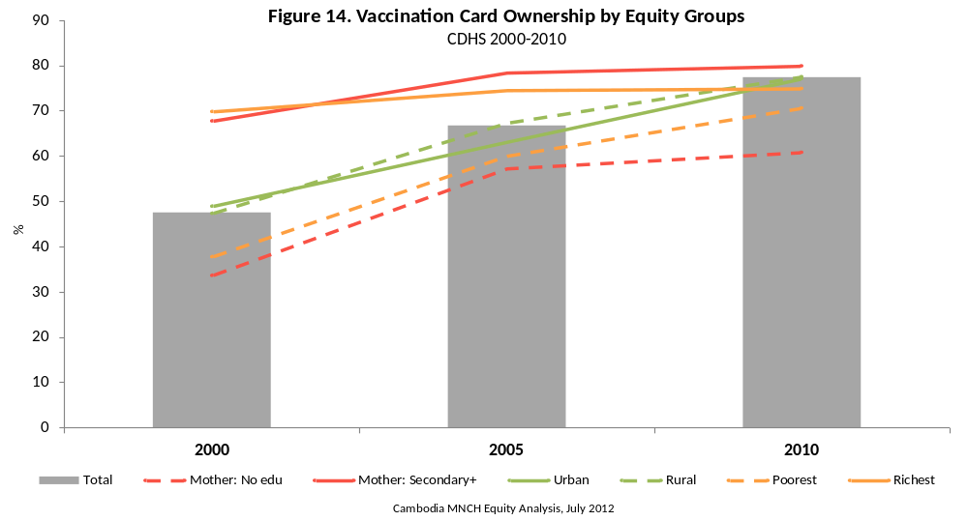

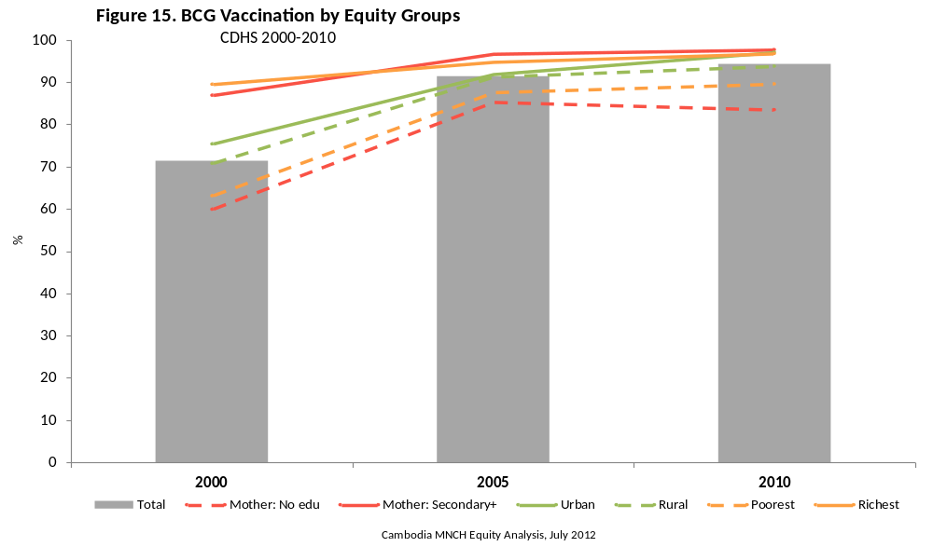

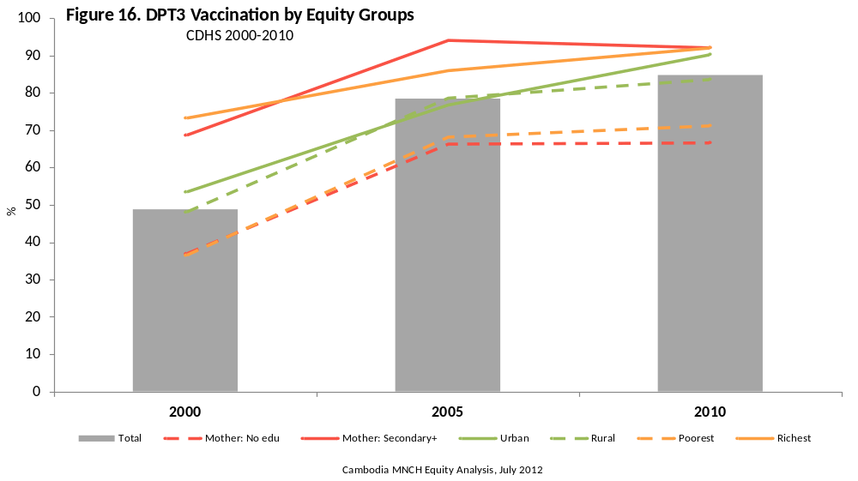

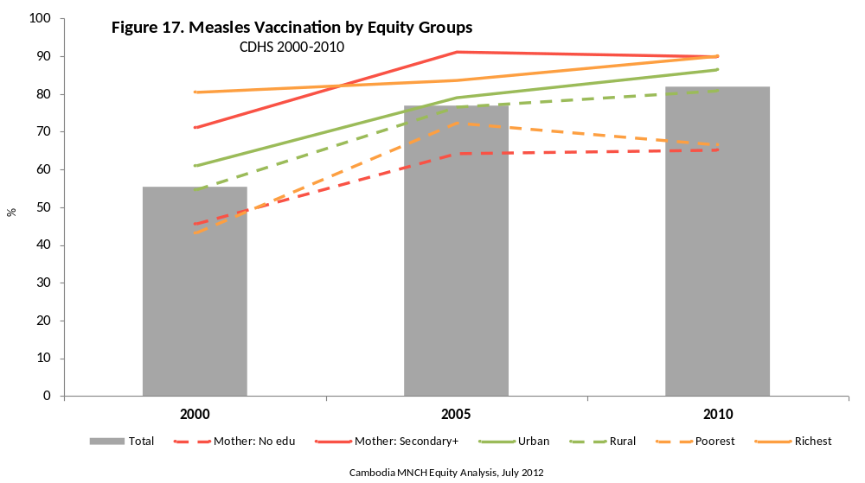

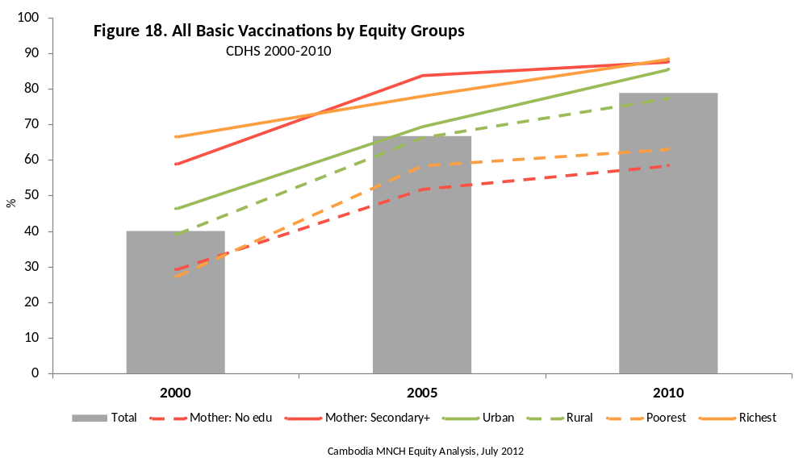

Coverage Trend

- BCG coverage increased 23 percentage points between 2000 and 2010, going from 71 to 94 per cent.
- Most of this improvement (87 per cent) occurred between 2000 and 2005.

- Measles immunization coverage increased from 55 to 82 per cent between 2000 and 2010.
- Nearly all of this improvement occurred between 2000 and 2005; overall coverage only improved by 5 percentage points from 2005 to 2010.

- Coverage of all vaccinations nearly doubled between 2000 and 2010 from 40 to 79 per cent.
- Again, most of this improvement (69 per cent) was realized from 2000 to 2005.

- From 2000 to 2010, the proportion of children with a vaccination card increased by 30 percentage points, from 48 to 78 per cent.
- Most of the improvement in vaccination card ownership (64 per cent) occurred from 2000 to 2005.

Current Equity Situation

- The largest equity gap for BCG vaccination in 2010 was according to maternal education: children of mothers with secondary or higher education were 17 per cent more likely to have BCG vaccination than those whose mothers had no education.
- Children living in urban areas and boys were not significantly more likely to have BCG vaccination than the comparative equity groups.

- The largest equity gap for measles vaccination in 2010 was according to maternal education and household wealth: children of mothers with secondary or higher education were 38 per cent more likely to have measles vaccination than those whose mothers had no education; and children living in the wealthiest households were 35 per cent more likely to have received measles vaccination than those living in the poorest households.
- Children living in urban areas were 7 per cent more likely to have received measles vaccination than those living in rural areas.

- The largest equity gap for all basic vaccinations in 2010 was according to maternal education and household wealth: children of mothers with secondary or higher education were 1.5 times more likely to have all basic vaccinations than those whose mothers had no education; and children living in the wealthiest households were 1.4 times more likely to have received all basic vaccinations than those living in the poorest households.
- Children living in urban areas were 10 per cent more likely to have received all basic vaccinations than those living in rural areas.

- The largest equity gap for vaccination card ownership in 2010 was according to maternal education: children of mothers with secondary or higher education were 31 per cent more likely to have owned vaccination cards than that those whose mothers had no education.
- Vaccination ownership was not significantly different in 2010 according to gender, household wealth, and residence.

Equity Trends

- Equity gaps observed according to gender and residence were never significant for BCG vaccination.
- The maternal education equity gap for BCG vaccination narrowed significantly between 2000 and 2005 (27 to 11 per cent); from 2005 to 2010 there was little change.
- The wealth equity gap also decreased from 2000 to 2005 (25 to 7 per cent). Again there was no improvement between 2005 and 2010. The improvement in wealth equity gap was the largest observed for BCG.
- Equity gaps observed according to gender for measles were never significant, but measles coverage for girls improved significantly more than for boys from 2000 to 2010.
- The maternal education equity gap for measles vaccination did not improve between 2000 and 2010 (remaining roughly 30 percentage points).
- While from 2000 to 2005 the residence equity gap for measles seemed to almost disappear, the gap grew between 2005 and 2010, resulting in urban children now being 6 per cent more likely to receive the vaccination.
- The household wealth equity gap for measles dramatically narrowed between 2000 and 2005, only to reverse in the second half (though this did not erase all of the gains made). Indeed, this reversal resulted because, as compared to the four higher wealth groups, the poorest households did not see a significant improvement in measles vaccination coverage between 2005 and 2010.
- Equity gaps observed according to gender for coverage of all basic vaccinations were never significant, but coverage for girls improved significantly more than for boys from 2000 to 2010.
- The maternal education equity gap for coverage of all basic vaccinations did not improve between 2000 and 2010 (remained roughly 30 percentage points); between 2005 and 2010, the most improvement was among mothers with primary education.
- While from 2000 to 2005 the residence equity gap for coverage of all basic vaccinations seemed to almost disappear, the gap grew between 2005 and 2010, resulting in urban children now being 10 per cent more likely to receive all basic vaccinations.
- The household wealth equity gap for coverage of all basic vaccinations dramatically narrowed between 2000 and 2005, only to reverse in the second half (though this did not erase all of the gains made). Indeed, this reversal resulted because, as compared to the four higher wealth groups, the poorest households did not see a significant improvement in coverage of all basic vaccinations between 2005 and 2010.
- There was very impressive improvement in vaccination card equity, relative to wealth, with the gap almost completely disappearing. Most of the improvement occurred in the first half of the decade. Ownership of vaccination cards among rich households did not improve over the decade.
- Improvement was also seen in the maternal education equity gap: in 2000, children of mothers with secondary or higher education were 2.0 times more likely to own a vaccination card, but just 1.3 times more likely in 2010. The only significant improvement seen between 2005 and 2010 was for children of mothers with primary education.

3.2 Vitamin A & Deworming Supplementation

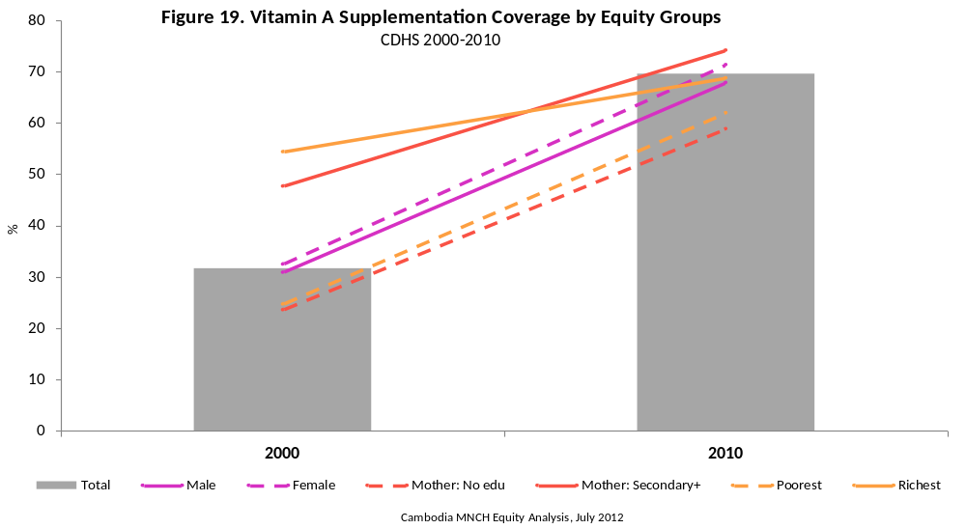

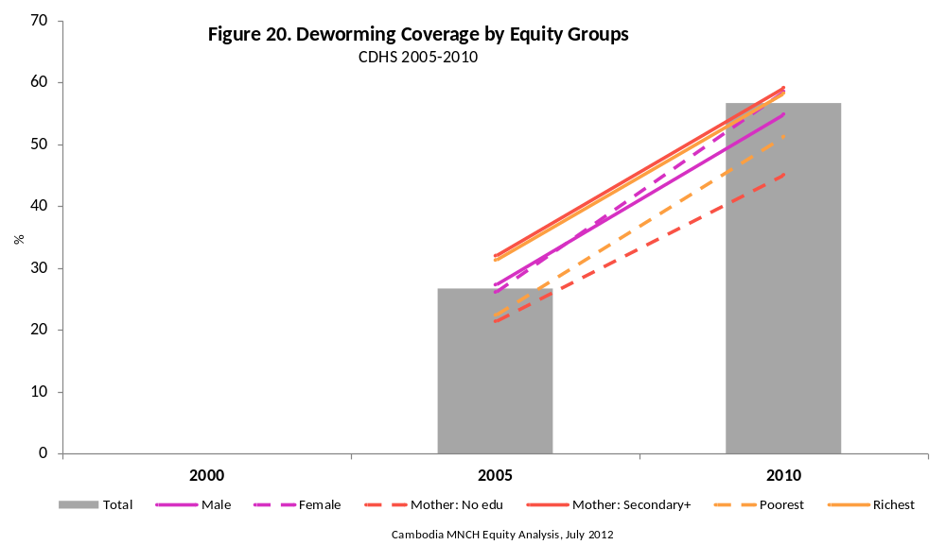

Coverage Trend

- Coverage of Vitamin A supplementation among children aged 6–59 months increased by nearly 40 percentage points between 2000 and 2010, from 32 to 70 per cent.

- From 2005 to 2010, the coverage of deworming among children aged 12–59 months more than doubled, from 30 to 61 per cent.

Current Equity Situation

- The largest equity gap for Vitamin A supplementation in 2010 was according to maternal education: children of mothers with secondary or higher education were 26 per cent more likely to have received Vitamin A supplementation than those whose mothers had no education.
- Household wealth and gender equity gaps also existed in 2010, with children living in the richest households, and girls, being more likely to have received Vitamin A supplementation than the comparative equity groups (11 per cent and 5 per cent, respectively). There was no difference found according to residence.
- The relationship between Vitamin A supplementation coverage and household wealth was not linear: children living in middle-wealth quintile households were most likely to receive Vitamin A supplementation in 2010.

- The largest equity gap for deworming coverage in 2010 was according to maternal education: children of mothers with secondary or higher education were 1.4 times more likely to have received deworming medication than those whose mothers had no education.
- Wealth was also an important equity gap in 2010, with children living in the wealthiest households 1.2 times more likely to receive deworming medication. Like Vitamin A supplementation, the relationship between deworming and household wealth was not linear in 2010.
- Girls were slightly more likely to receive deworming medication in 2010 compared to boys (1.05); there was no significant equity gap according to residence.

Equity Trends

- Between 2000 and 2010, the wealth, maternal education, and residence equity gaps for Vitamin A supplementation narrowed significantly; the residence equity gap was completely eliminated over this period.
- Girls remained slightly more likely to receive Vitamin A supplementation compared to boys between 2000 and 2010.

- For deworming coverage, the only statistically significant change in equity from 2005 to 2010 was seen according to gender, such that girls became slightly more likely to have received the medication during this period.

3.3 Comparability of Child Preventive Services Indicators

Vitamin A supplementation information from the 2005 CDHS is not directly comparable to that from 2000 and 2010, due to a change in the way these questions were put to mothers. The deworming programme began in 2004 and national statistics started to be collected in 2005; therefore, this information was not collected in the 2000 CDHS.

4. CHILD CURATIVE SERVICES

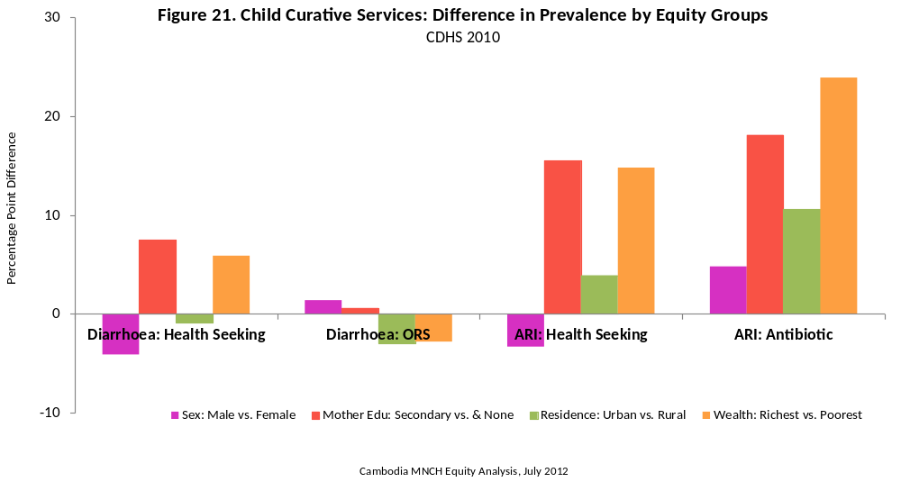

Summary

Between 2005 and 2010, wealth and maternal education equity gaps narrowed sharply for diarrhoea health seeking; an even more dramatic reduction occurred by residence, such that diarrhoea health seeking for affected rural children was no less likely than for those in urban areas, in 2010. Maternal education, residence, and wealth equity gaps also closed considerably for ARI health seeking. However, the health-seeking gaps reduced, in absolute terms, more for ARI from 2005 to 2010, perhaps because the equity gaps in 2005 were considerably higher than those observed for diarrhoea. This suggests that in 2005 (and even in 2010), though medical attention was sought for ARI at higher rates compared to diarrhoea across equity groups, some factor was preventing households in lower equity groups from seeking care in the same proportion. Perhaps caretakers in higher equity groups better recognize the signs of ARI as a situation requiring medical attention.

The divergent equity gap patterns observed for ORS treatment of diarrhoea and antibiotic treatment of ARI reflect the underlying differences between the public and private health systems in Cambodia and the populations accessing them. Whereas increased use of ORS across all equity groups from 2005 to 2010 suggests that the item is readily available to all households, the increasing equity gap for antibiotic treatment among the richest households, and those living in urban areas, supports the narrative that those accessing the private system are more likely to receive that course of treatment.

4.1 Diarrhoea: Health Seeking/ORS

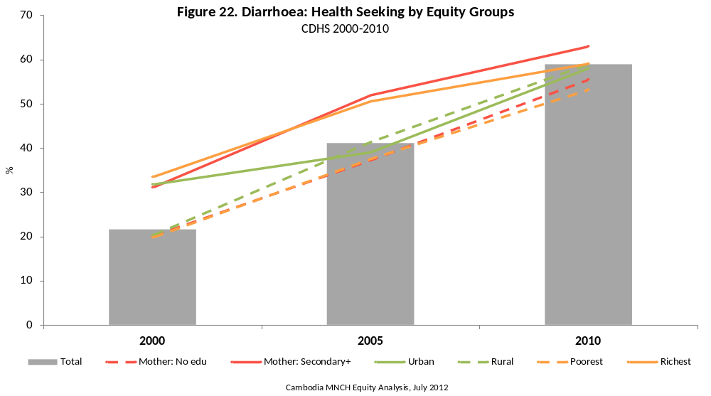

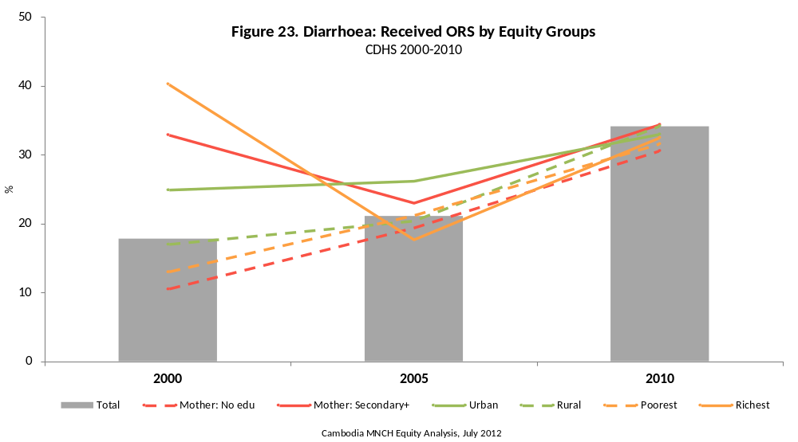

Coverage Trend

- Care seeking for diarrhoea improved from 2000 to 2010 by 37 percentage points, from 22 to 59 per cent of children being taken to a health facility or provider during an episode. The gain was realized equally from 2000 to 2005 and from 2005 to 2010 (+20 per cent and +18 per cent).
- Treatment of diarrhoeal episodes with ORS also increased from 2000 to 2010 by 16 percentage points, from 18 to 34 per cent. This gain was almost completely realized between 2005 and 2010 (+13 per cent).

Current Equity Situation

- In 2010, the main equity gaps observed in diarrhoea health seeking were according to maternal education and household wealth, such that children of mothers with secondary or higher education were 14 per cent more likely to have been taken to a health facility or provider during their diarrhoea episode than those whose mothers had no education; children living in the wealthiest households were 11 per cent more likely to have been taken for treatment.
- None of the equity gaps for treatment of diarrhoea with ORS were significant in 2010.

Equity Trend

- The equity gap for diarrhoea health seeking improved the most by residence; there is now no difference in the proportion of children living in urban and rural areas being taken for treatment of diarrhoea (nearly all of the improvement occurred from 2000 to 2005).
- The equity gaps according to household wealth and maternal education also reduced considerably between 2000 and 2010; most of this improvement occurred from 2005 to 2010.
- The wealth and maternal education equity gaps for ORS observed in 2000 were, by 2010, completely eliminated; nearly all of this improvement was realized between 2000 and 2005.

4.2 ARI: Health Seeking/Antibiotics

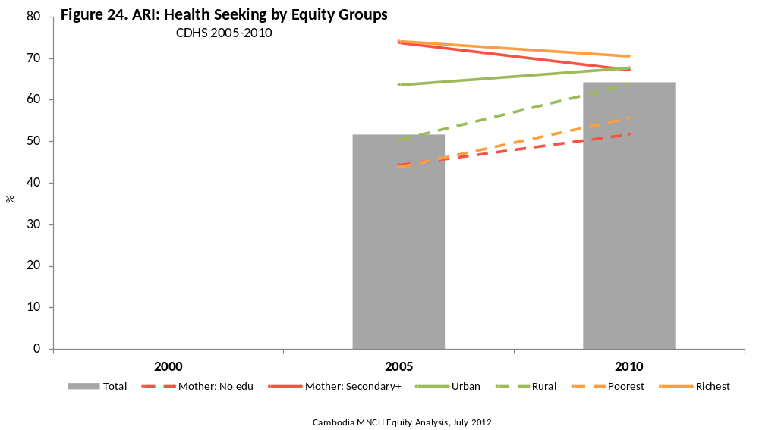

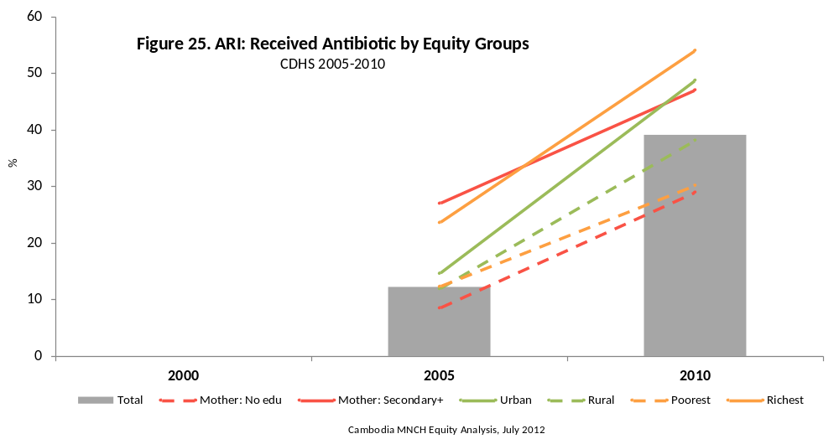

Coverage Trend

- Care seeking for ARI improved from 2005 to 2010 by 12 percentage points, from 52 to 64 per cent of children being taken to a health facility or provider during an episode.
- Treatment of ARI with antibiotics improved from 2005 to 2010 by 27 percentage points, from 12 to 39 per cent.

Current Equity Situation

- In 2010, there were no significant equity gaps observed in ARI health seeking, though this is almost certainly because the sample size of children with ARI was not large enough to draw robust statistical conclusions. The largest gaps observed were again seen in maternal education and household wealth: children of mothers with secondary or higher education were 30 per cent more likely to have been taken to a health facility or provider during their ARI episode than those whose mothers had no education; children living in the wealthiest households were 27 per cent more likely to have been taken for treatment.
- The main equity gaps observed for treatment of ARI with antibiotics in 2010 were according to household wealth and maternal education. Children with ARI in the wealthiest households were 79 per cent more likely to have received antibiotics than those in the poorest households; children of mothers with secondary or higher education were 62 per cent more likely to have received antibiotics than those whose mothers had no education.

Equity Trend

- The maternal education, residence, and household wealth equity gaps for ARI health seeking all reduced considerably between 2005 and 2010, though the small sample sizes prevented these changes from appearing significant.
- The maternal education equity gap for treatment of ARI with antibiotics remained unchanged from 2005 to 2010.
- The residence and wealth equity gaps for ARI treatment with antibiotics widened considerably from 2005 to 2010, though this again was not significant.

4.3 Comparability of Child Curative Services Indicators

There were some very minor variations in the health facility and health provider coding categories used in the 2000, 2005 and 2010 CDHS. There were also slight differences in the ORS coding categories between the three surveys, as well as some differences in the antibiotic coding categories used in the 2005 and 2010 CDHS.

5. INFANT AND YOUNG CHILD FEEDING BEHAVIOURS

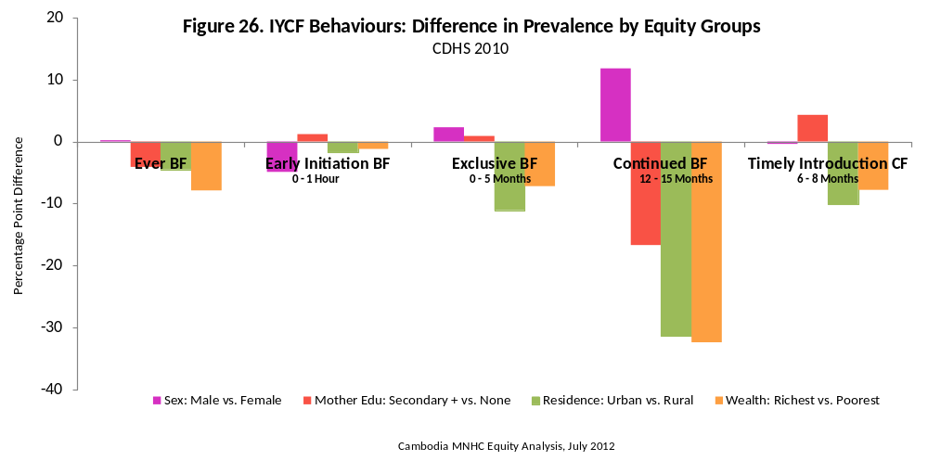

Summary

While nearly all children are breastfeed, it appears that children born to mothers in the highest equity groups are slightly less likely to ever breastfeed, perhaps because they are using formula.

Early initiation of breastfeeding improved dramatically throughout the decade. Between 2000 and 2005 this improvement occurred more among children born to mothers in wealthier households, but by 2010, roughly two-thirds of children born to mothers of all wealth groups were initiating early.

Exclusive breastfeeding improved dramatically between 2000 and 2005, most notably among children of mothers with secondary or higher education. Again, children of mothers in the highest equity groups were least likely to be exclusively breastfed.

Continued breastfeeding at one year decreased by 5 percentage points between 2000 and 2010. The decrease occurred exclusively between 2005 and 2010 and only among certain equity groups. Most of the decrease observed occurred among children living in urban areas, those living in wealthy households, and girls. Continued breastfeeding at one year was the most inequitable IYCF indicator.

Though the timely introduction of complementary foods is high, the equity gap patterns again suggest that children of mothers in the highest equity groups are delaying introduction because of a dependency on breast milk substitutes.

The IYCF equity gap patterns suggest that mothers in the highest equity groups (i.e. wealthier, more educated, and urban) are beginning to disregard standard infant feeding advice; the equity gaps are starting to grow in the other direction. As the wealth gap in Cambodia accelerates, it is likely that the IYCF equity patterns observed between 2005 and 2010 will become more pronounced.

5.1 Ever Breastfed and Early Initiation

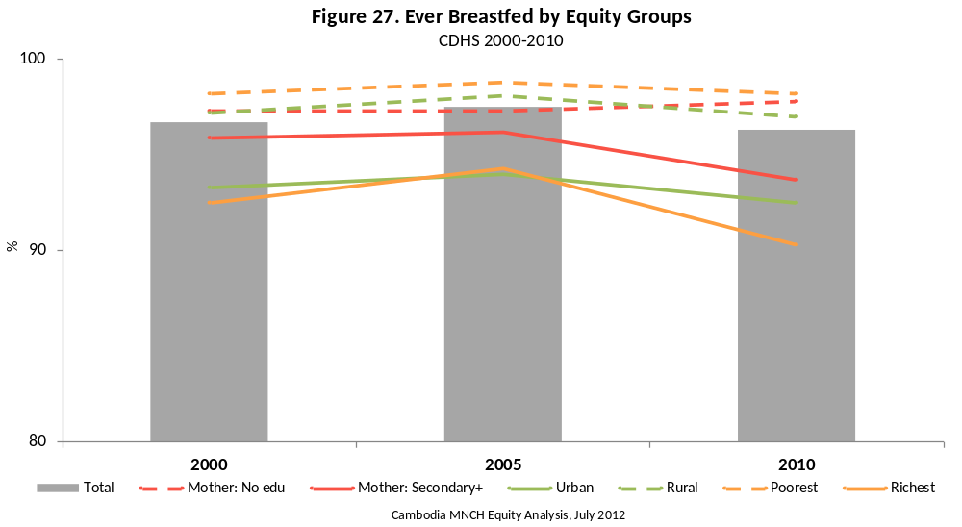

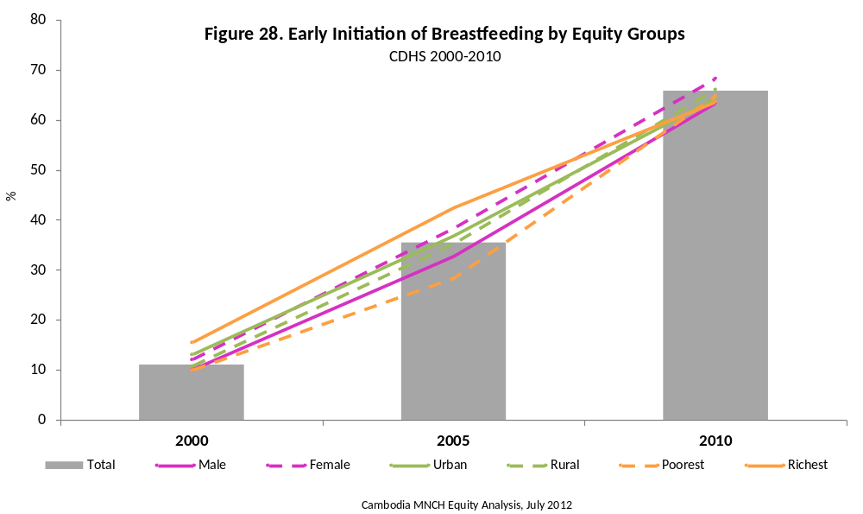

Coverage Trend

- Nearly all children are breastfed at some point (~96 per cent). From 2005 to 2010 there was a small, but significant decrease in the proportion of children ever breastfed (-1 per cent).

- Early initiation of breastfeeding has increased dramatically, going from 11 per cent in 2000 to 66 per cent in 2005. Improvement was almost evenly distributed in the first and second half of the decade, with a slightly higher rate of increase from 2005 to 2010.

Current Equity Situation

- The largest equity gap for children ever breastfed in 2010 was according to household wealth, such that children born to mothers in the poorest households were 9 per cent more likely to have ever been breastfed, compared to those born to mothers in the wealthiest households. Children born to women with secondary or higher education, and to those living in urban areas, were slightly less likely to have ever been breastfed.
- There was no equity gap for ever breastfed according to gender in 2010.
- Girls were 8 per cent more likely to have had breastfeeding initiated within the first hour compared to boys; this was the only significant equity gap for early initiation of breastfeeding in 2010.

Equity Trend

- There were no significant changes in equity gaps in ever breastfeeding between 2000 and 2010.
- The wealth equity gap for early initiation increased sharply between 2000 and 2005; this gap narrowed significantly between 2005 and 2010. While children born to mothers in the poorest households saw the least amount of improvement between 2000 and 2005, they saw the most improvement from 2005 to 2010.

5.2 Exclusive Breastfeeding

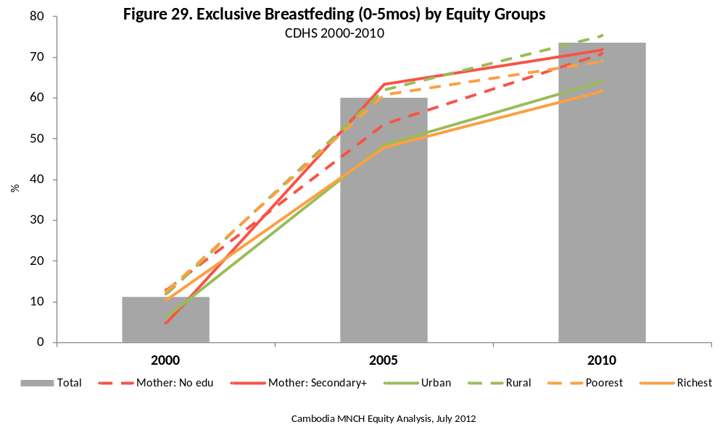

Coverage Trend

- The proportion of children aged 0–5 months exclusively breastfeeding improved significantly between 2000 and 2010, from 11 to 74 per cent.
- Though most of this improvement (79 per cent) was realized between 2000 and 2005, there was a steady gain of 3 percentage points per year since 2005.

Current Equity Situation

- The only significant equity gap for exclusive breastfeeding in 2010 was residence, with rural children being 1.2 times more likely to have been exclusively breastfed, compared to urban children.
- Children living in middle wealth households were most likely to have been exclusively breastfed.

Equity Trend

- In 2000, educated mothers were significantly less likely to exclusively breastfeed their 0–5-month-olds. This gap disappeared by 2005 and there was no maternal education equity gap for exclusive breastfeeding in 2010.
- The residence equity gap for exclusive breastfeeding appears to have increased between 2000 and 2010, such that children living in rural areas are more likely to be exclusively breastfed, though this difference was not significant.
- Although the wealth equity gap for exclusive breastfeeding was never significant, children living in the middle wealth quintiles have seen the most improvement between 2000 and 2010.

5.3 Continued Breastfeeding
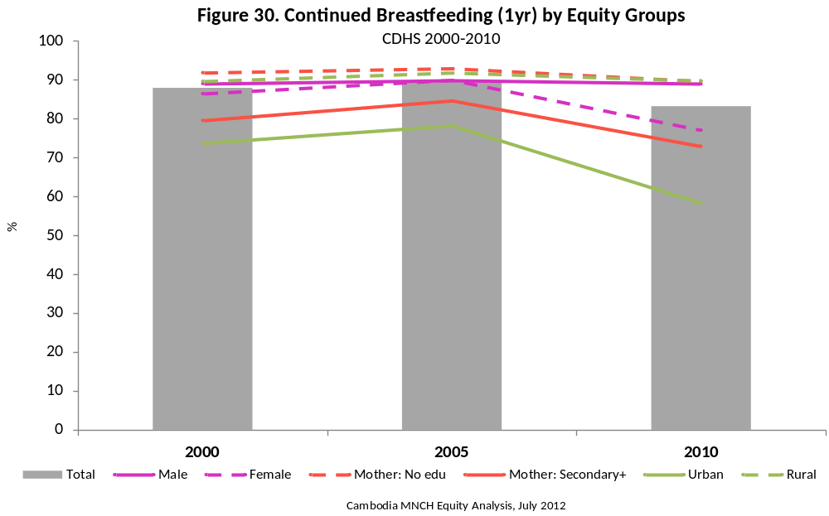

Coverage Trend

- Continued breastfeeding at one year (i.e. children aged 12–15 months) decreased significantly between 2000 and 2010, from 88 to 83 per cent. This decrease occurred from 2005 to 2010.

Current Equity Situation

- In 2010, the largest equity gaps in continued breastfeeding were according to household wealth and residence: children living in rural areas, and those living in the poorest households, were 1.6 times more likely to be breastfeeding at one year than those in the comparative groups.
- The maternal education and gender equity gaps for continued breastfeeding were also significant in 2010, such that children whose mothers had no education, and boys, were 23 per cent and 15 per cent more likely to be breastfeeding at one year than the comparative groups.

Equity Trend

- From 2000 to 2005 there were small but statistically insignificant improvements in continued breastfeeding at one year across all equity groups. From 2005 to 2010 the equity situation deteriorated, and nearly all groups experienced significant changes.
- The wealth and residence equity gaps were always significant, but they grew between 2005 and 2010 by nearly 20 percentage points.
- Between 2005 and 2010, the gender equity gap grew by 13 percentage points, resulting completely from a decrease in continued breastfeeding of girls at one year.

5.4 Timely Introduction of Complementary Foods
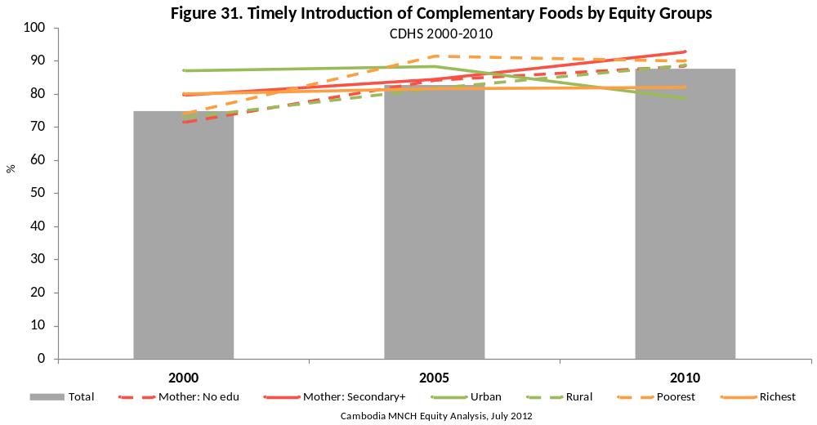

Coverage Trend

- The timely introduction of complementary foods (i.e. at 6–8 months) improved by 13 percentage points between 2000 and 2010, from 75 to 88 per cent.
- Most of this improvement (62 per cent) was realized between 2000 and 2005.

Current Equity Situation

- There were no significant equity gaps for timely introduction in 2010.

Equity Trend

- Timely introduction was 1.2 times more likely among urban children in 2000; this gap disappeared over time (and appears to have completely reversed), as timely introduction increased in rural areas, while it decreased in urban areas between 2005 and 2010.
- Although the wealth equity gap was never significant, most of the gains observed in timely introduction between 2000 and 2010 occurred among children in the bottom three wealth quintiles.

5.5 Comparability of IYCF Behaviour Indicators

The only notable difference between the surveys for IYCF indicators is the number of food groups queried during the 24-hour recall. The number was smallest in 2000, and did not include cheese.

SECTION II: WOMEN AGED 15–49 YEARS

6. WOMEN OUTCOMES

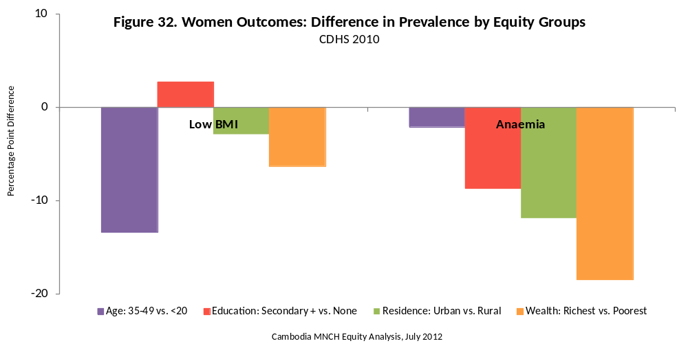

Summary

The overall prevalence of low BMI among women aged 15–49 years remained unchanged from 2000 to 2010. Indeed, the only meaningful change over time was a widening of the equity gap according to women’s age: women aged 35–49 years were about 25 per cent less likely to be thin in 2010 than in 2000, whereas those aged less than 20 years were slightly more likely to be thin. The widening of this age gap was observed equally between 2000–2005 and 2005–2010, which suggests that the trend is real and likely to continue. The single most important predictor of low BMI among women 15–49 was age, such that those less than 20 years were nearly twice as likely (1.9) to be thin as women aged 35–39 years.

In contrast to low BMI, considerable improvements were observed in anaemia rates for women between 2000 and 2010. However, most of the improvements in anaemia were realized during the first half of the decade; the overall prevalence of anaemia among women 15–49 did not significantly improve between 2005 and 2010. The results by equity group give a mixed picture about the underlying forces driving these improvements. As with BMI, women aged 35–49 years showed large, consistent absolute improvements (25 per cent decrease), while women living in urban areas experienced the greatest absolute improvement in anaemia prevalence (30 per cent decrease). Unlike BMI, there were considerable differences in the prevalence of anaemia according to equity group, the largest predictors of which were household wealth and residence.

6.1 Women: Low BMI (<18.5)

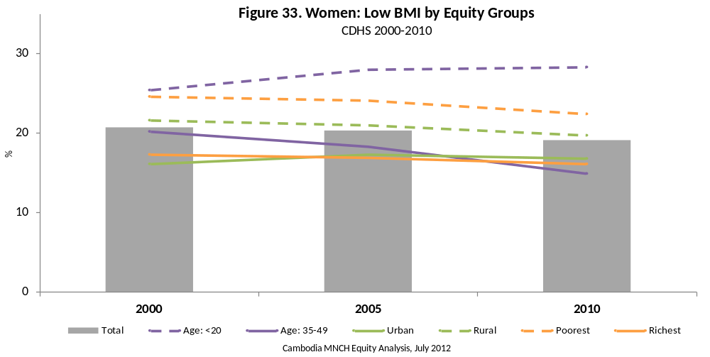

Prevalence Trend

- Low BMI (kg/m² < 18.5) among women aged 15–49 years remained unchanged over the period from 2000 to 2010 at approximately 20 per cent.

Current Equity Situation

- There was no significant equity gap according to a woman’s educational attainment for low BMI prevalence in 2010.
- The largest equity gap observed was according to a woman’s age. In 2010, women aged 15–19 years were 1.9 times more likely to be thin according to BMI than those aged 35–49 years.
- Women living in rural areas and those in the poorest quintile were 1.2 and 1.4 times more likely to be thin in 2010, respectively.

Equity Trend

- From 2000 to 2010 the equity situation either deteriorated or was stagnant for the comparison groups. The prevalence of low BMI decreased by roughly half among older women, whereas it deteriorated slightly among young women. This resulted in a net significant widening of the gap between the two age groups.

6.2 Women: Anaemia
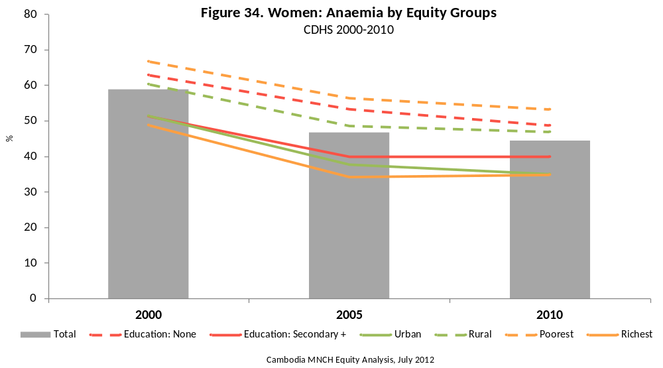

Prevalence Trend

- The prevalence of anaemia among women aged 15–49 years decreased significantly, by 14 percentage points between 2000 and 2010, from 59 to 44 per cent; virtually all of this improvement was experienced from 2000 to 2005.

Current Equity Situation

- There was no significant equity gap according to a woman’s age for anaemia prevalence in 2010.
- The largest equity gap observed was according to household wealth. In 2010, women living in the poorest households were 1.5 times more likely to be anaemic those living in the wealthiest households.
- Women living in rural areas and those with no education were 1.5 and 1.2 times more likely to be thin in 2010, respectively.

Equity Trend

- From 2000 to 2010 the equity situation for anaemia among women aged 15–49 years remained significantly unchanged for all comparison groups.

6.3 Comparability of Women Outcome Indicators

There were no comparability issues for BMI and anaemia among women aged 15–49 years. Women who had given birth in the two months preceding the survey, as well as those who were pregnant at the time of the survey, we not included in BMI calculations. Adjustments to haemoglobin measurements were made to account for the smoking status of women according to standard protocols [3].

7. WOMEN BEHAVIOUR & KNOWLEDGE

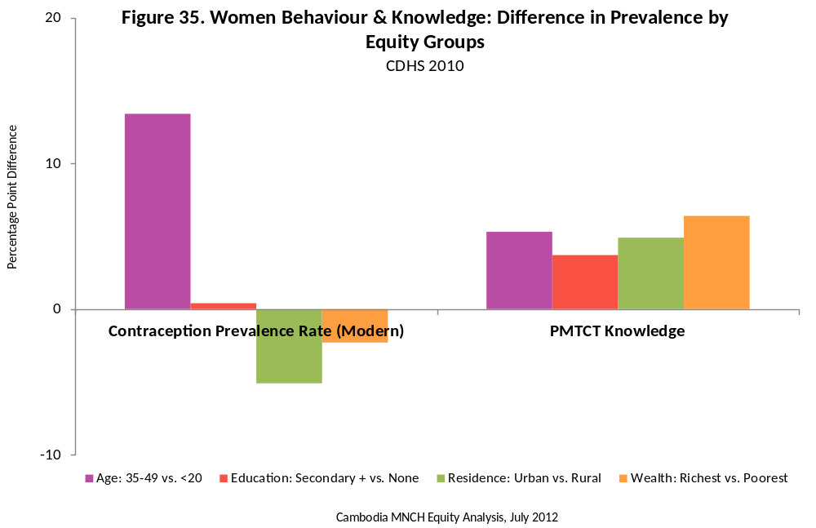

Summary

The proportion of women aged 15–49 years currently married or in a union using a modern contraceptive method nearly doubled between 2000 and 2010, from 19 to 35 per cent. Women in all equity subgroups saw improvements in contraceptive prevalence rate, with the biggest absolute gains occurring among those living in the lowest three wealth quintiles (+ 20 percentage points). The pattern of improvements suggests that more educated women, those in the wealthiest households, and those in urban areas, experienced the bulk of their gains in the first half of the decade (2000–2005), while those with primary or no education, living in the poorest households, and living in rural areas, experienced gains during the second half of the decade too (2005–2010). The biggest single predictor of contraceptive prevalence in 2010 was age, such that women aged 35–49 years were 1.7 times more likely to have been using any method than those under 20 years.

The proportion of all women aged 15–49 years capable of correctly identifying all three means of mother-to-child transmission of HIV did not significantly change from 2005–2010, remaining at 66 per cent. The only subgroup of women that showed improvements of note were those with no education and women living in urban areas (+ 5 and +7 percentage points, respectively)—these changes resulted in the significant narrowing and widening of the equity gaps for these groups. The largest predictor of mother-to-child transmission knowledge in 2010 was wealth: women living in the wealthiest households were 1.1 times more likely to correctly identify the three modes of transmission.

7.1 Contraceptive Prevalence Rate (Modern)

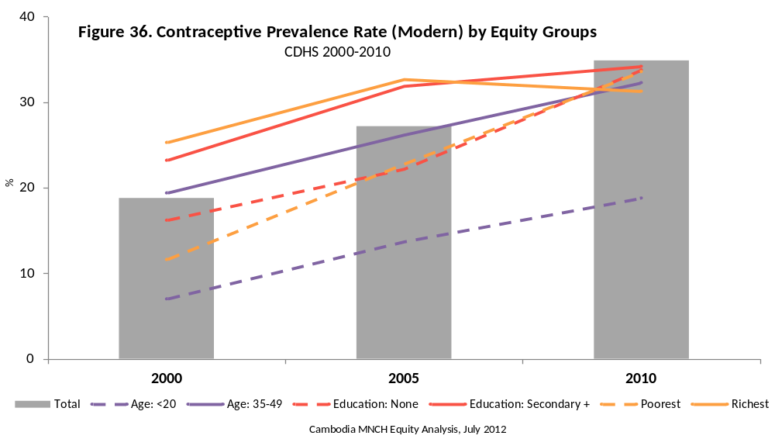

Prevalence Trend

- The use of a modern contraceptive method by women married or in a union nearly doubled between 2000 and 2010, from 19 to 35 per cent; this improvement occurred both between 2000–2005 and 2005–2010.

Current Equity Situation

- The largest equity gap observed was according to a woman’s age. In 2010, married women or those in a union aged 35–49 years were 1.7 times more likely to have currently been using a modern contraceptive method than those aged 15–19 years.
- Women living in rural areas and in the poorest households were 1.2 and 1.1 times more likely to have currently been using a modern contraceptive method than the comparative groups in 2010, respectively.
- The smallest equity gap observed in 2010 was according to education, such that women with secondary or higher education were just 1.01 times more likely to have currently been using a modern contraceptive method.

Equity Trend

- From 2000 to 2010 the equity situation for contraceptive use among women aged 15–49 years improved significantly according to wealth, residence and education, such that women living in the poorest households, those in rural areas, and those with no education were using a modern contraceptive method at a disproportionately higher rate in 2010 than they had in 2000.

7.2 Prevention of Mother to Child Transmission (PMTCT) Knowledge

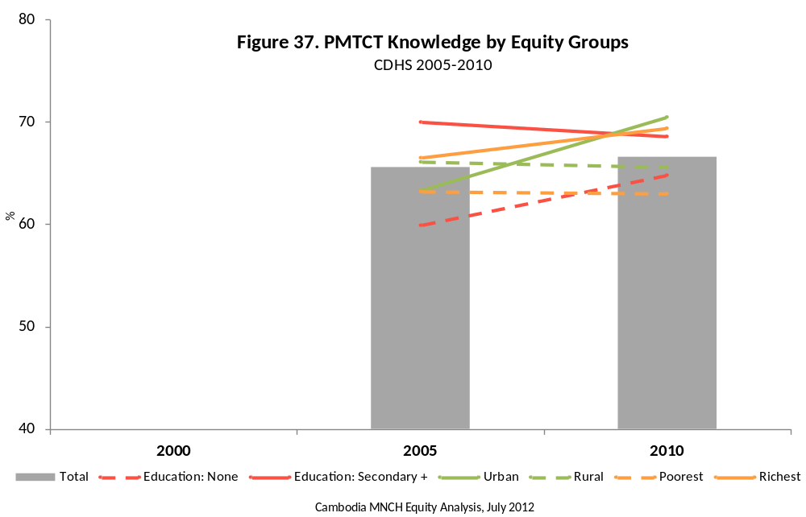

Prevalence Trend

- The proportion of women aged 15–49 years who could correctly identify all three means of mother-to-child transmission of HIV increased by only 1 percentage point between 2005 and 2010, from 66 to 67 per cent.

Current Equity Situation

- The largest equity gap observed was according to household wealth. In 2010, women living in the wealthiest households were 1.1 times more likely to have correctly identified the three modes of transmission than those living in the poorest households.
- Women aged 15–19 years, those living in urban areas and those with secondary or higher education were all 1.1 times more likely to have received a postnatal check-up than the comparative groups in 2010, respectively.

Equity Trend

- From 2005 to 2010 the equity situation for PMTCT knowledge improved significantly according to education, such that women with no education were disproportionately more likely to identify all three modes of transmission in 2010 than they were in 2005.
- From 2005 to 2010 the equity situation for PMTCT knowledge deteriorated significantly according to residence, such that women living in urban areas were disproportionately less likely to identify all three modes of transmission in 2010 than they were in 2005, which is a concern, noting Cambodia’s increasingly concentrated epidemic in urban areas.

7.3 Comparability of Women Behaviour & Knowledge Indicators
Because the 2000 CDHS asked a filtering question before querying women on how HIV can be passed from mother to child, it was not possible to accurately compare these values with those from the 2005 and 2010 CDHS.

8. MATERNAL HEALTH SERVICES

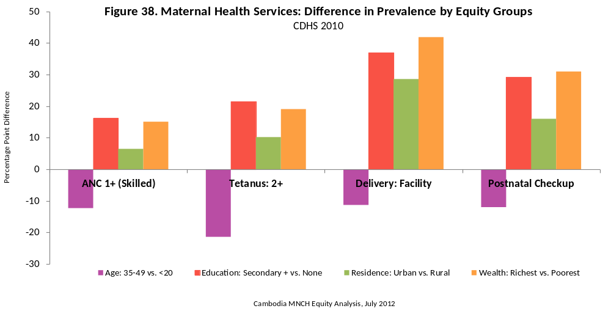

Summary

The proportion of women aged 15–49 years receiving ANC from a skilled provider at least once during their last pregnancy doubled between 2000 and 2010, from 46 to 92 per cent. The overall pattern of improvement showed that nearly two-thirds of these gains were realized during the first half of the decade (2000–2005), but this masks interesting patterns by equity group. While improvements by age followed the overall pattern, the equity gap between women living in urban and rural areas narrowed by 75 per cent; the gap between those living in the wealthiest and poorest households contracted by 68 per cent; and the gap between women with secondary or higher education and those with none decreased 63 per cent. Looking closer at the data, it becomes clear that the effects of increasing health system access were realized by most women between 2000 and 2005; only those living in the poorest households and those with no education continued reaping this benefit in the second half of the decade (2005–2010). The gap between women living in urban and rural areas was nearly erased between 2000 and 2010, while those living in the wealthiest households and with secondary or higher education remained, in 2010, 1.2 times more likely to receive ANC from a skilled provider at least once during their last pregnancy.

The proportion of these women receiving ANC from any provider at least four times during their most recent pregnancy also increased, but observed improvements followed a rather different pattern. While between 2000 and 2010 the proportion of 4+ ANC visits increased seven-fold, from 9 to 64 per cent, the absolute equity gaps for all equity groups actually increased during this time. In contrast to 1+ ANC, most of the improvement in 4+ ANC was realized between 2005 and 2010, and by the wealthiest, youngest, urban, and most educated women. The most consistent predictor of 4+ ANC remained household wealth, such that those living in the wealthiest households were 1.8 times more likely to receive the recommended minimum number of visits. Combined, these ANC findings suggest different underlying forces are driving the improvements seen in ANC from 2000 to 2010.

The proportion of women aged 15–49 who had their blood pressure taken and gave blood and urine samples during their last pregnancy improved just 20 percentage points between 2000 and 2010 (from 5 to 25 per cent). Similar to 4+ ANC, the equity gaps for all equity groups increased for three components, though with a revealing difference. Like 4+ ANC, most of the improvement in three components occurred between 2005 and 2010. However, unlike 4+ ANC, women living in urban areas and those in the wealthiest households showed considerably more improvement between 2005 and 2010 than their comparative groups, and were both significant predictors of receiving three components in 2010.

The proportion of women aged 15–49 years receiving two or more tetanus toxoid injections during their last pregnancy increased by 26 percentage points between 2000 and 2010, from 31 to 57 per cent. Most of this improvement (80 per cent) was realized during the first half of the decade (2000–2005). Women of all equity groups saw improvements, though interesting patterns emerge when looking by individual equity groups. The absolute equity gap by age actually widened from 9 to 21 percentage points due to continued improvement in 2+ TT for women aged less than 20 years between 2005 and 2010. Indeed, women living in urban areas and the wealthiest households dramatically outperformed their comparative groups between 2005 and 2010, somewhat erasing the improvements in equity gaps that were realized in the first half of the decade. In the 2010 survey, a woman’s education level (secondary or higher) and age (less than 20 years) were the largest predictors of receiving 2+ TT injections during her last pregnancy.

The proportion of women aged 15–49 years whose last birth was fully protected against neonatal tetanus increased significantly between 2005 and 2010, from 70 to 86 per cent. Women of all equity groups experienced improvements, though the equity gap patterns complicate a straightforward interpretation. The improvements by equity group appear to follow the patterns seen in 2+ TT, though are somewhat muted (women are more likely to be fully protected against neonatal tetanus by virtue of having received TT injections before their most recent pregnancy). This finding could reflect a general increase in the number of TT injections given throughout the public health system (i.e. outside of pregnancy as well). More analysis is needed to better interpret these findings.

The proportion of women aged 15–49 years who were offered and received the results of an HIV test during ANC of their last pregnancy increased 31 percentage points between 2005 and 2010, from 11 to 42 per cent. However, during this time the equity gap increased for all equity groups. The largest improvements were seen among the youngest women, those with secondary or higher education, those living in urban areas and in the wealthiest households (+33, +36, +40, and +38 percentage points, respectively). The patterns observed between 2005 and 2010 again suggest that these women are benefiting most from gains in access to quality health care, which in 2010 seemed to be more concentrated in the private sector.

The proportion of women aged 15–49 years who delivered their last child in a health facility increased 56 percentage points between 2000 and 2010, from 10 to 66 per cent. Most of this improvement was realized in the second half of the decade (2005–2010). The patterns of improvement within equity groups varied: the absolute equity gap increased according to women’s age, education and residence, while reducing according to household wealth. The only equity group to show a significant equity gap change over time—household wealth—resulted because the room for improvement among women in the wealthiest households was limited, due to the already high level of access in 2005. It is likely that the other equity gaps will continue to narrow as more women access the public health system. Women aged 35–49 years, who did not show improvements similar to other groups of women during this time, will require further observation and emphasis.

The proportion of women whose last birth was assisted by a skilled provider increased 45 percentage points between 2000 and 2010 from 34 to 79 per cent. Women within all equity groups saw improvements for this indicator, though comparisons of trends within and between equity groups is revealing. The trend observed according to women’s age closely followed the overall trend. However, unlike delivery location, women from the lowest equity subgroups—those with no education, living in rural areas, and in the poorest households—narrowed the equity gap significantly between 2000 and 2010, particularly the second half of the decade. This finding supports an interpretation that, in 2000, skilled birth attendance came down to which women could afford this support, and has, over the last ten years, become more associated with women delivering at health facilities (especially public) where these professionals are primarily located.

8.1 ANC: Skilled Provider (1+ visits)

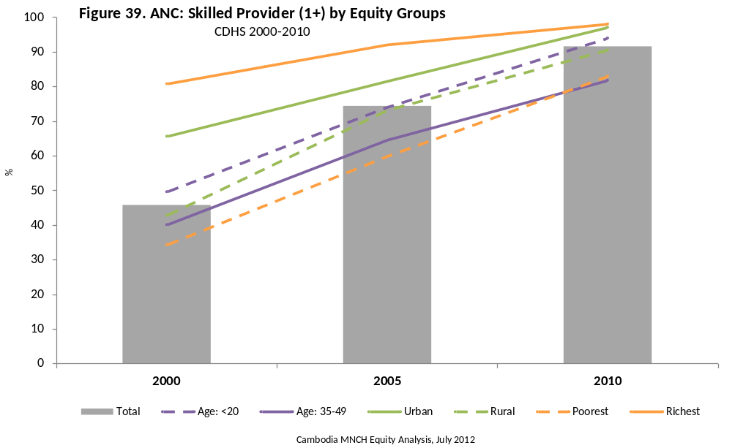

Prevalence Trend

- Access to ANC at least once from a skilled provider by women aged 15–49 years doubled between 2000 and 2010, from 46 to 92 per cent; this improvement occurred both between 2000–2005 and 2005–2010.

Current Equity Situation

- The largest equity gap observed was according to a woman’s educational attainment. In 2010, women with secondary or higher education were 1.2 times more likely to have accessed ANC services from a skilled provider at least once during their last pregnancy than those with no education.
- Women aged 15–19 years and those living in the wealthiest households were 1.1 and 1.2 times more likely to have accessed ANC from a skilled provider than the comparative groups in 2010, respectively.
- The smallest equity gap observed in 2010 was according to residence, such that women living in urban households were 1.1 times more likely to have accessed ANC from a skilled provider during their last pregnancy.

Equity Trend

- From 2000 to 2010 the equity situation for access to ANC from a skilled provider among women aged 15–49 years improved significantly according to wealth, education and residence, such that women with no education, those living in rural areas and those in the poorest households were all accessing ANC from a skilled provider at a disproportionately higher rate in 2010 than they did in 2000.

8.2 ANC: Any Provider (4+ visits)

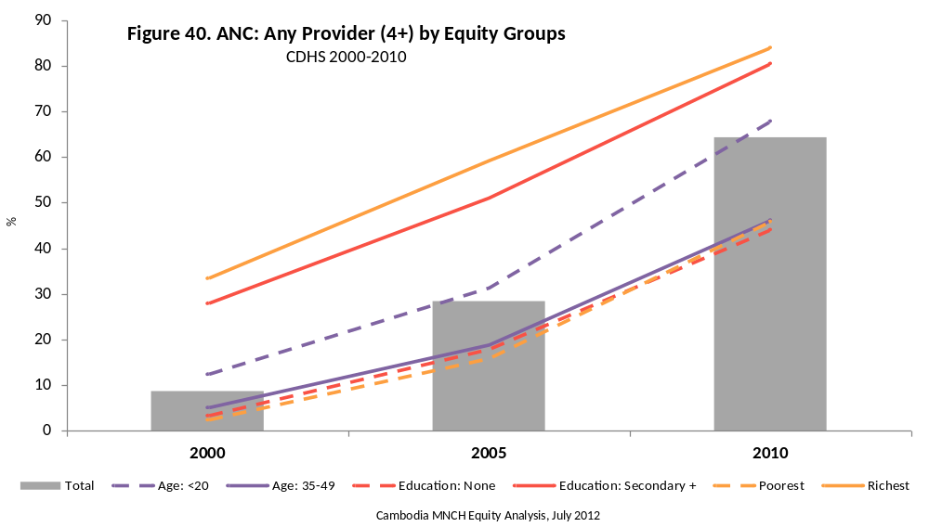

Prevalence Trend

- The proportion of women aged 15–49 years accessing ANC services at least four times during their last pregnancy (regardless of the provider) increased more than seven-fold between 2000 and 2010, from 9 to 64 per cent; close to two-thirds of this improvement (36 percentage points) occurred between 2005 and 2010.

Current Equity Situation

- The largest equity gap observed was according to household wealth. In 2010, women living in the wealthiest households were 1.8 times more likely to have accessed ANC services 4+ times during their last pregnancy than those living in the poorest households.
- Women aged 15–19 years and those with secondary or higher education were 1.5 and 1.3 times more likely to have accessed ANC 4+ times than the comparative groups in 2010, respectively.
- The smallest equity gap observed in 2010 was according to residence, such that women living in urban households were 1.3 times more likely to have accessed ANC 4+ times during their last pregnancy.

Equity Trend

- From 2000 to 2010 the equity situation for access to ANC 4+ times among women aged 15–49 years deteriorated significantly according to age and educational status, such that women aged 35–49 years and those with no education were accessing ANC 4+ times at a disproportionately lower rate in 2010 than they did in 2000.

8.3 ANC: 3 Basic Components

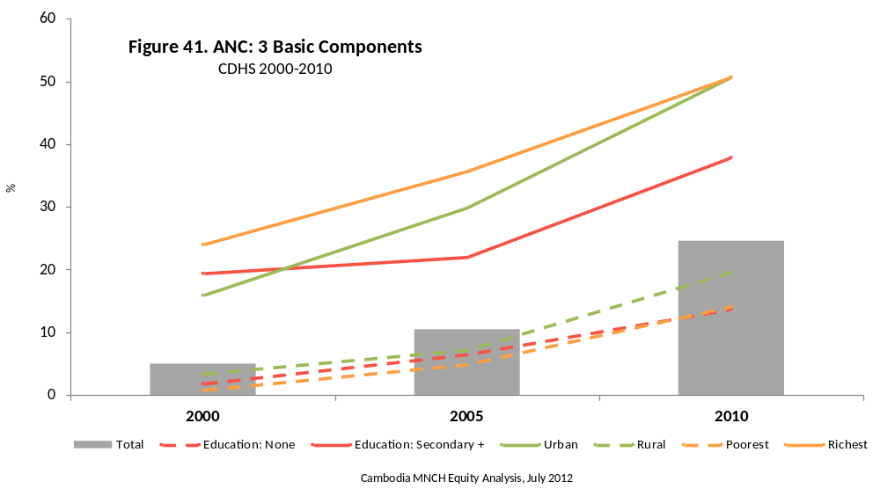

Prevalence Trend

- The proportion of women aged 15–49 years accessing ANC and having their blood pressure, urine and blood samples checked (“3 components”) during their last pregnancy improved five-fold between 2000 and 2010, from 5 to 25 per cent; roughly three-quarters of this improvement occurred between 2005 and 2010.

Current Equity Situation

- There was no significant equity gap for three components of ANC according to a woman’s age in 2010.
- The largest equity gap observed was according to household wealth. In 2010, women living in the wealthiest households were 3.6 times more likely to have all three components of ANC during their last pregnancy than those living in the poorest households.
- Women living in urban areas and those with secondary or higher education were 2.6 and 2.8 times more likely to have received all three components during their last pregnancy than the comparative groups in 2010, respectively.
Equity Trend

- From 2000 to 2010 the equity situation for receiving three components of ANC among women aged 15–49 years deteriorated significantly according to residence and household wealth, such that women living in rural areas and those in the poorest households were receiving three components of ANC at a disproportionately lower rate in 2010 than they did in 2000.

8.4 HIV Testing during Pregnancy

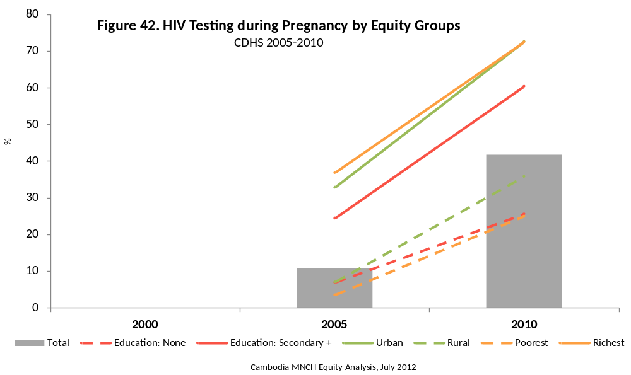

Prevalence Trend

- The proportion of women aged 15–49 years being offered an HIV test and receiving the results during their last pregnancy improved by 31 percentage points between 2005 and 2010, from 11 to 42 per cent.

Current Equity Situation

- The largest equity gap observed was according to household wealth. In 2010, women living in the wealthiest households were 2.9 times more likely to have been tested for HIV during their last pregnancy than those living in the poorest households.
- Women living in urban areas and those with secondary or higher education were 2.0 and 2.4 times more likely to have been tested for HIV during their last pregnancy than the comparative groups in 2010, respectively.

Equity Trend

- From 2005 to 2010 the equity situation for being tested for HIV during last pregnancy deteriorated significantly according to a woman’s education status, residence and household wealth, such that women with no education, those living in rural areas and those in the poorest households were disproportionately less likely to have been tested for HIV during their last pregnancy in 2010 than they were in 2005.

8.5 Tetanus Toxoid: 2+ Injections during last Pregnancy

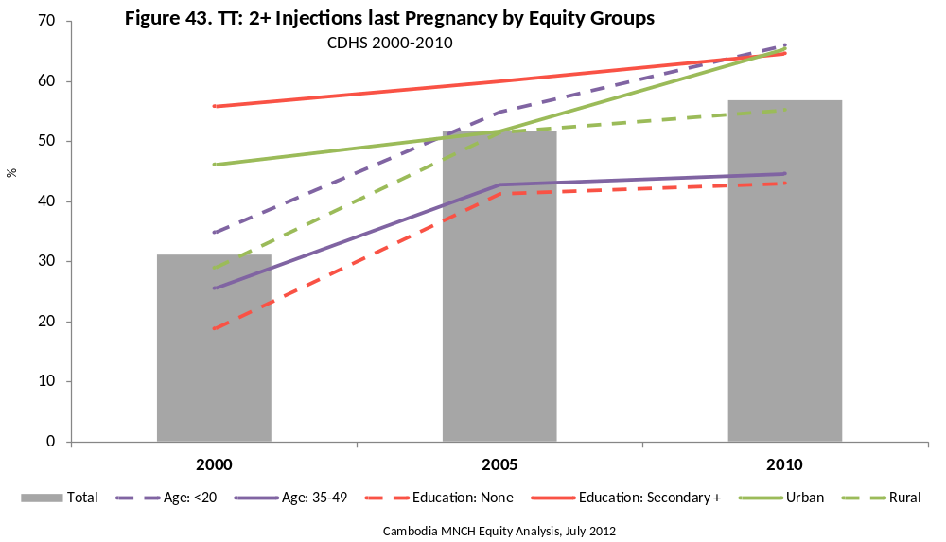

Prevalence Trend

- The proportion of women aged 15–49 years receiving 2+ tetanus injections during their last pregnancy improved by 26 percentage points between 2000 and 2010, from 31 to 57 per cent; most of this improvement was realized between 2000 and 2005 (21 percentage points).

Current Equity Situation

- The largest equity gap observed was according to a woman’s educational status. In 2010, women with secondary or higher education were 1.5 times more likely to have received 2+ TT injections during their last pregnancy than those with no education.
- Women aged 15–19 years, those living in urban areas and those with secondary or higher education were 1.5, 1.4, and 1.4 times more likely to have received 2+ TT injections during their last pregnancy than the comparative groups in 2010, respectively.

Equity Trend

- From 2000 to 2010 the equity situation for receiving 2+ TT injections during last pregnancy deteriorated significantly according to a woman’s age, such that women aged 35–49 years were disproportionately less likely to have received 2+ TT injections during their last pregnancy in 2010 than they were in 2000.
- From 2000 to 2010 the equity situation for receiving 2+ TT injections during last pregnancy improved significantly according to education status, residence and household wealth, such that women with secondary or higher education, those living in rural areas and those in the poorest households were disproportionately more likely to have received 2+ TT injections during their last pregnancy in 2010 than they were in 2000.

8.6 Tetanus Toxoid: Last Birth Protected

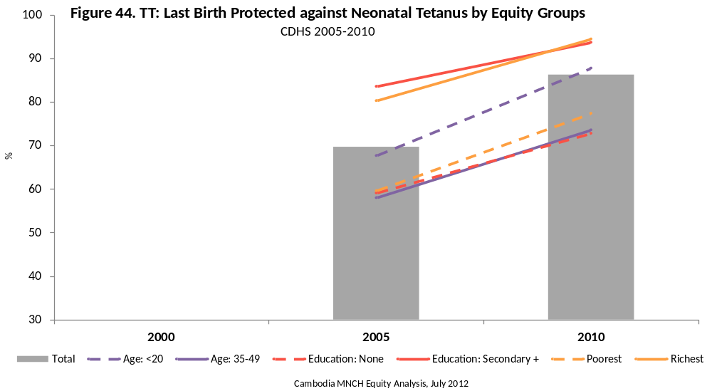

Prevalence Trend

- The proportion of women aged 15–49 years fully protected against neonatal tetanus during their last pregnancy improved by 16 percentage points between 2005 and 2010, from 70 to 86 per cent.

Current Equity Situation

- The largest equity gap observed was according to a woman’s educational status. In 2010, women with secondary or higher education were 1.3 times more likely to have been fully protected against neonatal tetanus during their last pregnancy than those with no education.
- Women aged 15–19 years, those living in urban areas and those living in the poorest households were 1.2, 1.1, and 1.2 times more likely to have been fully protected against neonatal tetanus during their last pregnancy than the comparative groups in 2010, respectively.

Equity Trend

- From 2000 to 2010 the equity situation for full protection against neonatal tetanus during the last pregnancy among women aged 15–49 years remained significantly unchanged for all comparison groups.

8.7 Delivery Location: Health Facility

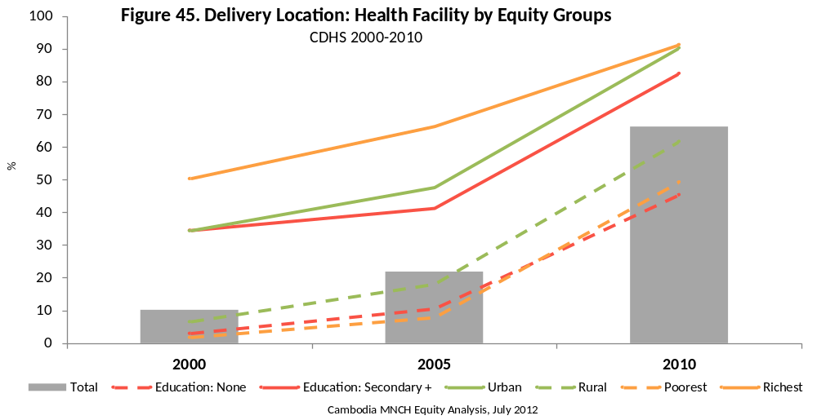

Prevalence Trend

- The proportion of women aged 15–49 years delivering their baby at a health facility during their last pregnancy improved more than six-fold (56 percentage points) between 2000 and 2010, from 10 to 66 per cent; the majority of this improvement (44 percentage points) was realized between 2005 and 2010.

Current Equity Situation

- The largest equity gap observed was according to household wealth. In 2010, women living in the wealthiest households were 1.9 times more likely to have delivered their last baby in a health facility than those living in the poorest households.
- Women aged 15–19 years, those living in urban areas and those with secondary or higher education were 1.2, 1.5 and 1.8 times more likely to have delivered their last baby in a health facility than the comparative groups in 2010, respectively.

Equity Trend

- From 2000 to 2010 the equity situation for delivering their last baby at a health facility among women aged 15–49 years remained significantly unchanged for all comparison groups. A significant improvement did occur between 2005 and 2010 according to household wealth.

8.8 Delivery Assistance: Skilled Provider

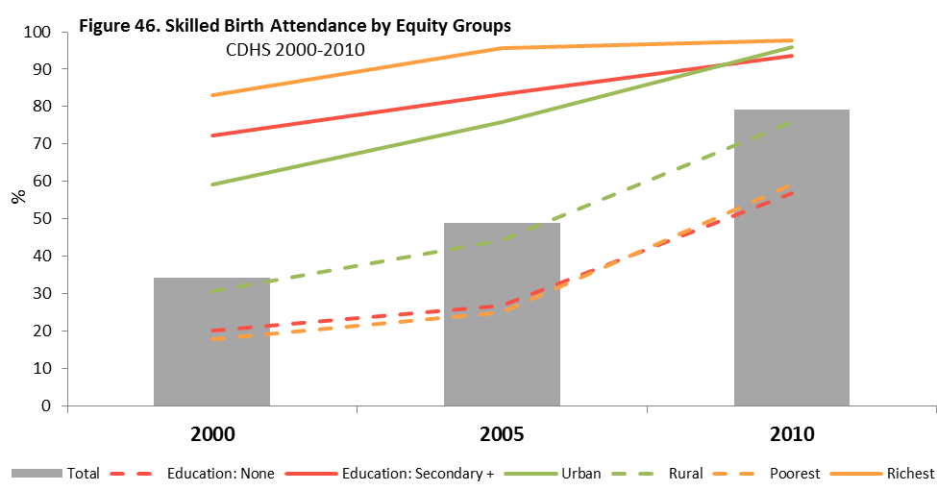

Prevalence Trend

- The proportion of women aged 15–49 years delivering their last baby with the help of a skilled provider more than doubled (45 percentage points) between 2000 and 2010, from 34 to 79 per cent; two-thirds of this improvement (30 percentage points) was realized between 2005 and 2010.

Current Equity Situation

- The largest equity gap observed was according to household wealth. In 2010, women living in the wealthiest households were 1.7 times more likely to have delivered their last baby with skilled assistance than those living in the poorest households.
- Women aged 15–19 years, those living in urban areas and those with secondary or higher education were 1.2, 1.3 and 1.7 times more likely to have delivered their last baby with skilled assistance than the comparative groups in 2010, respectively.

Equity Trend

- From 2000 to 2010 the equity situation for delivering their last baby with skilled assistance improved significantly according to education status and household wealth, such that women with no education and those in the poorest households were disproportionately more likely to have delivered with skilled assistance in 2010 than they were in 2000.

8.9 Postnatal Check-up
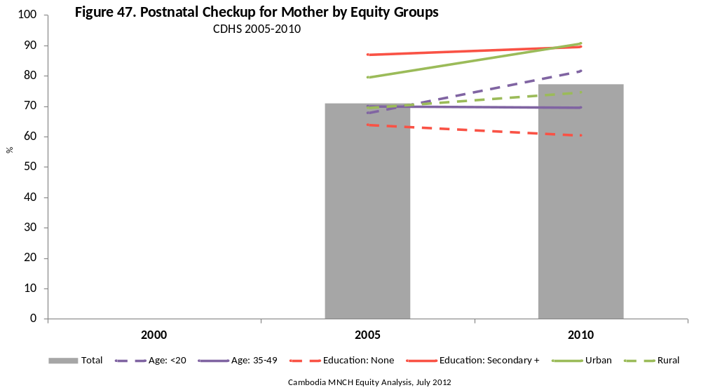

Prevalence Trend

- The proportion of women aged 15–49 years who received a health check while in a facility, or at home following delivery, or a post-natal care visit within two days after delivery increased by 6 percentage points between 2005 and 2010, from 71 to 77 per cent.

Current Equity Situation

- The largest equity gap observed was according to household wealth. In 2010, women living in the wealthiest households were 1.5 times more likely to have received a postnatal check-up than those living in the poorest households.
- Women aged 15–19 years, those living in urban areas and those with secondary or higher education were 1.2, 1.2 and 1.5 times more likely to have received a postnatal check-up than the comparative groups in 2010, respectively.

Equity Trend

- From 2005 to 2010 the equity situation for receiving a postnatal check-up deteriorated significantly according to age, such that women aged 35–49 years were disproportionately less likely to have received a postnatal check-up in 2010 than they were in 2000.

8.10 Comparability of Maternal Health Services Indicators

Delivery indicators were calculated for deliveries occurring within the last two years to give more current estimates and to improve reliability by decreasing the recall period. The CDHS report includes deliveries occurring within the last five years.

The 2000 CDHS did not ask women about the total number of tetanus injections they had received before their most recent pregnancy, and as a result, the Last Birth Protected against Neonatal Tetanus could not be calculated and compared for that survey. The 2000 CDHS also did not ask women whether they had been offered an HIV test during their most recent ANC and thus could not be compared with the 2005 and 2010 CDHS. Finally, the 2000 CDHS did not ask the appropriate sequence of questions to create the post-natal check-up of mother indicator using the modern definition, and thus, could not be compared to the 2005 and 2010 CDHS.

REFERENCES & RESOURCES

- WHO, UNICEF. Countdown to 2015 decade report (2000–2010): taking stock of maternal, newborn and child survival, Geneva 2010. Geneva, Switzerland: World Health Organization, 2010.
- 2009 Stata Conference. “Using Stata for Subpopulation Analysis of Complex Sample Survey Data.” Bradley T. West, Michigan Program in Survey Methodology. PowerPoint. 2000. 30 July 2009. < http://www.stata.com/meeting/dcconf09/abstracts.html >.
- Centers for Disease Control and Prevention. Recommendations to Prevent and Control Iron Deficiency in the United States. MMWR 1998; 47(No. RR-3):[12-13].
- Demographic and Health Survey 2010. Phnom Penh, Cambodia and Calverton, Maryland, USA: National Institute of Statistics, Directorate General for Health, and ICF Macro.
- WHO, UNICEF. Monitoring Maternal, Newborn and Child Health: Understanding key progress indicators, Geneva 2011. Geneva, Switzerland: World Health Organization, 2011.
- WHO, UNICEF. Indicators for Assessing Infant and Young Child Feeding Practices, Part 2: Measurement, Geneva 2010. Geneva, Switzerland: World Health Organization, 2010.

APPENDIX 1. INDICATOR DEFINITIONS

Table 1.
INDICATOR | NUMERATOR | DENOMINATOR | SOURCE
Childhood Mortality
Neonatal mortality rate | Probability of dying within the first month of life, during the 5-year period preceding the survey |  | MICS 1.3
Post-neonatal mortality rate | Difference between infant and neonatal mortality rates, during the 5-year period preceding the survey |  | MICS 1.4
Infant mortality rate | Probability of dying by exact age 1 year |  | MICS 1.2, MDG 4.2
Child mortality rate | Probability of dying between exact ages 1 and 5, during the 5-year period preceding the survey |  | MICS 1.5
Under-five mortality rate | Probability of dying by exact age 5 years |  | MICS 1.1, MDG 4.1
Child Outcomes
Underweight | Number of children under age 5 who fall below minus two standard deviations from the median weight-for-age of the WHO standard | Total number of children under age 5 | MICS 2.1a, MDG 1.8
Stunting | Number of children under age 5 who fall below minus two standard deviations from the median height-for-age of the WHO standard | Total number of children under age 5 | MICS 2.2a
Wasting | Number of children under age 5 who fall below minus two standard deviations from the median weight-for-height of the WHO standard | Total number of children under age 5 | MICS 2.3a
Anaemia | Number of children aged 6–59 months with anemia (Hb < 11 g/dL) | Total number of children aged 6–59 months
Diarrhoea | Number of children with diarrhoea in the two weeks preceding the survey | Total number of children aged 0–59 months
Acute Respiratory Infection | Number of children with symptoms of ARI (illness with a cough and rapid breathing from chest) in the two weeks preceding the survey | Total number of children aged 0–59 months
Child Preventive Services
Tuberculosis Immunization Coverage (BCG) | Number of children aged 12–23 months who received BCG vaccine | Total number of children aged 12–23 months | MICS 3.1
Diphtheria, Pertussis, and Tetanus Immunization Coverage (DPT3) | Number of children aged 12–23 months who received DPT3 vaccine | Total number of children aged 12–23 months | MICS 3.3
Measles Immunization Coverage | Number of children aged 12–23 months who received measles vaccine | Total number of children aged 12–23 months | MICS 3.4, MDG 4.3
All Basic Vaccinations | Number of children aged 12–23 months who received BCG, DPT3, and measles vaccine | Total number of children aged 12–23 months
Vaccination Card | Number of children aged 12–23 months with a vaccination card seen | Total number of children aged 12–23 months
Vitamin A Supplementation | Number of children aged 6–59 months who received at least one high-dose Vitamin A supplement in the 6 months preceding the survey | Total number of children aged 6–59 months | MICS 2.17
Deworming Supplementation | Number of children aged 12–59 months who received a deworming supplement in the 6 months preceding the survey | Total number of children aged 12–59 months
Child Curative Services
Diarrhoea: Health Seeking | Number of children under age 5 with diarrhoea in the previous 2 weeks who were taken to an appropriate health provider | Total number of children under age 5 with diarrhoea in the previous 2 weeks
Diarrhoea: Received ORS
ARI: Health Seeking | Number of children under age 5 with suspected pneumonia in the previous 2 weeks who were taken to an appropriate health provider | Total number of children under age 5 with suspected pneumonia in the previous 2 weeks | MICS 3.9
ARI: Received Antibiotics | Number of children under age 5 with suspected pneumonia in the previous 2 weeks who received antibiotics | Total number of children under age 5 with suspected pneumonia in the previous 2 weeks | MICS 3.10
Infant and Young Child Feeding Behaviours
Ever Breastfed | Number of youngest children born in the 2 years preceding the survey who were ever breastfed | Number of youngest children born in the 2 years preceding the survey
Early Initiation of Breastfeeding | Number of youngest children born in the 2 years preceding the survey who started breastfeeding within one hour of birth | Number of youngest children born in the 2 years preceding the survey
Exclusive Breastfeeding (0-5 months) | Number of infants under 6 months of age who are exclusively breastfed | Total number of infants under 6 months of age | MICS 2.6
Continued Breastfeeding (1 year) | Number of children aged 12-15 months who are currently breastfeeding | Total number of children aged 12-15 months | MICS 2.7
Timely Introduction of Complementary Foods | Number of infants aged 6-8 months who received solid, semi-solid or soft foods during the previous day | Total number of infants aged 6-8 months | MICS 2.12
Women Outcomes
Women: Low BMI | Number of women aged 15–49 who had neither given birth in the 2 months preceding the survey nor were currently pregnant classified as thin (BMI < 18.5) | Number of women aged 15–49 who have neither given birth in the 2 months preceding the survey nor currently pregnant
Women: Anaemia | Number of women age 15-49 with anemia (non-pregnant: Hb < 12 g/dL; pregnant: Hb < 11 g/dL) | Total number of women aged 15–49 years
Women Behaviour & Knowledge
Contraceptive Prevalence Rate (Modern Method) | Number of women aged 15–49 years currently married or in a union who are using (or whose partner is using) a modern contraceptive method | Total number of women aged 15–49 years who are currently married or in a union
PMTCT Knowledge | Number of women aged 15–49 years who correctly identify all three means (transmission during pregnancy, during delivery, and by breastfeeding) of mother-to-child transmission of HIV | Total number of women aged 15–49 years | MICS 9.3
Maternal Health Services
ANC: Skilled Provider (1+ visits) | Number of women aged 15–49 years who were attended at least once by skilled personnel during pregnancy in the 2 years preceding the survey | Total number of women aged 15–49 years with a live birth in the 2 years preceding the survey | MICS 5.5a, MDG 5.5
ANC: Any Provider (4+ visits) | Number of women aged 15–49 years who were attended at least four times by any provider during pregnancy in the 2 years preceding the survey | Total number of women aged 15–49 years with a live birth in the 2 years preceding the survey | MICS 5.5b
ANC: 3 Basic Components | Number of women aged 15–49 years with a live birth in the 2 years preceding the survey who had their blood pressure measured and gave urine and blood samples during the last pregnancy | Total number of women aged 15–49 years with a live birth in the 2 years preceding the survey | MICS 5.6
HIV Testing during Pregnancy | Number of women aged 15–49 years who gave birth in the 2 years preceding the survey and received antenatal care, reporting that they were offered and accepted an HIV test during antenatal care and received their results | Total number of women age 15-49 years who gave birth in the 2 years preceding the survey | MICS 9.9
TT: 2+ Injections last Pregnancy | Number of women aged 15–49 years with a live birth in the 2 years preceding the survey who were given at least two doses of tetanus toxoid vaccine within the appropriate interval prior to giving birth | Total number of women aged 15–49 years with a live birth in the 2 years preceding the survey | MICS 3.7
TT: Last Birth Protected against Neonatal Tetanus | Number of women aged 15–49 years with a live birth in the 2 years preceding the survey who received: at least two doses of tetanus toxoid vaccine during last pregnancy; 1 TT during last pregnancy, 1 before pregnancy; 2 TT before pregnancy, last within 3 years; 3 TT before pregnancy, last within 5 years; 4 TT before pregnancy, last within 10 years; 5 TT ever | Total number of women aged 15–49 years with a live birth in the 2 years preceding the survey
Delivery Location: Health Facility | Number of women aged 15–49 years with a live birth in the 2 years preceding the survey who delivered in a health facility | Total number of women aged 15–49 years with a live birth in the 2 years preceding the survey | MICS 5.8
Skilled Birth Attendant | Number of women aged 15–49 years with a live birth in the 2 years preceding the survey who were attended during childbirth by skilled health personnel | Total number of women age 15-49 years with a live birth in the 2 years preceding the survey | MICS 5.7, MDG 5.2
Postnatal Check-up for Mother | Number of women aged 15–49 years with a live birth in the 2 years preceding the survey who received a health check while in a facility or at home following delivery, or a post-natal care visit within 2 days after delivery | Total number of women aged 15–49 years with a live birth in the 2 years preceding the survey | MICS 5.12

APPENDIX 2. DATA TABLES

Underweight | Stunting
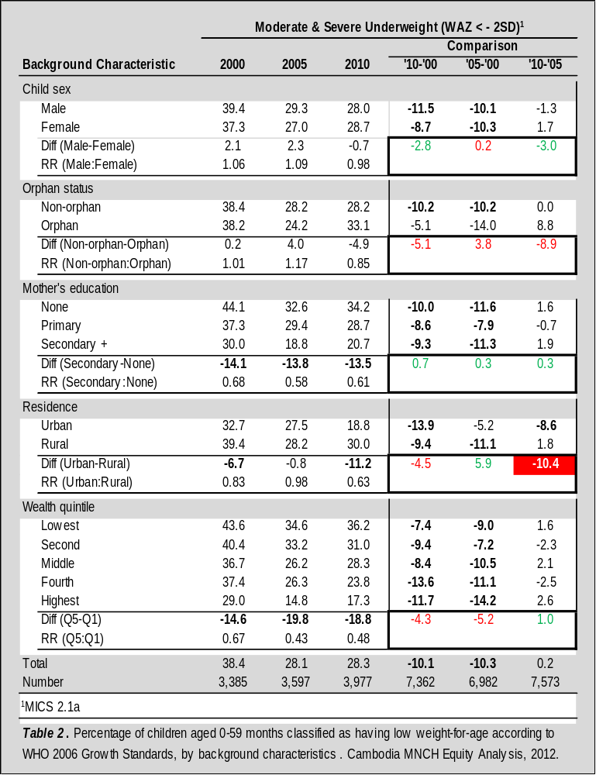
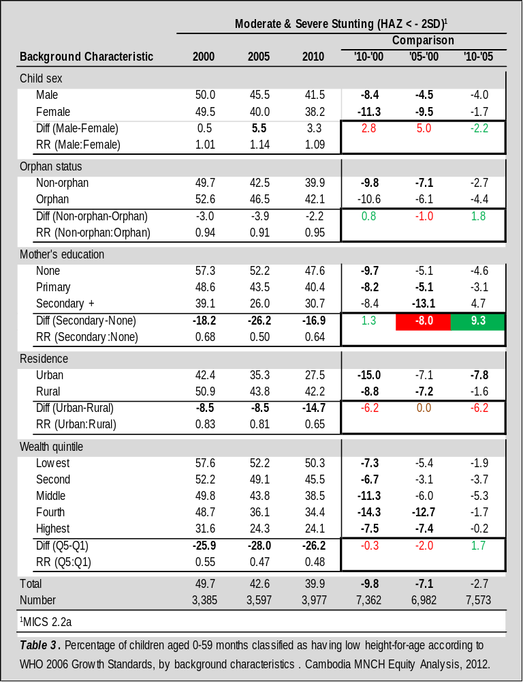
Wasting | Anaemia
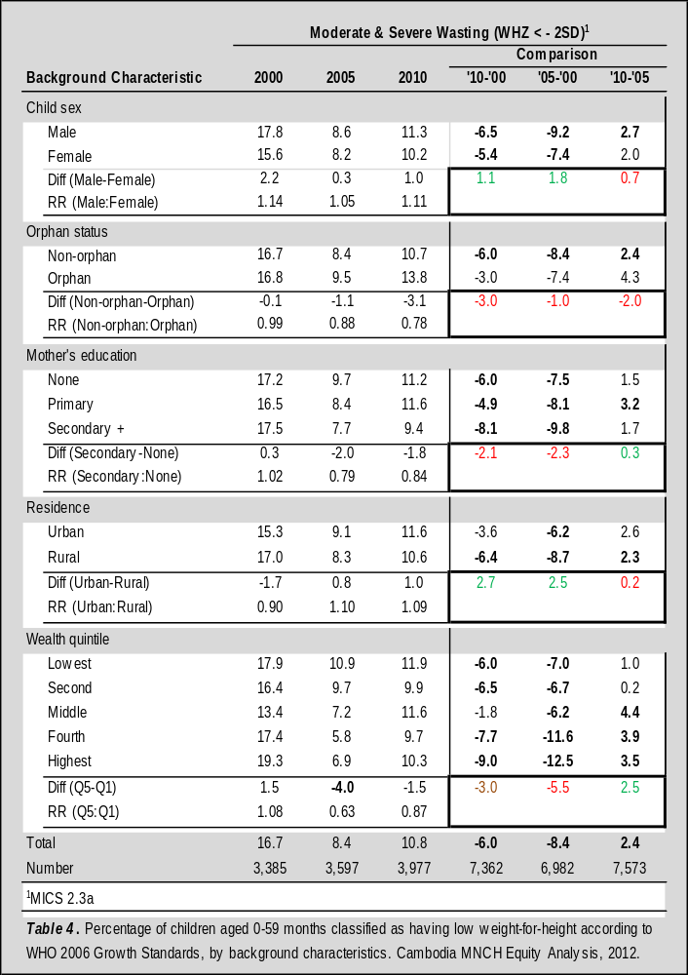
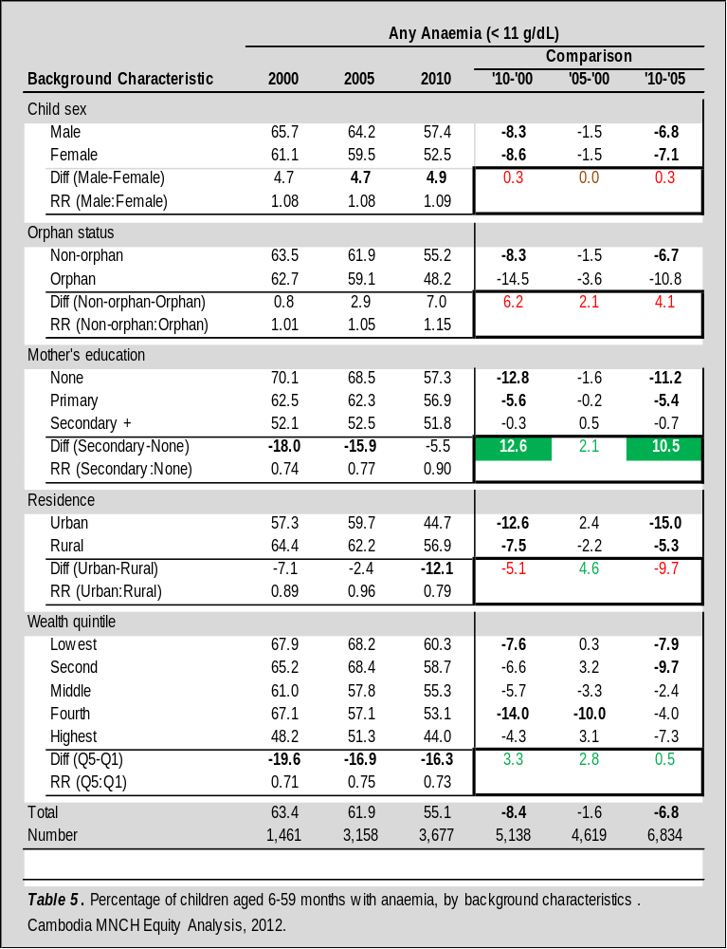
Diarrhoea
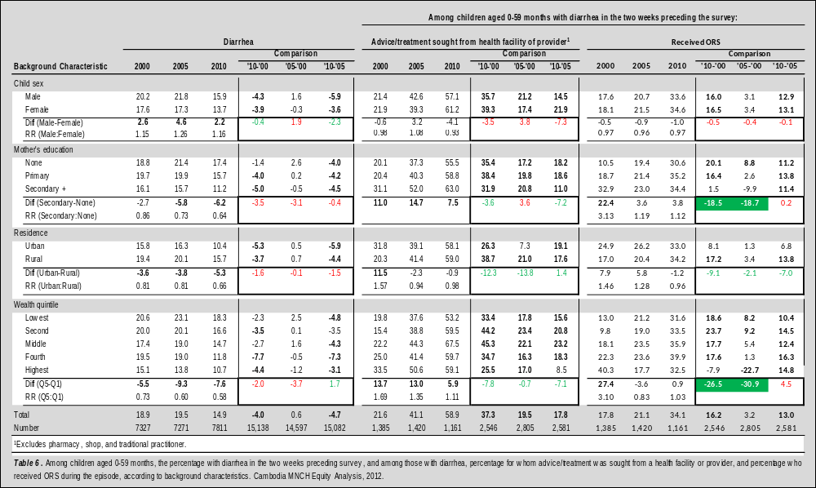
ARI
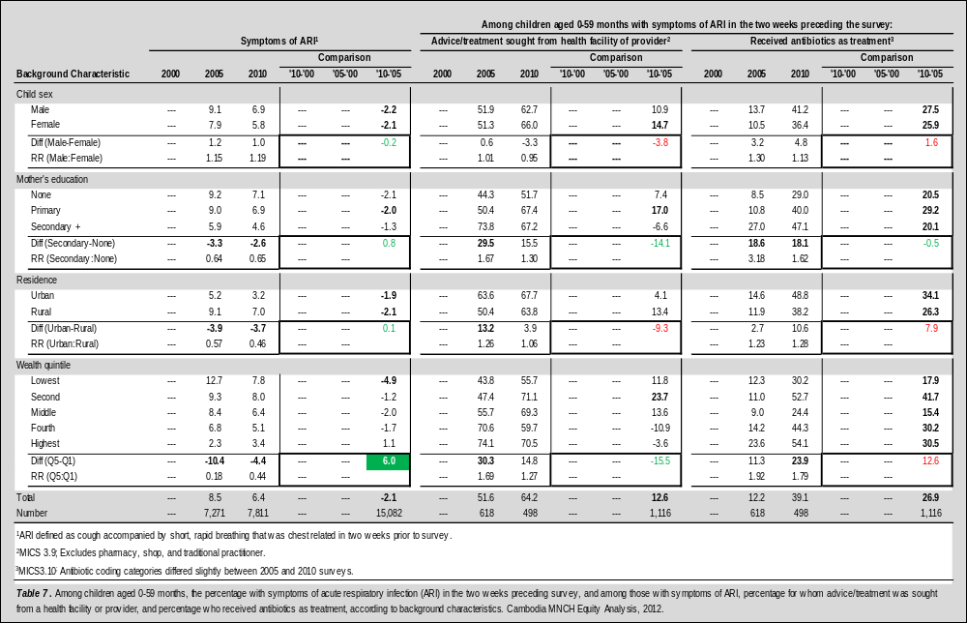
Immunization
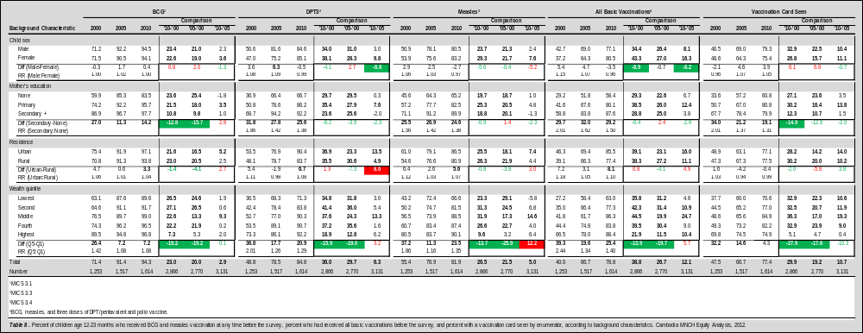

Vitamin A & Deworming
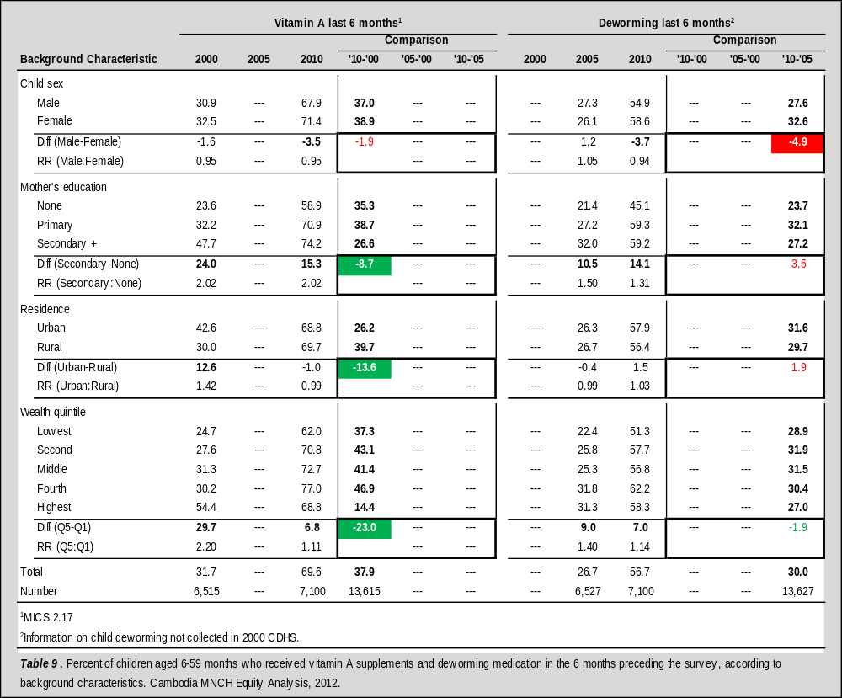

Ever Breastfed
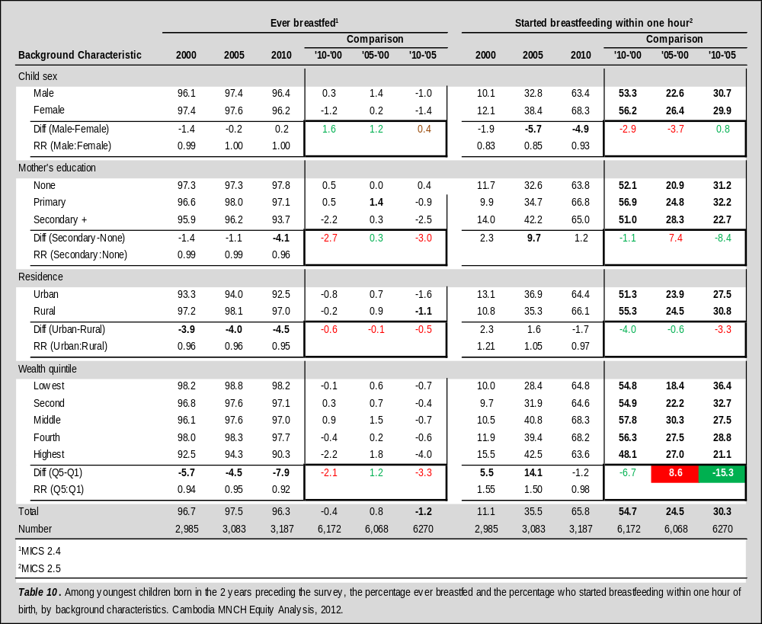
Exclusive Breastfeeding | Continued Breastfeeding
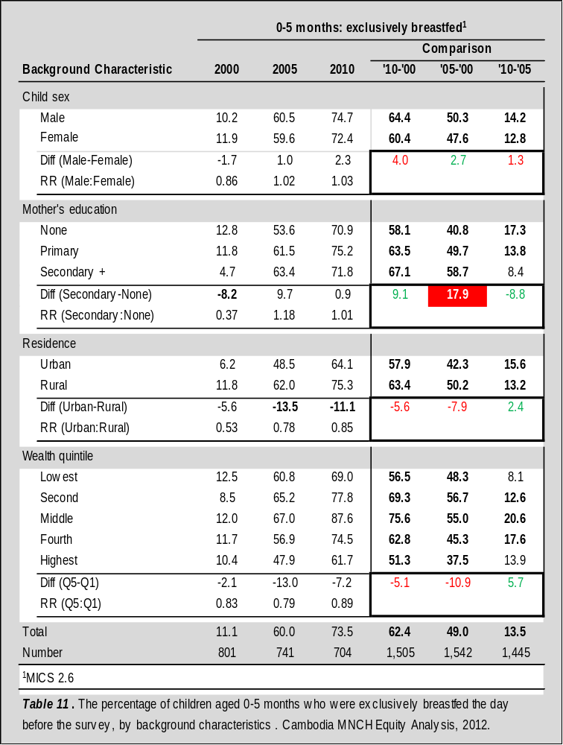
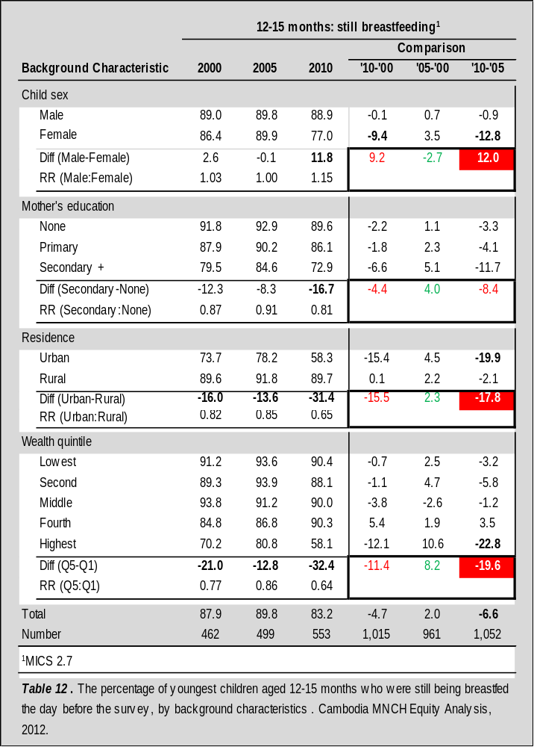
Timely Introduction of Complementary Foods
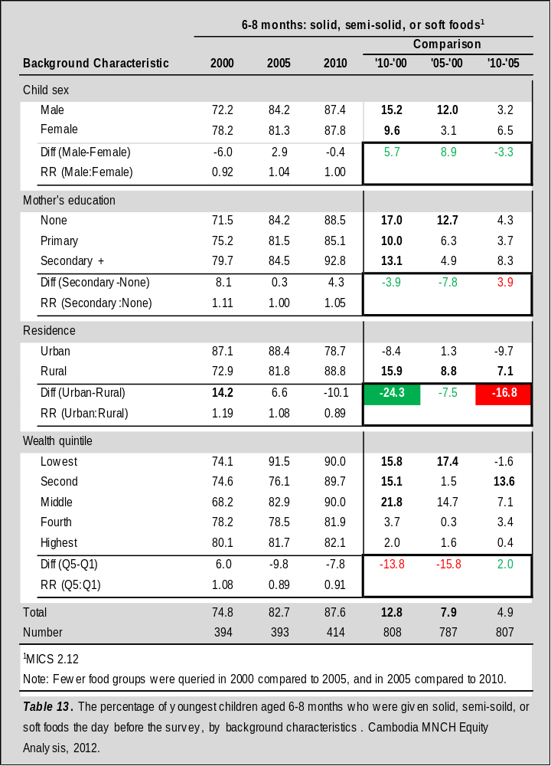
Women: Low BMI | Women: Anaemia
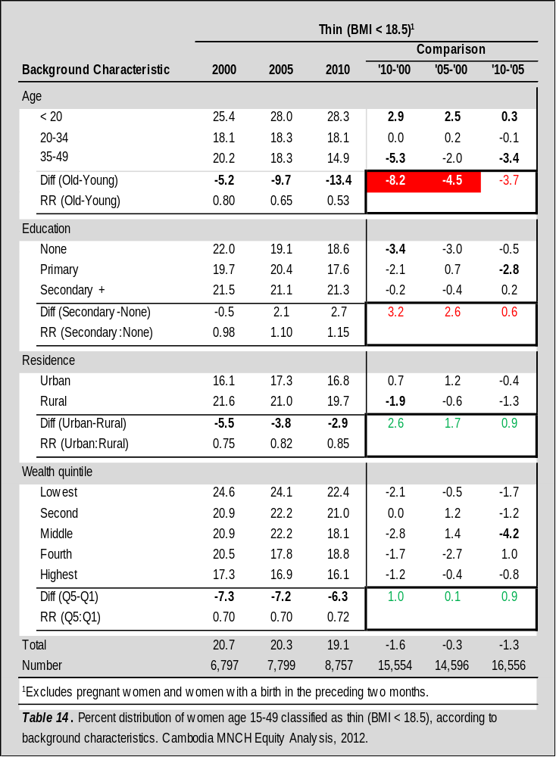
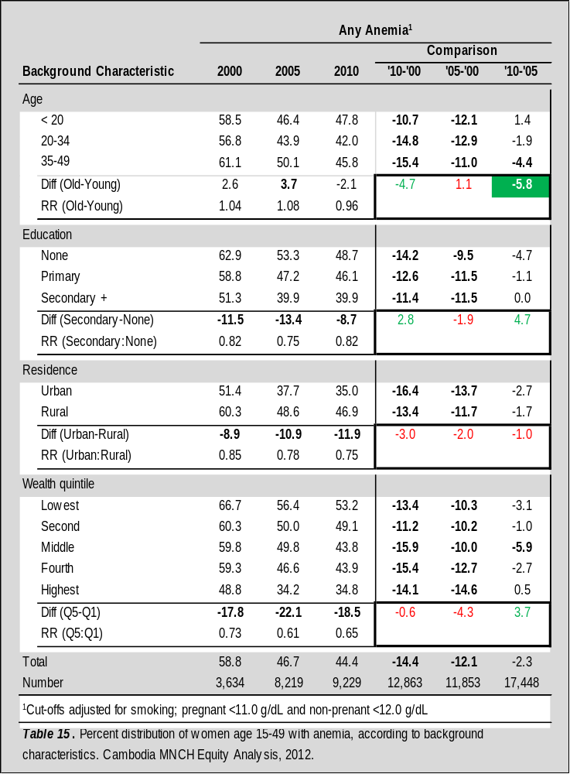
Contraceptive Prevalence Rate (Modern) | PMTCT Knowledge
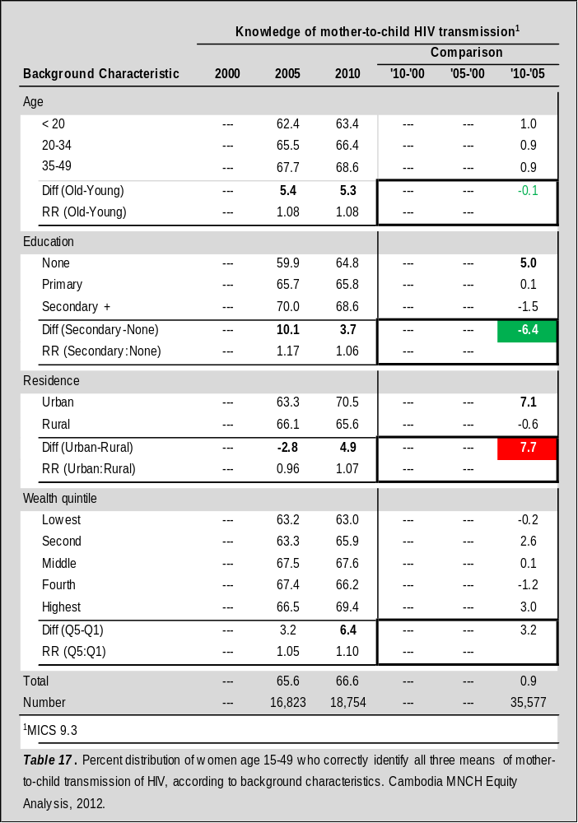
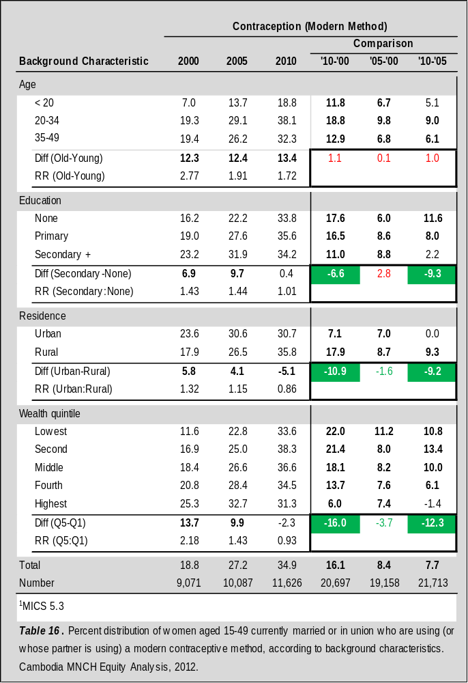
Antenatal Care
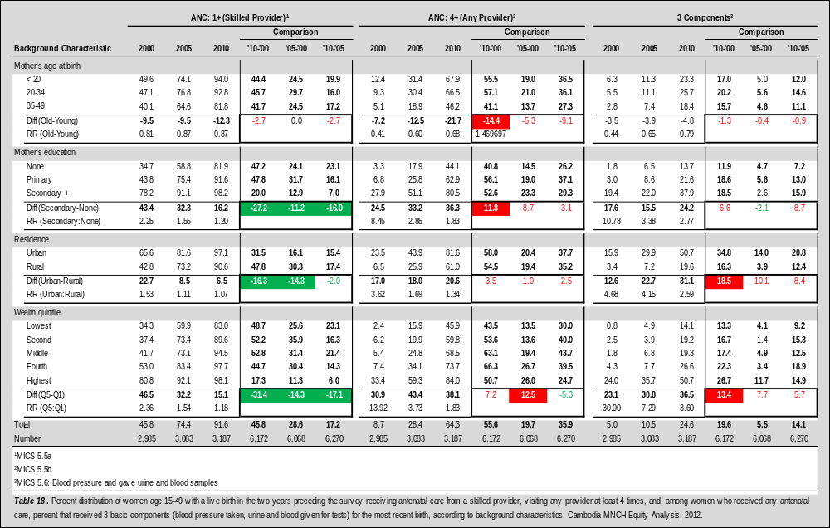
HIV Testing
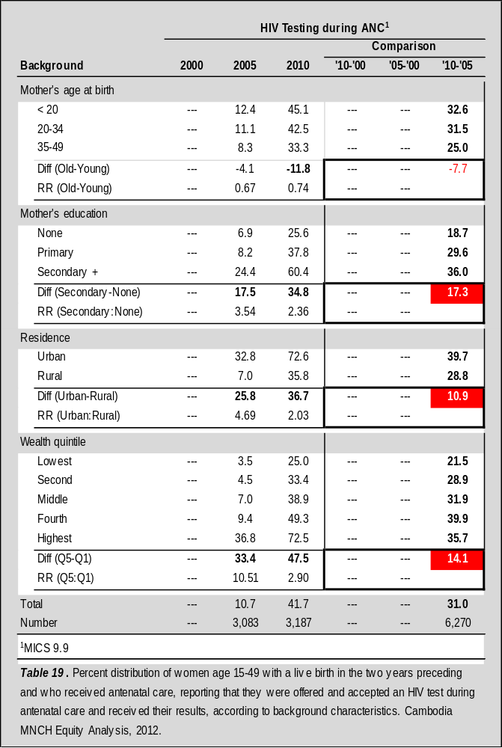
Tetanus Toxoid
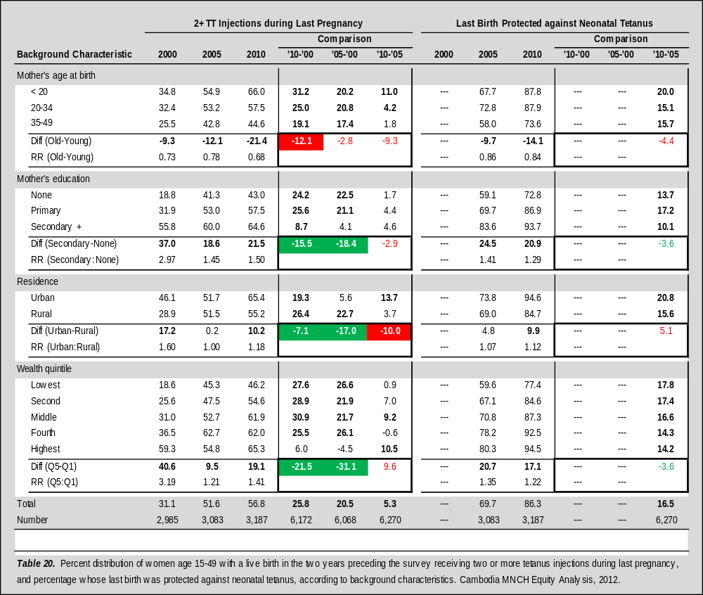
Delivery Location | Skilled Birth Attendant
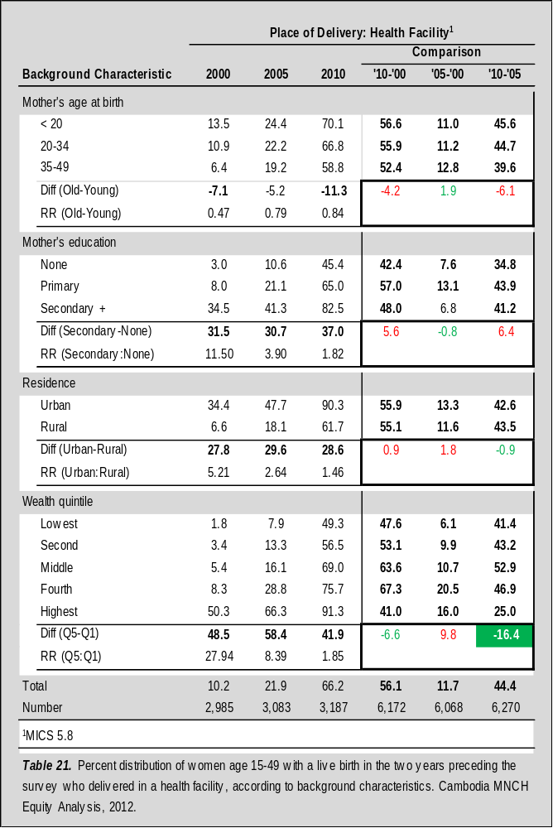
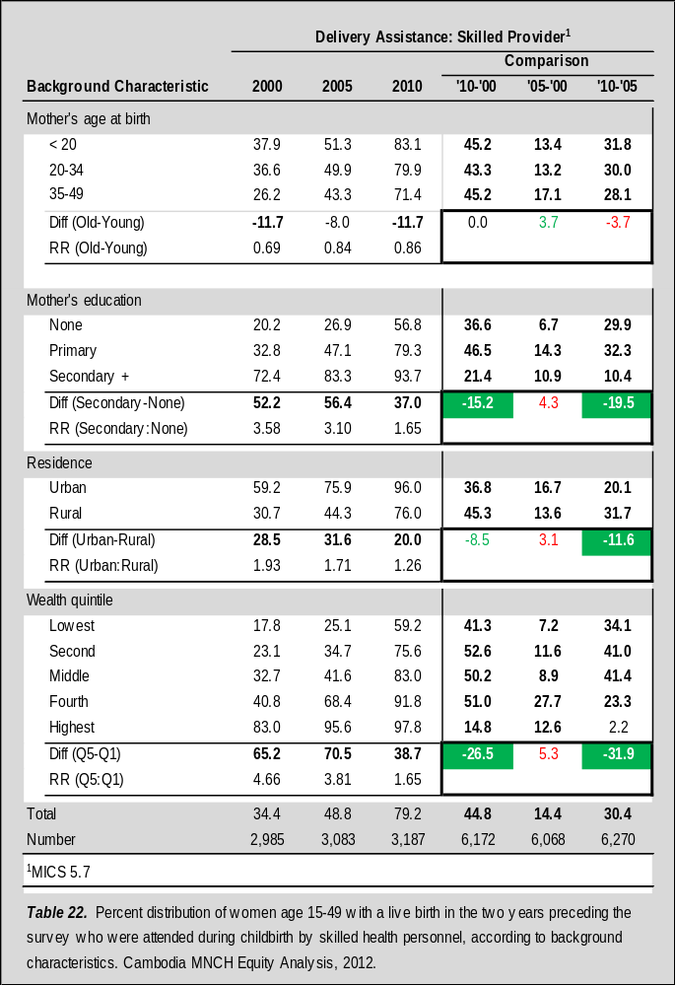
Postnatal Check-up
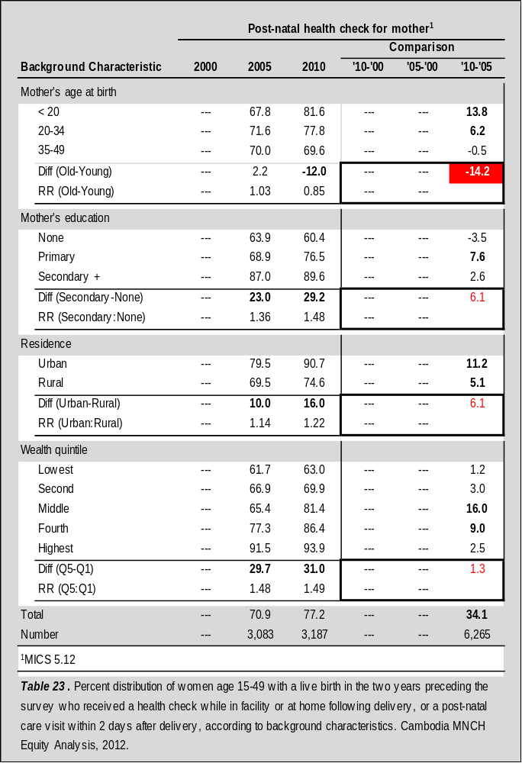

Some estimates in this report differ slightly from the estimates provided in the Cambodia Demographic and Health Survey because indicators have been altered to ensure reliability and comparability over time. All indicator definitions are included in the appendix and changes are noted in each section of the report.
A global wealth index, combining households from all three surveys, was also created to explore the potential impact “wealth inflation” could have on the equity analysis.
The data presented in the Childhood Mortality Overview were not reproduced according to the procedures described in the Methodology Section; these figures were appropriated directly from the CDHS reports. Note that the wealth indicator used in the Childhood Mortality Overview is not directly comparable to that produced for the rest of the Equity Analysis.
Childhood mortality data were collected using the same techniques and estimated using the same methodologies for all three Cambodia Demographic and Health Surveys, and are therefore considered generally comparable.
“This excess mortality among boys is not observed only in Cambodia but is a universal phenomenon.” [4]; the effect of child sex on survival appears to reduce dramatically after the first year.
To be sure, this trend is somewhat complicated since older women are less likely to require 2+ TT injections because they have received other TT injections during their lifetime.
Note that the absolute equity gaps for SBA in 2000 were much larger than the equity gaps for delivery in a health facility at the same time.

